1. Acme Sales Management 34
1.1. Acme Process Sales Order 34
1.1.1. BDR for Sales, Order 34
1.1.2. Enter Customer Order 34
1.1.3. Receive Customer Order from EDI/MHS/XML 34
1.1.4. Enter Customer Order, Additional Activities or Information 34
1.1.5. Confirm Customer Order 34
1.1.6. Release Customer Order 35
1.1.7. Handle Customer Order, Additional Activities 35
1.1.8. Reserve Customer Order 35
1.1.9. Manage Customer Order 35
1.2. Acme Process Customer Management 36
1.2.1. Create Customer and Contacts 36
1.2.2. Manage Customer and Contacts 36
1.2.3. Define Customer Credit Control 37
1.3. Acme Process Customer Price List and Agreement Management 39
1.3.1. BDR for Pricing 39
1.3.2. Manage Standard Prices 39
1.3.3. Manage Customer Price Lists 39
1.3.4. Manage Customer Agreements 39
1.3.5. Manage Campaigns 39
1.3.6. Send Price List to Customer 39
1.3.7. Manage Commission 39
1.3.8. Manage Rebates 39
1.4. Run Final Rebate Settlement 39
1.4.1. Introduction 39
1.4.1.1. Objective 39
1.4.1.2. Background information 39
1.4.2. Steps 40
1.5. Run Periodic Rebate Settlement 40
1.5.1. Introduction 40
1.5.1.1. Objective 40
1.5.1.2. Background information 40
1.5.2. Steps 40
1.6. Enter Rebate Agreement 40
1.6.1. Introduction 40
1.6.1.1. Objective 41
1.6.1.2. Background information 41
1.6.2. Steps 41
1.7. Calculate and Handle Commissions 41
1.7.1. Introduction 41
1.7.1.1. Objective 42
1.7.1.2. Background information 42
1.7.2. Steps 42
1.8. Enter External Commission Agreement 42
1.8.1. Introduction 42
1.8.1.1. Objective 42
1.8.1.2. Background information 42
1.8.2. Steps 42
1.9. Enter Internal Commission Agreement 42
1.9.1. Introduction 42
1.9.1.1. Objective 43
1.9.1.2. Background information 43
1.9.2. Steps 43
1.10. Enter Commission Agreement 43
1.10.1. Introduction 43
1.10.1.1. Objective 43
1.10.1.2. Background information 44
1.10.2. Steps 44
1.11. Send Price List to Customer via EDI/MHS 44
1.11.1. Introduction 44
1.11.1.1. Objective 44
1.11.1.2. Background information 44
1.11.2. Steps 44
1.12. Manage Assortment Campaigns without Supplier Agreement (Retail ext) 44
1.12.1. Introduction 44
1.12.1.1. Objective 44
1.12.1.2. Background information 45
1.12.2. Steps 45
1.13. Manage Assortment Campaigns (Retail ext) 45
1.13.1. Introduction 45
1.13.1.1. Objective 45
1.13.1.2. Background information 45
1.13.2. Steps 45
1.14. Add campaign for sales promotion 45
1.14.1. Introduction 45
1.14.1.1. Objective 46
1.14.1.2. Background information 46
1.14.2. Steps 47
1.15. Add general campaign for Assortment 47
1.15.1. Introduction 47
1.15.1.1. Objective 47
1.15.1.2. Background information 47
1.15.2. Steps 47
1.16. Add general campaign supported with purchase agreement 47
1.16.1. Introduction 47
1.16.1.1. Objective 48
1.16.1.2. Background information 48
1.16.2. Steps 48
1.17. Add general campaign for parts 48
1.17.1. Introduction 48
1.17.1.1. Objective 49
1.17.1.2. Background information 49
1.17.2. Steps 49
1.18. Manage Campaigns 49
1.18.1. Introduction 49
1.18.1.1. Objective 50
1.18.1.2. Background information 50
1.18.2. Steps 50
1.19. Enter Customer Agreement - Deal per Assortment 50
1.19.1. Introduction 50
1.19.1.1. Objective 50
1.19.1.2. Background information 50
1.19.2. Steps 50
1.20. Enter Customer Agreement - Discount for Sales group 50
1.20.1. Introduction 50
1.20.1.1. Objective 50
1.20.1.2. Background information 51
1.20.2. Steps 51
1.21. Enter Customer Agreement for Part 51
1.21.1. Introduction 51
1.21.1.1. Objective 51
1.21.1.2. Background information 51
1.21.2. Steps 51
1.22. Maintain Price Lists 51
1.22.1. Introduction 51
1.22.1.1. Objective 52
1.22.1.2. Background information 52
1.22.2. Steps 52
1.23. Enter Price Lists, CTO Basic 52
1.23.1. Introduction 52
1.23.1.1. Objective 52
1.23.1.2. Background information 52
1.23.2. Steps 53
1.24. Enter Price Lists, CTO 53
1.24.1. Introduction 53
1.24.1.1. Objective 53
1.24.1.2. Background information 53
1.24.2. Steps 53
1.25. Update Cost based Price List 53
1.25.1. Introduction 53
1.25.1.1. Objective 53
1.25.1.2. Background information 53
1.25.2. Steps 54
1.26. Enter Cost Based Price List 54
1.26.1. Introduction 54
1.26.1.1. Objective 56
1.26.1.2. Background information 56
1.26.2. Steps 56
1.27. Enter Assortment Based Price List 56
1.27.1. Introduction 56
1.27.1.1. Objective 56
1.27.1.2. Background information 56
1.27.2. Steps 56
1.28. Enter Unit based Price List 56
1.28.1. Introduction 56
1.28.1.1. Objective 57
1.28.1.2. Background information 57
1.28.2. Steps 57
1.29. Enter Price List 57
1.29.1. Introduction 57
1.29.1.1. Objective 58
1.29.1.2. Background information 58
1.29.2. Steps 58
1.30. Manage Standard Prices 58
1.30.1. Introduction 58
1.30.1.1. Objective 59
1.30.1.2. Background information 59
1.30.2. Steps 59
1.31. Define Customer Credit Control 59
1.31.1. Introduction 59
1.31.1.1. Objective 59
1.31.1.2. Background information 60
1.31.2. Steps 60
1.32. Manually Update Customer 60
1.32.1. Introduction 60
1.32.1.1. Objective 60
1.32.1.2. Background information 60
1.32.2. Steps 60
1.33. Create Internal Customer based on Template 60
1.33.1. Introduction 60
1.33.1.1. Objective 61
1.33.1.2. Background information 61
1.33.2. Steps 61
1.34. Create Customer and Customer Hierarchy 61
1.34.1. Introduction 61
1.34.1.1. Objective 61
1.34.1.2. Background information 61
1.34.2. Steps 61
1.35. Create Internal Customer 61
1.35.1. Introduction 61
1.35.1.1. Objective 62
1.35.1.2. Background information 62
1.35.2. Steps 62
1.36. Create Customer from Sales & Marketing (CRM) 62
1.36.1. Introduction 62
1.36.1.1. Objective 63
1.36.1.2. Background information 63
1.36.2. Steps 63
1.37. Manually Create Customer 63
1.37.1. Introduction 63
1.37.1.1. Objective 64
1.37.1.2. Background information 64
1.37.2. Steps 64
1.38. BDR Schedule Reservation 64
1.38.1. Introduction 64
1.38.1.1. Objective 65
1.38.1.2. Background information 65
1.38.2. Steps 65
1.39. Change/update price 65
1.39.1. Introduction 65
1.39.1.1. Objective 65
1.39.1.2. Background information 65
1.39.2. Steps 65
1.40. Change Delivery Information 65
1.40.1. Introduction 65
1.40.1.1. Objective 66
1.40.1.2. Background information 66
1.40.2. Steps 66
1.41. Change Delivery date/qty 66
1.41.1. Introduction 66
1.41.1.1. Objective 67
1.41.1.2. Background information 67
1.41.2. Steps 67
1.42. Run Automatic Reservation of Box Order Line, Started Manually (Retail ext) 67
1.42.1. Introduction 67
1.42.1.1. Objective 67
1.42.1.2. Background information 67
1.42.2. Steps 68
1.43. Run Automatic Reservation of Customer Order Line, Started Manually 68
1.43.1. Introduction 68
1.43.1.1. Objective 68
1.43.1.2. Background information 68
1.43.2. Steps 68
1.44. Run Automatic Reservation of Customer Order, Started by Order Type 68
1.44.1. Introduction 68
1.44.1.1. Objective 68
1.44.1.2. Background information 68
1.44.2. Steps 68
1.45. Run Automatic Reservation of Customer Order, Started Manually 68
1.45.1. Introduction 68
1.45.1.1. Objective 68
1.45.1.2. Background information 68
1.45.2. Steps 69
1.46. Run Automatic Reservation of a Batch of Customer Orders per Site, Started by Scheduled Task 69
1.46.1. Introduction 69
1.46.1.1. Objective 69
1.46.1.2. Background information 69
1.46.2. Steps 69
1.47. Run Automatic Reservation of a Batch of Customer Orders per Site, Started Manually 69
1.47.1. Introduction 69
1.47.1.1. Objective 69
1.47.1.2. Background information 69
1.47.2. Steps 69
1.48. Manually Reserve Customer Order Line 69
1.48.1. Introduction 69
1.48.1.1. Objective 70
1.48.1.2. Background information 70
1.48.2. Steps 70
1.49. Reserve Customer Order (Std) 70
1.49.1. Introduction 70
1.49.1.1. Objective 71
1.49.1.2. Background information 71
1.49.2. Steps 71
1.50. Handle Customer Order, Additional Activities (std) 71
1.50.1. Introduction 71
1.50.1.1. Objective 72
1.50.1.2. Background information 72
1.50.2. Steps 72
1.51. Release Customer Order 72
1.51.1. Introduction 72
1.51.1.1. Objective 73
1.51.1.2. Background information 73
1.51.2. Steps 73
1.52. Send Customer Order Confirmation via EDI 73
1.52.1. Introduction 73
1.52.1.1. Objective 73
1.52.1.2. Background information 73
1.52.2. Steps 74
1.53. Email Customer Order Confirmation 74
1.53.1. Introduction 74
1.53.1.1. Objective 74
1.53.1.2. Background information 74
1.53.2. Steps 74
1.54. Print Customer Order Confirmation 74
1.54.1. Introduction 74
1.54.1.1. Objective 75
1.54.1.2. Background information 75
1.54.2. Steps 75
1.55. Confirm Customer Order 75
1.55.1. Introduction 75
1.55.1.1. Objective 75
1.55.1.2. Background information 76
1.55.2. Steps 76
1.56. BDR for Charges 76
1.56.1. Introduction 76
1.56.1.1. Objective 76
1.56.1.2. Background information 76
1.56.2. Steps 76
1.57. Enter Customer Order CTO, Additional Activities or Information 76
1.57.1. Introduction 76
1.57.1.1. Objective 76
1.57.1.2. Background information 77
1.57.2. Steps 77
1.58. Source Non-sourced Customer Order Lines 77
1.58.1. Introduction 77
1.58.1.1. Objective 77
1.58.1.2. Background information 77
1.58.2. Steps 77
1.59. Stage Billing on Customer Order 77
1.59.1. Introduction 77
1.59.1.1. Objective 78
1.59.1.2. Background information 78
1.59.2. Steps 78
1.60. Handle Tax, Discount and/or Charges 78
1.60.1. Introduction 78
1.60.1.1. Objective 78
1.60.1.2. Background information 79
1.60.2. Steps 79
1.61. Connect Customer Order Line to Project Activity 79
1.61.1. Introduction 79
1.61.1.1. Objective 79
1.61.1.2. Background information 79
1.61.2. Steps 79
1.62. Enter Customer Order, Additional Activities or Information 79
1.62.1. Introduction 79
1.62.1.1. Objective 80
1.62.1.2. Background information 81
1.62.2. Steps 81
1.63. Receive Customer Order Change Request from EDI/MHS/XML 81
1.63.1. Introduction 81
1.63.1.1. Objective 81
1.63.1.2. Background information 81
1.63.2. Steps 81
1.64. Receive Customer Order from EDI/MHS/XML 81
1.64.1. Introduction 81
1.64.1.1. Objective 81
1.64.1.2. Background information 81
1.64.2. Steps 81
1.65. Manually Create Customer Order, CTO 81
1.65.1. Introduction 81
1.65.1.1. Objective 81
1.65.1.2. Background information 81
1.65.2. Steps 82
1.66. Manually Create Customer Order, Basic 82
1.66.1. Introduction 82
1.66.1.1. Objective 82
1.66.1.2. Background information 82
1.66.2. Steps 82
1.67. Enter Customer Order 82
1.67.1. Introduction 82
1.67.1.1. Objective 83
1.67.1.2. Background information 83
1.67.2. Steps 84
1.68. BDR for Delivery Confirmation 84
1.68.1. Introduction 84
1.68.1.1. Objective 84
1.68.1.2. Background information 84
1.68.2. Steps 84
1.69. BDR for Customer Consignment Stock 84
1.69.1. Introduction 84
1.69.1.1. Objective 85
1.69.1.2. Background information 85
1.69.2. Steps 85
1.70. BDR for Sales Quotation 85
1.70.1. Introduction 85
1.70.1.1. Objective 85
1.70.1.2. Background information 86
1.70.2. Steps 86
1.71. BDR for Sourcing 86
1.71.1. Introduction 86
1.71.1.1. Objective 86
1.71.1.2. Background information 86
1.71.2. Steps 86
1.72. BDR for Shipping by Route 86
1.72.1. Introduction 86
1.72.1.1. Objective 87
1.72.1.2. Background information 87
1.72.2. Steps 87
1.73. BDR for Sales 87
1.73.1. Introduction 87
1.73.1.1. Objective 88
1.73.1.2. Background information 88
1.73.2. Steps 89
1.74. BDR for Freight 89
1.74.1. Introduction 89
1.74.1.1. Objective 89
1.74.1.2. Background information 89
1.74.2. Steps 89
1.75. BDR for Pricing 89
1.75.1. Introduction 89
1.75.1.1. Objective 90
1.75.1.2. Background information 90
1.75.2. Steps 90
1.76. BDR for Supply Chain Relations 90
1.76.1. Introduction 90
1.76.1.1. Objective 90
1.76.1.2. Background information 91
1.76.2. Steps 91
2. Acme Procurement Management 91
2.1. Acme Process Purchase Order 91
2.1.1. BDR for Manage Purchase 92
2.1.2. Enter Purchase Requisition 92
2.1.3. Handle Purchase Requisition 92
2.1.4. Purchase Authorization 93
2.1.5. Handle Purchase Order 93
2.1.6. Create Supplier Agreement Release 93
2.1.7. Print and/or Send Purchase Order 93
2.1.8. Purchase Order Confirmation 93
2.1.9. Supplier Material Function 93
2.1.10. Manage and Monitor Purchase Order 93
2.1.11. Authorization Rule Setup 94
2.1.12. Handle Purchase Order Change Order 94
2.2. Acme Process Supplier Management 94
2.2.1. Create Supplier 94
2.2.2. Manage Supplier 95
2.3. Acme Process Supplier Agreement Management 96
2.3.1. Enter Supplier Agreement 96
2.3.2. Enter Request for Supplier Agreement Quotation 97
2.3.3. Handle Supplier Agreement Quotation 98
2.3.4. Re-Negotiate Supplier Agreement 99
2.4. Re-Negotiate Supplier Agreement 99
2.4.1. Introduction 99
2.4.1.1. Objective 100
2.4.1.2. Background information 100
2.4.2. Steps 101
2.5. Handle Supplier Agreement Quotation 101
2.5.1. Introduction 101
2.5.1.1. Objective 101
2.5.1.2. Background information 101
2.5.2. Steps 101
2.6. Enter Request for Supplier Agreement Quotation 101
2.6.1. Introduction 101
2.6.1.1. Objective 102
2.6.1.2. Background information 102
2.6.2. Steps 102
2.7. Create Part and Manage Agreement Prices from eBuyer (Scand ext.) 102
2.7.1. Introduction 102
2.7.1.1. Objective 102
2.7.1.2. Background information 102
2.7.2. Steps 103
2.8. Create and manage Agreement prices and terms, EDI import (PRICAT) 103
2.8.1. Introduction 103
2.8.1.1. Objective 103
2.8.1.2. Background information 103
2.8.2. Steps 103
2.9. Create and manage Agreement prices and terms, excel import (SDMan) 103
2.9.1. Introduction 103
2.9.1.1. Objective 103
2.9.1.2. Background information 103
2.9.2. Steps 104
2.10. Enter Blanket Purchase Order 104
2.10.1. Introduction 104
2.10.1.1. Objective 104
2.10.1.2. Background information 104
2.10.2. Steps 104
2.11. Enter Purchase Agreement 104
2.11.1. Introduction 104
2.11.1.1. Objective 105
2.11.1.2. Background information 105
2.11.2. Steps 105
2.12. Approve supplier for Quality/Environmental std. 105
2.12.1. Introduction 105
2.12.1.1. Objective 106
2.12.1.2. Background information 106
2.12.2. Steps 106
2.13. Add supplier to Approved suppliers list 106
2.13.1. Introduction 106
2.13.1.1. Objective 106
2.13.1.2. Background information 107
2.13.2. Steps 107
2.14. Replace Supplier for parts - batch 107
2.14.1. Introduction 107
2.14.1.1. Objective 107
2.14.1.2. Background information 107
2.14.2. Steps 107
2.15. Phase out Supplier 107
2.15.1. Introduction 107
2.15.1.1. Objective 108
2.15.1.2. Background information 108
2.15.2. Steps 108
2.16. Create Internal Supplier based on template 108
2.16.1. Introduction 108
2.16.1.1. Objective 108
2.16.1.2. Background information 109
2.16.2. Steps 109
2.17. Create Internal Supplier 109
2.17.1. Introduction 109
2.17.1.1. Objective 109
2.17.1.2. Background information 109
2.17.2. Steps 109
2.18. Create Supplier for EDI collaboration 109
2.18.1. Introduction 109
2.18.1.1. Objective 109
2.18.1.2. Background information 109
2.18.2. Steps 110
2.19. Create External Supplier 110
2.19.1. Introduction 110
2.19.1.1. Objective 110
2.19.1.2. Background information 110
2.19.2. Steps 110
2.20. Handle Purchase Order Change Order 110
2.20.1. Introduction 110
2.20.1.1. Objective 111
2.20.1.2. Background information 111
2.20.2. Steps 111
2.21. Purchase Order Authorization Rule Setup 111
2.21.1. Introduction 111
2.21.1.1. Objective 111
2.21.1.2. Background information 111
2.21.2. Steps 112
2.22. Purchase Requisition Authorization Rule Setup 112
2.22.1. Introduction 112
2.22.1.1. Objective 112
2.22.1.2. Background information 112
2.22.2. Steps 112
2.23. Purchase Order Authorization Rules Setup 112
2.23.1. Introduction 112
2.23.1.1. Objective 112
2.23.1.2. Background information 112
2.23.2. Steps 113
2.24. Purchase Order Requisition Authorization Rules Setup 113
2.24.1. Introduction 113
2.24.1.1. Objective 113
2.24.1.2. Background information 113
2.24.2. Steps 113
2.25. Basic Data for Authorization Rules 113
2.25.1. Introduction 113
2.25.1.1. Objective 114
2.25.1.2. Background information 114
2.25.2. Steps 114
2.26. Receive of Direct Delivery 114
2.26.1. Introduction 114
2.26.1.1. Objective 114
2.26.1.2. Background information 115
2.26.2. Steps 115
2.27. Change Purchase Order with revision control 115
2.27.1. Introduction 115
2.27.1.1. Objective 115
2.27.1.2. Background information 115
2.27.2. Steps 115
2.28. Change Purchase Order without revision control 115
2.28.1. Introduction 115
2.28.1.1. Objective 116
2.28.1.2. Background information 116
2.28.2. Steps 116
2.29. Monitoring Purchase Order with Confirmation from Supplier 116
2.29.1. Introduction 116
2.29.1.1. Objective 117
2.29.1.2. Background information 117
2.29.2. Steps 118
2.30. Handle Supplier Material Function 118
2.30.1. Introduction 118
2.30.1.1. Objective 118
2.30.1.2. Background information 118
2.30.2. Steps 118
2.31. Confirm Purchase Order 118
2.31.1. Introduction 118
2.31.1.1. Objective 119
2.31.1.2. Background information 119
2.31.2. Steps 119
2.32. Send Purchase Order to B2B Portal 119
2.32.1. Introduction 119
2.32.1.1. Objective 119
2.32.1.2. Background information 120
2.32.2. Steps 120
2.33. Print/Send/E-mail Purchase Order 120
2.33.1. Introduction 120
2.33.1.1. Objective 120
2.33.1.2. Background information 120
2.33.2. Steps 120
2.34. Print / Send Purchase Order 120
2.34.1. Introduction 120
2.34.1.1. Objective 121
2.34.1.2. Background information 121
2.34.2. Steps 121
2.35. Create Supplier Agreement Release 121
2.35.1. Introduction 121
2.35.1.1. Objective 121
2.35.1.2. Background information 122
2.35.2. Steps 122
2.36. Process Purchase Order for External Service Order 122
2.36.1. Introduction 122
2.36.1.1. Objective 122
2.36.1.2. Background information 122
2.36.2. Steps 122
2.37. Process Subcontracting Purchase Order 122
2.37.1. Introduction 122
2.37.1.1. Objective 122
2.37.1.2. Background information 122
2.37.2. Steps 122
2.38. Process Purchase Order from Quotation 122
2.38.1. Introduction 122
2.38.1.1. Objective 122
2.38.1.2. Background information 122
2.38.2. Steps 123
2.39. Modify Purchase Order Terms or Alternate Delivery Address 123
2.39.1. Introduction 123
2.39.1.1. Objective 123
2.39.1.2. Background information 123
2.39.2. Steps 123
2.40. Handle Purchase Order (Basic) 123
2.40.1. Introduction 123
2.40.1.1. Objective 124
2.40.1.2. Background information 124
2.40.2. Steps 124
2.41. Handle Purchase Order 124
2.41.1. Introduction 124
2.41.1.1. Objective 125
2.41.1.2. Background information 125
2.41.2. Steps 125
2.42. Authorize Purchase Requisition, Automatic Order Processing 125
2.42.1. Introduction 125
2.42.1.1. Objective 125
2.42.1.2. Background information 126
2.42.2. Steps 126
2.43. Authorize Purchase Order 126
2.43.1. Introduction 126
2.43.1.1. Objective 126
2.43.1.2. Background information 126
2.43.2. Steps 126
2.44. Authorize Purchase Order Requsistion 126
2.44.1. Introduction 126
2.44.1.1. Objective 126
2.44.1.2. Background information 126
2.44.2. Steps 126
2.45. Process Centralized Purchase Requisitions into one Purchase Order 126
2.45.1. Introduction 126
2.45.1.1. Objective 127
2.45.1.2. Background information 127
2.45.2. Steps 127
2.46. Handle Purchase Requisition, Automatic Order Processing 127
2.46.1. Introduction 127
2.46.1.1. Objective 128
2.46.1.2. Background information 128
2.46.2. Steps 128
2.47. Handle Express Purchase Order Requisition 128
2.47.1. Introduction 128
2.47.1.1. Objective 129
2.47.1.2. Background information 129
2.47.2. Steps 129
2.48. Process PO Requisition to Quotation 129
2.48.1. Introduction 129
2.48.1.1. Objective 130
2.48.1.2. Background information 130
2.48.2. Steps 130
2.49. Process Purchase Order Requisition 130
2.49.1. Introduction 130
2.49.1.1. Objective 130
2.49.1.2. Background information 130
2.49.2. Steps 130
2.50. Handle Purchase Requisition 130
2.50.1. Introduction 130
2.50.1.1. Objective 131
2.50.1.2. Background information 131
2.50.2. Steps 131
2.51. Enter Purchase Requisition with eBuyer 131
2.51.1. Introduction 131
2.51.1.1. Objective 132
2.51.1.2. Background information 132
2.51.2. Steps 132
2.52. Enter Purchase Order Requisition for External Services with pre-posting 132
2.52.1. Introduction 132
2.52.1.1. Objective 132
2.52.1.2. Background information 132
2.52.2. Steps 132
2.53. Enter Purchase Order Requisition for External Services 132
2.53.1. Introduction 132
2.53.1.1. Objective 133
2.53.1.2. Background information 133
2.53.2. Steps 133
2.54. Enter Express PO Requisition 133
2.54.1. Introduction 133
2.54.1.1. Objective 133
2.54.1.2. Background information 133
2.54.2. Steps 133
2.55. Enter Purchase Order Requisition with Wizard 133
2.55.1. Introduction 133
2.55.1.1. Objective 134
2.55.1.2. Background information 134
2.55.2. Steps 134
2.56. Enter Purchase Order Requisition with Pre-Posting 134
2.56.1. Introduction 134
2.56.1.1. Objective 135
2.56.1.2. Background information 135
2.56.2. Steps 135
2.57. Enter Purchase Order Requisition 135
2.57.1. Introduction 135
2.57.1.1. Objective 136
2.57.1.2. Background information 136
2.57.2. Steps 136
2.58. Enter Purchase Order Requisition 136
2.58.1. Introduction 136
2.58.1.1. Objective 137
2.58.1.2. Background information 137
2.58.2. Steps 137
2.59. BDR for Procurement 137
2.59.1. Introduction 137
2.59.1.1. Objective 138
2.59.1.2. Background information 138
2.59.2. Steps 138
2.60. BDR for Charge/No Charge 138
2.60.1. Introduction 138
2.60.1.1. Objective 139
2.60.1.2. Background information 139
2.60.2. Steps 139
2.61. BDR for Automatic Order Processing 139
2.61.1. Introduction 139
2.61.1.1. Objective 139
2.61.1.2. Background information 140
2.61.2. Steps 140
2.62. BDR for Automatic Invoicing (Self Billing) 140
2.62.1. Introduction 140
2.62.1.1. Objective 140
2.62.1.2. Background information 140
2.62.2. Steps 140
2.63. BDR for Supplier Agreement 140
2.63.1. Introduction 140
2.63.1.1. Objective 141
2.63.1.2. Background information 141
2.63.2. Steps 141
2.64. BDR for Supply Chain Relations 141
2.64.1. Introduction 141
2.64.1.1. Objective 141
2.64.1.2. Background information 142
2.64.2. Steps 142
3. Acme Warehouse Management 142
3.1. Acme Process Receipt 142
3.1.1. BDR for Receipt Process 142
3.1.2. Report Arrival 142
3.1.3. Move Into Inspection Location 144
3.1.4. Perform Quality Inspection & Handle Discrepancies 145
3.1.5. Handle Arrival 146
3.1.6. Move into Stock 147
3.1.7. Handle Receipt for Direct Delivery 148
3.2. Acme Process Handle Inventory 149
3.2.1. BDR for Maintain Inventory 149
3.2.2. Handle Material Requisition 149
3.2.3. Issue Material 149
3.2.4. Handle Parts 150
3.2.5. Handle Counting 150
3.3. Acme Process Shipment 150
3.3.1. BDR for Shipment 150
3.3.2. Create Shipment 150
3.3.3. Handle Picking 151
3.3.4. Packing of Goods 152
3.3.5. Deliver Customer Order 152
3.4. Deliver Customer Order Box Line (Retail ext) 152
3.4.1. Introduction 152
3.4.1.1. Objective 152
3.4.1.2. Background information 152
3.4.2. Steps 153
3.5. Deliver Customer Order, Single Order Delivery, Pre-shipment Delivery Note 153
3.5.1. Introduction 153
3.5.1.1. Objective 153
3.5.1.2. Background information 153
3.5.2. Steps 154
3.6. Deliver Customer Order, Load List 154
3.6.1. Introduction 154
3.6.1.1. Objective 154
3.6.1.2. Background information 154
3.6.2. Steps 154
3.7. Finalize Shipment 154
3.7.1. Introduction 154
3.7.1.1. Objective 155
3.7.1.2. Background information 155
3.7.2. Steps 155
3.8. Deliver Customer Order, Shipment 155
3.8.1. Introduction 155
3.8.1.1. Objective 156
3.8.1.2. Background information 156
3.8.2. Steps 156
3.9. Deliver Customer Order, Single Order Delivery 156
3.9.1. Introduction 156
3.9.1.1. Objective 157
3.9.1.2. Background information 157
3.9.2. Steps 157
3.10. Packing of Goods with Shipment 157
3.10.1. Introduction 157
3.10.1.1. Objective 158
3.10.1.2. Background information 158
3.10.2. Steps 158
3.11. Packing of Goods without Shipment 158
3.11.1. Introduction 158
3.11.1.1. Objective 159
3.11.1.2. Background information 159
3.11.2. Steps 159
3.12. Handle Picking of Boxes without Shipment (Retail ext) 159
3.12.1. Introduction 159
3.12.1.1. Objective 159
3.12.1.2. Background information 159
3.12.2. Steps 159
3.13. Handle Picking with Shipment 159
3.13.1. Introduction 159
3.13.1.1. Objective 160
3.13.1.2. Background information 160
3.13.2. Steps 160
3.14. Handle Picking without Shipment 160
3.14.1. Introduction 160
3.14.1.1. Objective 161
3.14.1.2. Background information 161
3.14.2. Steps 161
3.15. Create Consolidated Shipment 161
3.15.1. Introduction 161
3.15.1.1. Objective 162
3.15.1.2. Background information 162
3.15.2. Steps 162
3.16. Create Shipment 162
3.16.1. Introduction 162
3.16.1.1. Objective 163
3.16.1.2. Background information 163
3.16.2. Steps 163
3.17. BDR for SSCC 163
3.17.1. Introduction 163
3.17.1.1. Objective 164
3.17.1.2. Background information 164
3.17.2. Steps 164
3.18. BDR for Counting 164
3.18.1. Introduction 164
3.18.1.1. Objective 164
3.18.1.2. Background information 165
3.18.2. Steps 165
3.19. Handle Counting without Count Report 165
3.19.1. Introduction 165
3.19.1.1. Objective 165
3.19.1.2. Background information 165
3.19.2. Steps 165
3.20. Handle Counting using Count Report 165
3.20.1. Introduction 165
3.20.1.1. Objective 166
3.20.1.2. Background information 166
3.20.2. Steps 166
3.21. Transfer To/From Project Inventory 166
3.21.1. Introduction 166
3.21.1.1. Objective 166
3.21.1.2. Background information 166
3.21.2. Steps 167
3.22. Scrap from Stock 167
3.22.1. Introduction 167
3.22.1.1. Objective 167
3.22.1.2. Background information 167
3.22.2. Steps 167
3.23. Handle Direct Receipt, with Pallet handling 167
3.23.1. Introduction 167
3.23.1.1. Objective 168
3.23.1.2. Background information 168
3.23.2. Steps 168
3.24. Handle Direct Receipt, with No Pallet handling 168
3.24.1. Introduction 168
3.24.1.1. Objective 169
3.24.1.2. Background information 169
3.24.2. Steps 169
3.25. Handle Direct Issue 169
3.25.1. Introduction 169
3.25.1.1. Objective 170
3.25.1.2. Background information 170
3.25.2. Steps 170
3.26. Handle Barcodes 170
3.26.1. Introduction 170
3.26.1.1. Objective 170
3.26.1.2. Background information 171
3.26.2. Steps 171
3.27. Change Inventory Location, Transport Tasks 171
3.27.1. Introduction 171
3.27.1.1. Objective 171
3.27.1.2. Background information 171
3.27.2. Steps 171
3.28. Change Inventory Location 171
3.28.1. Introduction 171
3.28.1.1. Objective 172
3.28.1.2. Background information 172
3.28.2. Steps 172
3.29. Issue Material 172
3.29.1. Introduction 172
3.29.1.1. Objective 172
3.29.1.2. Background information 173
3.29.2. Steps 173
3.30. Handle Material Requisition (std) 173
3.30.1. Introduction 173
3.30.1.1. Objective 173
3.30.1.2. Background information 174
3.30.2. Steps 174
3.31. BDR for Substance 174
3.31.1. Introduction 174
3.31.1.1. Objective 174
3.31.1.2. Background information 174
3.31.2. Steps 174
3.32. BDR for Periodic Weighted Average 174
3.32.1. Introduction 174
3.32.1.1. Objective 175
3.32.1.2. Background information 175
3.32.2. Steps 175
3.33. BDR for Multiple UoM 175
3.33.1. Introduction 175
3.33.1.1. Objective 175
3.33.1.2. Background information 176
3.33.2. Steps 176
3.34. BDR for Planning Hierarchy 176
3.34.1. Introduction 176
3.34.1.1. Objective 176
3.34.1.2. Background information 176
3.34.2. Steps 176
3.35. BDR for Inventory Locations 176
3.35.1. Introduction 176
3.35.1.1. Objective 177
3.35.1.2. Background information 177
3.35.2. Steps 177
3.36. BDR for Inventory 177
3.36.1. Introduction 177
3.36.1.1. Objective 178
3.36.1.2. Background information 178
3.36.2. Steps 179
3.37. BDR for Handling Units 179
3.37.1. Introduction 179
3.37.1.1. Objective 179
3.37.1.2. Background information 179
3.37.2. Steps 179
3.38. BDR for Externally Owned Stock 179
3.38.1. Introduction 179
3.38.1.1. Objective 180
3.38.1.2. Background information 180
3.38.2. Steps 180
3.39. BDR for Availability Control 180
3.39.1. Introduction 180
3.39.1.1. Objective 181
3.39.1.2. Background information 181
3.39.2. Steps 181
3.40. BDR for Automatic Interchange of Planning Method 181
3.40.1. Introduction 181
3.40.1.1. Objective 181
3.40.1.2. Background information 181
3.40.2. Steps 181
3.41. Handle Receipt for Direct Delivery 181
3.41.1. Introduction 181
3.41.1.1. Objective 182
3.41.1.2. Background information 182
3.41.2. Steps 182
3.42. Move into Stock with Pallet Handled Parts 182
3.42.1. Introduction 182
3.42.1.1. Objective 182
3.42.1.2. Background information 182
3.42.2. Steps 182
3.43. Move into Stock with No Pallet Handled Parts 182
3.43.1. Introduction 182
3.43.1.1. Objective 183
3.43.1.2. Background information 183
3.43.2. Steps 183
3.44. Handle Arrival 183
3.44.1. Introduction 183
3.44.1.1. Objective 184
3.44.1.2. Background information 184
3.44.2. Steps 184
3.45. Perform Quality Inspection & Handle Discrepancies 184
3.45.1. Introduction 184
3.45.1.1. Objective 185
3.45.1.2. Background information 185
3.45.2. Steps 185
3.46. Move Into Inspection Location with Pallet Handled Parts 185
3.46.1. Introduction 185
3.46.1.1. Objective 186
3.46.1.2. Background information 186
3.46.2. Steps 186
3.47. Move Into Inspection Location with No Pallet Handled Parts 186
3.47.1. Introduction 186
3.47.1.1. Objective 186
3.47.1.2. Background information 186
3.47.2. Steps 186
3.48. Report Arrival, Component MRO 186
3.48.1. Introduction 186
3.48.1.1. Objective 187
3.48.1.2. Background information 187
3.48.2. Steps 187
3.49. Report Direct Receipt of No-Number Parts 187
3.49.1. Introduction 187
3.49.1.1. Objective 188
3.49.1.2. Background information 188
3.49.2. Steps 188
3.50. Report Arrival Using Dispatch Advice 188
3.50.1. Introduction 188
3.50.1.1. Objective 189
3.50.1.2. Background information 189
3.50.2. Steps 189
3.51. Report Arrival 189
3.51.1. Introduction 189
3.51.1.1. Objective 190
3.51.1.2. Background information 190
3.51.2. Steps 190
3.52. BDR for Warehousing 190
3.52.1. Introduction 190
3.52.1.1. Objective 191
3.52.1.2. Background information 191
3.52.2. Steps 191
3.53. BDR for Receipt, Pallets 191
3.53.1. Introduction 191
3.53.1.1. Objective 191
3.53.1.2. Background information 191
3.53.2. Steps 191
3.54. BDR for Receipt 191
3.54.1. Introduction 191
3.54.1.1. Objective 192
3.54.1.2. Background information 192
3.54.2. Steps 192
4. Acme Financial Management 192
4.1. Acme Process AR - Customer Invoicing 192
4.1.1. Customer Order Invoicing 192
4.1.2. Manage Customer Invoice Output 193
4.1.3. Queries Invoicing 193
4.1.4. Reports Invoicing 193
4.2. Acme Process AR - Customer Payment 194
4.2.1. BDR for Customer Payments 194
4.2.2. Customer Payment, Manually matched Payment Specification 194
4.2.3. Customer Payment on File 194
4.2.4. Customer Direct Debiting, Create Payment Order 195
4.2.5. Customer Repayment Process, Create Repayment Order 196
4.2.6. Acknowledge and Create Customer Payments 197
4.3. Acme Process AP - Supplier Invoice Management 198
4.3.1. BDR for Supplier Invoice, Enter and Post 199
4.3.2. Receive or Enter Supplier Invoice 199
4.3.3. Purchase Order Receipt Matching 199
4.3.4. Post Supplier Invoice 199
4.3.5. Authorize Supplier Invoice for Payment 199
4.3.6. Cancel Supplier Invoices 199
4.4. Acme Process AP - Supplier Payment 199
4.4.1. BDR for Supplier Payments 199
4.4.2. Manual Supplier Payment 199
4.4.3. Supplier Interest Payment 200
4.4.4. Cancel Supplier Payment 200
4.5. Cancel Supplier Bill of Exchange Payment 200
4.5.1. Introduction 200
4.5.1.1. Objective 200
4.5.1.2. Background information 201
4.5.2. Steps 201
4.6. Reverse Cashed Supplier Check 201
4.6.1. Introduction 201
4.6.1.1. Objective 201
4.6.1.2. Background information 201
4.6.2. Steps 201
4.7. Cancel Supplier Payment 201
4.7.1. Introduction 201
4.7.1.1. Objective 201
4.7.1.2. Background information 201
4.7.2. Steps 202
4.8. Calculate Supplier Interest Provision 202
4.8.1. Introduction 202
4.8.1.1. Objective 202
4.8.1.2. Background information 202
4.8.2. Steps 202
4.9. Enter and Match Supplier Payment 202
4.9.1. Introduction 202
4.9.1.1. Objective 203
4.9.1.2. Background information 203
4.9.2. Steps 203
4.10. BDR for External Payment Recipient 203
4.10.1. Introduction 203
4.10.1.1. Objective 203
4.10.1.2. Background information 204
4.10.2. Steps 204
4.11. Specify Stamp Duty Info for Supplier Bills of Exchange 204
4.11.1. Introduction 204
4.11.1.1. Objective 204
4.11.1.2. Background information 204
4.11.2. Steps 204
4.12. Enter Basic Data and Set Up Reports for Central Bank Reporting 204
4.12.1. Introduction 204
4.12.1.1. Objective 205
4.12.1.2. Background information 205
4.12.2. Steps 205
4.13. Define External Clearing System Identification Codes 205
4.13.1. Introduction 205
4.13.1.1. Objective 205
4.13.1.2. Background information 206
4.13.2. Steps 206
4.14. Cancel Supplier Invoices 206
4.14.1. Introduction 206
4.14.1.1. Objective 206
4.14.1.2. Background information 206
4.14.2. Steps 206
4.15. Authorize Supplier Invoice for Payment 206
4.15.1. Introduction 206
4.15.1.1. Objective 207
4.15.1.2. Background information 207
4.15.2. Steps 207
4.16. BDR for Supplier Invoice, Enter and Post 207
4.16.1. Introduction 207
4.16.1.1. Objective 208
4.16.1.2. Background information 208
4.16.2. Steps 208
4.17. Post Supplier Invoice 208
4.17.1. Introduction 208
4.17.1.1. Objective 208
4.17.1.2. Background information 209
4.17.2. Steps 209
4.18. Manually Balance Supplier Invoice 209
4.18.1. Introduction 209
4.18.1.1. Objective 209
4.18.1.2. Background information 209
4.18.2. Steps 209
4.19. Match and Adjust Purchase Order Receipt 209
4.19.1. Introduction 209
4.19.1.1. Objective 210
4.19.1.2. Background information 210
4.19.2. Steps 210
4.20. Match Purchase Order Receipt 210
4.20.1. Introduction 210
4.20.1.1. Objective 210
4.20.1.2. Background information 211
4.20.2. Steps 211
4.21. BDR for External Supplier Invoices 211
4.21.1. Introduction 211
4.21.1.1. Objective 211
4.21.1.2. Background information 211
4.21.2. Steps 211
4.22. Receive Supplier Invoice on File 211
4.22.1. Introduction 211
4.22.1.1. Objective 212
4.22.1.2. Background information 212
4.22.2. Steps 212
4.23. Enter Manual Supplier Invoice 212
4.23.1. Introduction 212
4.23.1.1. Objective 213
4.23.1.2. Background information 213
4.23.2. Steps 213
4.24. Enter Preliminary Supplier Invoice 213
4.24.1. Introduction 213
4.24.1.1. Objective 214
4.24.1.2. Background information 214
4.24.2. Steps 214
4.25. BDR for Posting Template 214
4.25.1. Introduction 214
4.25.1.1. Objective 214
4.25.1.2. Background information 215
4.25.2. Steps 215
4.26. BDR Create Supplier Invoice Template 215
4.26.1. Introduction 215
4.26.1.1. Objective 215
4.26.1.2. Background information 215
4.26.2. Steps 215
4.27. Acknowledge Payment Order and Create Customer Payments 215
4.27.1. Introduction 215
4.27.1.1. Objective 216
4.27.1.2. Background information 216
4.27.2. Steps 216
4.28. Create Repayment Order for Customer Repayment, Check 216
4.28.1. Introduction 216
4.28.1.1. Objective 217
4.28.1.2. Background information 217
4.28.2. Steps 217
4.29. Create Repayment Order for Customer Repayment, File 217
4.29.1. Introduction 217
4.29.1.1. Objective 218
4.29.1.2. Background information 218
4.29.2. Steps 219
4.30. Create Payment Order for Customer Direct Debiting 219
4.30.1. Introduction 219
4.30.1.1. Objective 220
4.30.1.2. Background information 220
4.30.2. Steps 220
4.31. Customer Payment on File 220
4.31.1. Introduction 220
4.31.1.1. Objective 220
4.31.1.2. Background information 220
4.31.2. Steps 221
4.32. Manual Customer Payment 221
4.32.1. Introduction 221
4.32.1.1. Objective 221
4.32.1.2. Background information 221
4.32.2. Steps 221
4.33. BDR for Payment Documents 221
4.33.1. Introduction 221
4.33.1.1. Objective 222
4.33.1.2. Background information 222
4.33.2. Steps 222
4.34. BDR for External Payments 222
4.34.1. Introduction 222
4.34.1.1. Objective 223
4.34.1.2. Background information 223
4.34.2. Steps 223
4.35. BDR for Define Selection Template 223
4.35.1. Introduction 223
4.35.1.1. Objective 224
4.35.1.2. Background information 224
4.35.2. Steps 224
4.36. BDR for Bill of Exchange 224
4.36.1. Introduction 224
4.36.1.1. Objective 224
4.36.1.2. Background information 225
4.36.2. Steps 225
4.37. Reports Invoicing 225
4.37.1. Introduction 225
4.37.1.1. Objective 225
4.37.1.2. Background information 225
4.37.2. Steps 225
4.38. Queries Invoicing 225
4.38.1. Introduction 225
4.38.1.1. Objective 226
4.38.1.2. Background information 226
4.38.2. Steps 227
4.39. Send Invoice via file (XML/EDI) 227
4.39.1. Introduction 227
4.39.1.1. Objective 227
4.39.1.2. Background information 227
4.39.2. Steps 227
4.40. Handle, Print and Post Customer Invoice 227
4.40.1. Introduction 227
4.40.1.1. Objective 228
4.40.1.2. Background information 228
4.40.2. Steps 228
4.41. BDR for Self-Billing 228
4.41.1. Introduction 228
4.41.1.1. Objective 229
4.41.1.2. Background information 229
4.41.2. Steps 229
4.42. BDR for External Customer Invoices 229
4.42.1. Introduction 229
4.42.1.1. Objective 229
4.42.1.2. Background information 230
4.42.2. Steps 230
4.43. Customer Order Invoicing for consignment 230
4.43.1. Introduction 230
4.43.1.1. Objective 230
4.43.1.2. Background information 230
4.43.2. Steps 230
4.44. Create Customer Order Correction Invoice 230
4.44.1. Introduction 230
4.44.1.1. Objective 230
4.44.1.2. Background information 230
4.44.2. Steps 231
4.45. Create Customer Order Credit Invoice 231
4.45.1. Introduction 231
4.45.1.1. Objective 231
4.45.1.2. Background information 231
4.45.2. Steps 231
4.46. Create Rebate Credit Invoice 231
4.46.1. Introduction 231
4.46.1.1. Objective 231
4.46.1.2. Background information 231
4.46.2. Steps 232
4.47. Create Shipment Invoice 232
4.47.1. Introduction 232
4.47.1.1. Objective 232
4.47.1.2. Background information 232
4.47.2. Steps 232
4.48. Create Stage Billing Invoice 232
4.48.1. Introduction 232
4.48.1.1. Objective 232
4.48.1.2. Background information 232
4.48.2. Steps 232
4.49. Create Prepayment Based Invoice 232
4.49.1. Introduction 232
4.49.1.1. Objective 232
4.49.1.2. Background information 232
4.49.2. Steps 233
4.50. Create Advance Invoice 233
4.50.1. Introduction 233
4.50.1.1. Objective 233
4.50.1.2. Background information 233
4.50.2. Steps 233
4.51. Self Billing Invoice 233
4.51.1. Introduction 233
4.51.1.1. Objective 233
4.51.1.2. Background information 233
4.51.2. Steps 233
4.52. Create Customer Order Collective Invoice with Rental Transactions 233
4.52.1. Introduction 233
4.52.1.1. Objective 233
4.52.1.2. Background information 233
4.52.2. Steps 234
4.53. Create Customer Order Collective Invoicing 234
4.53.1. Introduction 234
4.53.1.1. Objective 234
4.53.1.2. Background information 234
4.53.2. Steps 234
4.54. Create Customer Order Invoice with Rental Transactions 234
4.54.1. Introduction 234
4.54.1.1. Objective 234
4.54.1.2. Background information 234
4.54.2. Steps 235
4.55. Create Customer Order Invoice 235
4.55.1. Introduction 235
4.55.1.1. Objective 235
4.55.1.2. Background information 235
4.55.2. Steps 235
5. Acme End 2 End Processes 235
5.1. Acme E2E Process Order to Cash 235
5.1.1. Enter Customer Order 235
5.1.2. Release Customer Order 236
5.1.3. Confirm Customer Order 236
5.1.4. Reserve Customer Order 236
5.1.5. Handle Picking 237
5.1.6. Deliver Customer Order 237
5.1.7. Customer Order Invoicing 237
5.1.8. Manage Customer Invoice Output 238
5.2. Acme E2E Process Purchase to Pay 238
5.2.1. Handle Purchase Requisition 238
5.2.2. Handle Purchase Order 239
5.2.3. Print and/or Send Purchase Order 239
5.2.4. Report Arrival 239
5.2.5. Perform Quality Inspection & Handle Discrepancies 241
5.2.6. Receive or Enter Supplier Invoice 243
5.2.7. Purchase Order Receipt Matching 243
5.2.8. Post Supplier Invoice 243
5.2.9. Authorize Supplier Invoice for Payment 243
5.2.10. Manual Supplier Payment 243
5.2.11. Handle Arrival 244
5.2.12. Move into Stock 245
5.2.13. Purchase Order Confirmation 246
5.3. Enter and Match Supplier Payment 246
5.3.1. Introduction 246
5.3.1.1. Objective 247
5.3.1.2. Background information 247
5.3.2. Steps 247
5.4. Authorize Supplier Invoice for Payment 247
5.4.1. Introduction 247
5.4.1.1. Objective 247
5.4.1.2. Background information 247
5.4.2. Steps 247
5.5. BDR for Supplier Invoice, Enter and Post 247
5.5.1. Introduction 247
5.5.1.1. Objective 248
5.5.1.2. Background information 248
5.5.2. Steps 248
5.6. Post Supplier Invoice 248
5.6.1. Introduction 248
5.6.1.1. Objective 249
5.6.1.2. Background information 249
5.6.2. Steps 249
5.7. Manually Balance Supplier Invoice 249
5.7.1. Introduction 249
5.7.1.1. Objective 250
5.7.1.2. Background information 250
5.7.2. Steps 250
5.8. Match and Adjust Purchase Order Receipt 250
5.8.1. Introduction 250
5.8.1.1. Objective 250
5.8.1.2. Background information 251
5.8.2. Steps 251
5.9. Match Purchase Order Receipt 251
5.9.1. Introduction 251
5.9.1.1. Objective 251
5.9.1.2. Background information 251
5.9.2. Steps 251
5.10. BDR for External Supplier Invoices 251
5.10.1. Introduction 251
5.10.1.1. Objective 252
5.10.1.2. Background information 252
5.10.2. Steps 252
5.11. Receive Supplier Invoice on File 252
5.11.1. Introduction 252
5.11.1.1. Objective 253
5.11.1.2. Background information 253
5.11.2. Steps 253
5.12. Enter Manual Supplier Invoice 253
5.12.1. Introduction 253
5.12.1.1. Objective 254
5.12.1.2. Background information 254
5.12.2. Steps 254
5.13. Enter Preliminary Supplier Invoice 254
5.13.1. Introduction 254
5.13.1.1. Objective 255
5.13.1.2. Background information 255
5.13.2. Steps 255
5.14. Send Invoice via file (XML/EDI) 255
5.14.1. Introduction 255
5.14.1.1. Objective 256
5.14.1.2. Background information 256
5.14.2. Steps 256
5.15. Handle, Print and Post Customer Invoice 256
5.15.1. Introduction 256
5.15.1.1. Objective 257
5.15.1.2. Background information 257
5.15.2. Steps 257
5.16. BDR for Self-Billing 257
5.16.1. Introduction 257
5.16.1.1. Objective 258
5.16.1.2. Background information 258
5.16.2. Steps 258
5.17. BDR for External Customer Invoices 258
5.17.1. Introduction 258
5.17.1.1. Objective 258
5.17.1.2. Background information 259
5.17.2. Steps 259
5.18. Customer Order Invoicing for consignment 259
5.18.1. Introduction 259
5.18.1.1. Objective 259
5.18.1.2. Background information 259
5.18.2. Steps 259
5.19. Create Customer Order Correction Invoice 259
5.19.1. Introduction 259
5.19.1.1. Objective 259
5.19.1.2. Background information 259
5.19.2. Steps 260
5.20. Create Customer Order Credit Invoice 260
5.20.1. Introduction 260
5.20.1.1. Objective 260
5.20.1.2. Background information 260
5.20.2. Steps 260
5.21. Create Rebate Credit Invoice 260
5.21.1. Introduction 260
5.21.1.1. Objective 260
5.21.1.2. Background information 260
5.21.2. Steps 261
5.22. Create Shipment Invoice 261
5.22.1. Introduction 261
5.22.1.1. Objective 261
5.22.1.2. Background information 261
5.22.2. Steps 261
5.23. Create Stage Billing Invoice 261
5.23.1. Introduction 261
5.23.1.1. Objective 261
5.23.1.2. Background information 261
5.23.2. Steps 261
5.24. Create Prepayment Based Invoice 261
5.24.1. Introduction 261
5.24.1.1. Objective 261
5.24.1.2. Background information 261
5.24.2. Steps 262
5.25. Create Advance Invoice 262
5.25.1. Introduction 262
5.25.1.1. Objective 262
5.25.1.2. Background information 262
5.25.2. Steps 262
5.26. Self Billing Invoice 262
5.26.1. Introduction 262
5.26.1.1. Objective 262
5.26.1.2. Background information 262
5.26.2. Steps 262
5.27. Create Customer Order Collective Invoice with Rental Transactions 262
5.27.1. Introduction 262
5.27.1.1. Objective 262
5.27.1.2. Background information 262
5.27.2. Steps 263
5.28. Create Customer Order Collective Invoicing 263
5.28.1. Introduction 263
5.28.1.1. Objective 263
5.28.1.2. Background information 263
5.28.2. Steps 263
5.29. Create Customer Order Invoice with Rental Transactions 263
5.29.1. Introduction 263
5.29.1.1. Objective 263
5.29.1.2. Background information 263
5.29.2. Steps 264
5.30. Create Customer Order Invoice 264
5.30.1. Introduction 264
5.30.1.1. Objective 264
5.30.1.2. Background information 264
5.30.2. Steps 264
5.31. Deliver Customer Order Box Line (Retail ext) 264
5.31.1. Introduction 264
5.31.1.1. Objective 264
5.31.1.2. Background information 264
5.31.2. Steps 264
5.32. Deliver Customer Order, Single Order Delivery, Pre-shipment Delivery Note 264
5.32.1. Introduction 265
5.32.1.1. Objective 265
5.32.1.2. Background information 265
5.32.2. Steps 266
5.33. Deliver Customer Order, Load List 266
5.33.1. Introduction 266
5.33.1.1. Objective 266
5.33.1.2. Background information 266
5.33.2. Steps 266
5.34. Finalize Shipment 266
5.34.1. Introduction 266
5.34.1.1. Objective 267
5.34.1.2. Background information 267
5.34.2. Steps 267
5.35. Deliver Customer Order, Shipment 267
5.35.1. Introduction 267
5.35.1.1. Objective 268
5.35.1.2. Background information 268
5.35.2. Steps 268
5.36. Deliver Customer Order, Single Order Delivery 268
5.36.1. Introduction 268
5.36.1.1. Objective 269
5.36.1.2. Background information 269
5.36.2. Steps 269
5.37. Handle Picking of Boxes without Shipment (Retail ext) 269
5.37.1. Introduction 269
5.37.1.1. Objective 269
5.37.1.2. Background information 269
5.37.2. Steps 270
5.38. Handle Picking with Shipment 270
5.38.1. Introduction 270
5.38.1.1. Objective 270
5.38.1.2. Background information 270
5.38.2. Steps 270
5.39. Handle Picking without Shipment 270
5.39.1. Introduction 270
5.39.1.1. Objective 271
5.39.1.2. Background information 271
5.39.2. Steps 271
5.40. Move into Stock with Pallet Handled Parts 271
5.40.1. Introduction 271
5.40.1.1. Objective 271
5.40.1.2. Background information 271
5.40.2. Steps 272
5.41. Move into Stock with No Pallet Handled Parts 272
5.41.1. Introduction 272
5.41.1.1. Objective 272
5.41.1.2. Background information 272
5.41.2. Steps 272
5.42. Handle Arrival 272
5.42.1. Introduction 272
5.42.1.1. Objective 273
5.42.1.2. Background information 273
5.42.2. Steps 273
5.43. Perform Quality Inspection & Handle Discrepancies 273
5.43.1. Introduction 273
5.43.1.1. Objective 274
5.43.1.2. Background information 274
5.43.2. Steps 274
5.44. Report Arrival, Component MRO 274
5.44.1. Introduction 274
5.44.1.1. Objective 275
5.44.1.2. Background information 275
5.44.2. Steps 275
5.45. Report Direct Receipt of No-Number Parts 275
5.45.1. Introduction 275
5.45.1.1. Objective 276
5.45.1.2. Background information 276
5.45.2. Steps 276
5.46. Report Arrival Using Dispatch Advice 276
5.46.1. Introduction 276
5.46.1.1. Objective 277
5.46.1.2. Background information 277
5.46.2. Steps 277
5.47. Report Arrival 277
5.47.1. Introduction 277
5.47.1.1. Objective 278
5.47.1.2. Background information 278
5.47.2. Steps 278
5.48. Confirm Purchase Order 278
5.48.1. Introduction 278
5.48.1.1. Objective 279
5.48.1.2. Background information 279
5.48.2. Steps 279
5.49. Send Purchase Order to B2B Portal 279
5.49.1. Introduction 279
5.49.1.1. Objective 279
5.49.1.2. Background information 280
5.49.2. Steps 280
5.50. Print/Send/E-mail Purchase Order 280
5.50.1. Introduction 280
5.50.1.1. Objective 280
5.50.1.2. Background information 280
5.50.2. Steps 280
5.51. Print / Send Purchase Order 280
5.51.1. Introduction 280
5.51.1.1. Objective 281
5.51.1.2. Background information 281
5.51.2. Steps 281
5.52. Process Purchase Order for External Service Order 281
5.52.1. Introduction 281
5.52.1.1. Objective 281
5.52.1.2. Background information 281
5.52.2. Steps 281
5.53. Process Subcontracting Purchase Order 281
5.53.1. Introduction 281
5.53.1.1. Objective 281
5.53.1.2. Background information 282
5.53.2. Steps 282
5.54. Process Purchase Order from Quotation 282
5.54.1. Introduction 282
5.54.1.1. Objective 282
5.54.1.2. Background information 282
5.54.2. Steps 282
5.55. Modify Purchase Order Terms or Alternate Delivery Address 282
5.55.1. Introduction 282
5.55.1.1. Objective 282
5.55.1.2. Background information 283
5.55.2. Steps 283
5.56. Handle Purchase Order (Basic) 283
5.56.1. Introduction 283
5.56.1.1. Objective 283
5.56.1.2. Background information 283
5.56.2. Steps 283
5.57. Handle Purchase Order 283
5.57.1. Introduction 283
5.57.1.1. Objective 284
5.57.1.2. Background information 284
5.57.2. Steps 284
5.58. Process Centralized Purchase Requisitions into one Purchase Order 284
5.58.1. Introduction 284
5.58.1.1. Objective 285
5.58.1.2. Background information 285
5.58.2. Steps 285
5.59. Handle Purchase Requisition, Automatic Order Processing 285
5.59.1. Introduction 285
5.59.1.1. Objective 286
5.59.1.2. Background information 286
5.59.2. Steps 286
5.60. Handle Express Purchase Order Requisition 286
5.60.1. Introduction 286
5.60.1.1. Objective 287
5.60.1.2. Background information 287
5.60.2. Steps 287
5.61. Process PO Requisition to Quotation 287
5.61.1. Introduction 287
5.61.1.1. Objective 288
5.61.1.2. Background information 288
5.61.2. Steps 288
5.62. Process Purchase Order Requisition 288
5.62.1. Introduction 288
5.62.1.1. Objective 288
5.62.1.2. Background information 288
5.62.2. Steps 288
5.63. Handle Purchase Requisition 288
5.63.1. Introduction 288
5.63.1.1. Objective 289
5.63.1.2. Background information 289
5.63.2. Steps 289
5.64. Run Automatic Reservation of Box Order Line, Started Manually (Retail ext) 289
5.64.1. Introduction 289
5.64.1.1. Objective 289
5.64.1.2. Background information 289
5.64.2. Steps 290
5.65. Run Automatic Reservation of Customer Order Line, Started Manually 290
5.65.1. Introduction 290
5.65.1.1. Objective 290
5.65.1.2. Background information 290
5.65.2. Steps 290
5.66. Run Automatic Reservation of Customer Order, Started by Order Type 290
5.66.1. Introduction 290
5.66.1.1. Objective 290
5.66.1.2. Background information 290
5.66.2. Steps 290
5.67. Run Automatic Reservation of Customer Order, Started Manually 290
5.67.1. Introduction 290
5.67.1.1. Objective 290
5.67.1.2. Background information 290
5.67.2. Steps 291
5.68. Run Automatic Reservation of a Batch of Customer Orders per Site, Started by Scheduled Task 291
5.68.1. Introduction 291
5.68.1.1. Objective 291
5.68.1.2. Background information 291
5.68.2. Steps 291
5.69. Run Automatic Reservation of a Batch of Customer Orders per Site, Started Manually 291
5.69.1. Introduction 291
5.69.1.1. Objective 291
5.69.1.2. Background information 291
5.69.2. Steps 291
5.70. Manually Reserve Customer Order Line 291
5.70.1. Introduction 291
5.70.1.1. Objective 292
5.70.1.2. Background information 292
5.70.2. Steps 292
5.71. Reserve Customer Order (Std) 292
5.71.1. Introduction 292
5.71.1.1. Objective 293
5.71.1.2. Background information 293
5.71.2. Steps 293
5.72. Release Customer Order 293
5.72.1. Introduction 293
5.72.1.1. Objective 294
5.72.1.2. Background information 294
5.72.2. Steps 294
5.73. Send Customer Order Confirmation via EDI 294
5.73.1. Introduction 294
5.73.1.1. Objective 294
5.73.1.2. Background information 294
5.73.2. Steps 295
5.74. Email Customer Order Confirmation 295
5.74.1. Introduction 295
5.74.1.1. Objective 295
5.74.1.2. Background information 295
5.74.2. Steps 295
5.75. Print Customer Order Confirmation 295
5.75.1. Introduction 295
5.75.1.1. Objective 296
5.75.1.2. Background information 296
5.75.2. Steps 296
5.76. Confirm Customer Order 296
5.76.1. Introduction 296
5.76.1.1. Objective 296
5.76.1.2. Background information 297
5.76.2. Steps 297
5.77. Manually Create Customer Order, CTO 297
5.77.1. Introduction 297
5.77.1.1. Objective 297
5.77.1.2. Background information 297
5.77.2. Steps 297
5.78. Manually Create Customer Order, Basic 297
5.78.1. Introduction 297
5.78.1.1. Objective 297
5.78.1.2. Background information 298
5.78.2. Steps 298
5.79. Enter Customer Order 298
5.79.1. Introduction 298
5.79.1.1. Objective 299
5.79.1.2. Background information 299
5.79.2. Steps 299

Acme Sales Management

Acme Process Sales Order
This process handles the creation of a customer order, verification of the availability of parts to complete the customer order, pricing and discounts, invoice terms, completion of the customer order through to picking and transport booking.

BDR for Sales, Order

Enter Customer Order
This sub process creates the customer order.

- During the process of creating a customer order you enter the customer order, specify any detailed information about pre-posting, complementary parts, charges, taxes, milestones, or staged billing. Also enter any notes and document text.
- When you are working in a CTO environment, entering a customer order works much in the same way as described above, but in this process you can also create and handle configurations and interim orders.
- This sub process can also handle the creation of a customer order in a preliminary or planned state when the order has been received as an EDI/MHS/XML order message or updates a customer order if a message to change an existing order is received.

Receive Customer Order from EDI/MHS/XML

Enter Customer Order, Additional Activities or Information
This sub process manages:

- Sourcing options for the parts in the customer order and allows for the manual overriding of the default options Carries out the checking of availability of a part required to fulfil a customer order is either available in inventory, already being supplied on an existing supplier purchase order or needs to be purchased. Prices and discounts applied to a customer for the items on a customer order.

Confirm Customer Order
This sub process handles the notification to the customer that the customer order is confirmed once the fulfillment of the customer order has been verified. Depending on the customer the method of notification can be a printed notification, and email or and EDI message.
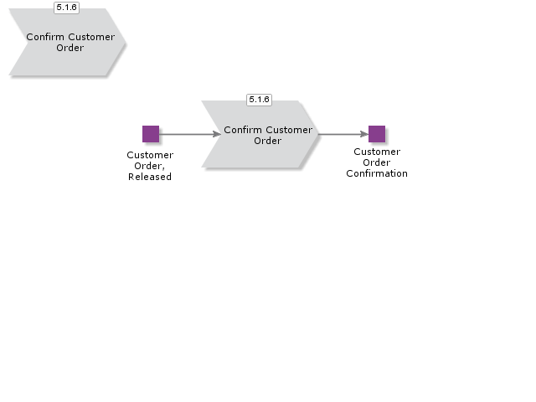

Release Customer Order

Handle Customer Order, Additional Activities

Reserve Customer Order
This sub process reserves the items on the customer order

- If the order is prioritized, you do not need to prioritize the parts. They were already reserved when the customer order was released.
- If the order is not prioritized, the ordered parts must be reserved. You can do this either manually or in batch. If there are not enough parts and you use the batch method, not all order lines will be reserved. Instead, they will appear in the shortage window. In the same window you can also calculate the optimal time of delivery, simulate what will happen if the delivery date is prolonged or partial deliveries take place,
- Finally, you can issue a booking proposal to a forwarding agent.

Manage Customer Order
The purpose of this sub-process are to handle changes that needs to be done in released and confirmed orders. Ensure that changes can be confirmed to customer and the internal information about changes are secured.
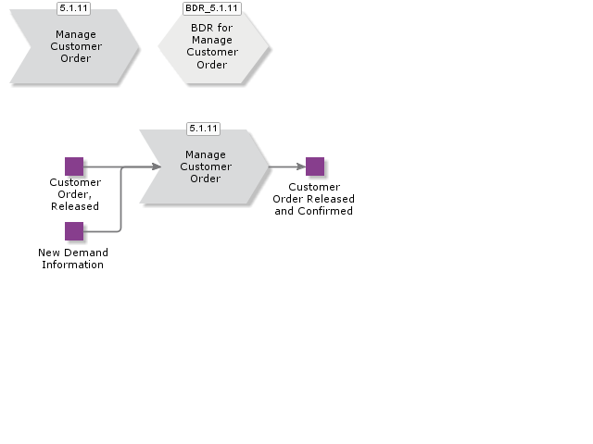

Acme Process Customer Management
The customer management process handles the recording or all information related to a customer.

New customer data is captured for all site addresses and delivery addresses and details of contacts in the various business departments.

Once a customer is created the information is kept up to date by modifying the information as addresses and contact details change.

Another area of management is the recording and updating of credit control information which governs if new customer orders are progressed or stopped depending on the payments history and status of the customer..

Create Customer and Contacts

Manage Customer and Contacts
The purpose of this process are to maintain customer master data and information when required.
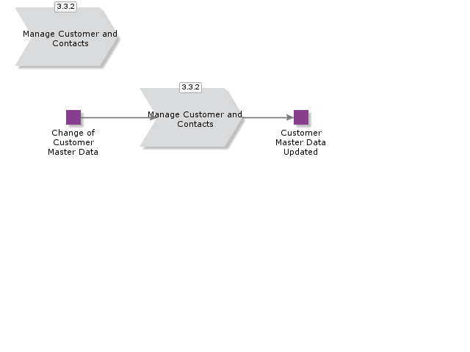

Define Customer Credit Control
The Customer Credit Information process handles assignment of credit analysts to customer accounts for tracking and monitoring purposes.

The system enables feedback from customers via credit notes at both the invoice header and line item levels.

Invoice messages can automatically be sent to the credit analyst for a specified credit note.

By using groups of messages for sending messages to credit analysts you specify the event that create credit analyst messages such as invoice follow-up date reached.

These messages are produced via an updating routine..
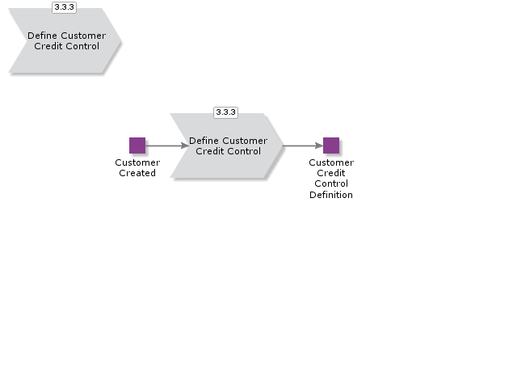

Acme Process Customer Price List and Agreement Management

BDR for Pricing

Manage Standard Prices

Manage Customer Price Lists

Manage Customer Agreements

Manage Campaigns

Send Price List to Customer

Manage Commission

Manage Rebates

Run Final Rebate Settlement

Introduction
Write introduction here.
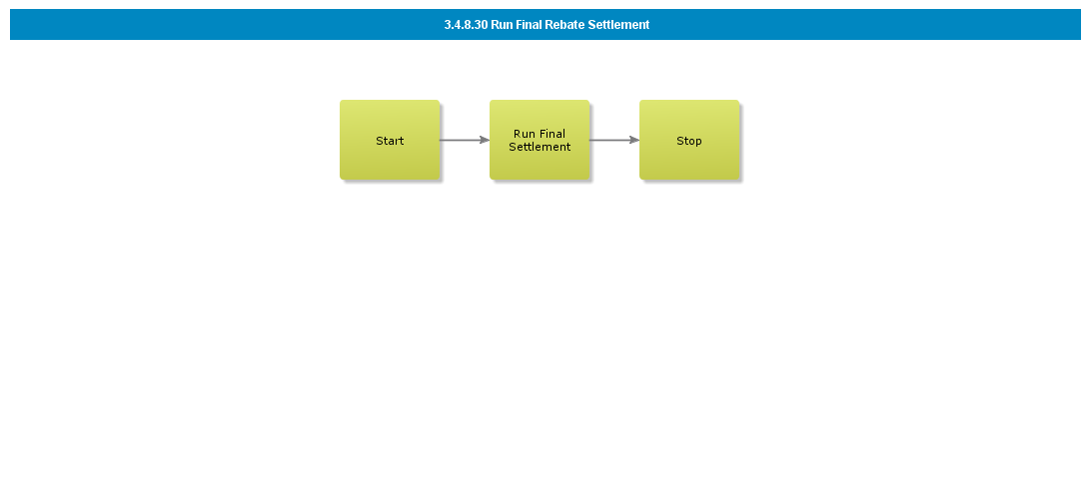

Objective
Write the objective here.

Background information
Write the background here.

Steps

Run Periodic Rebate Settlement

Introduction
Write introduction here.
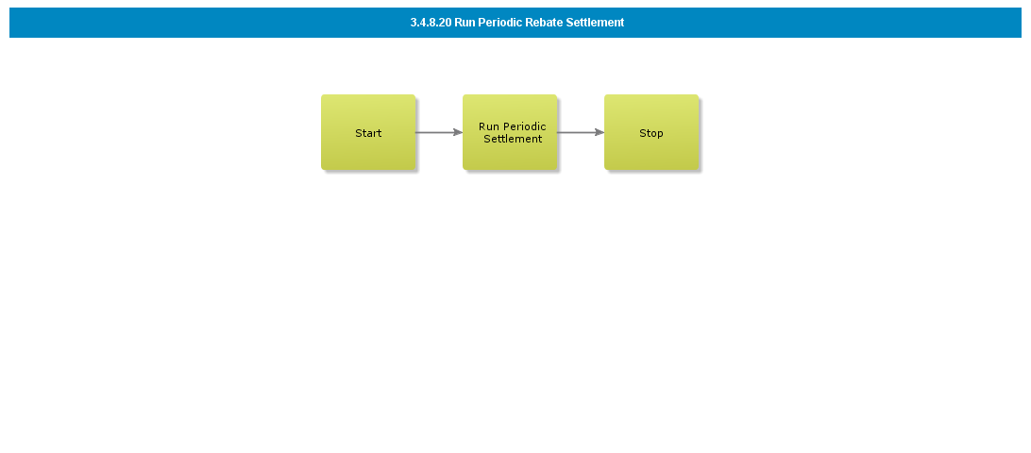

Objective
Write the objective here.

Background information
Write the background here.

Steps

Enter Rebate Agreement

Introduction
Write introduction here.
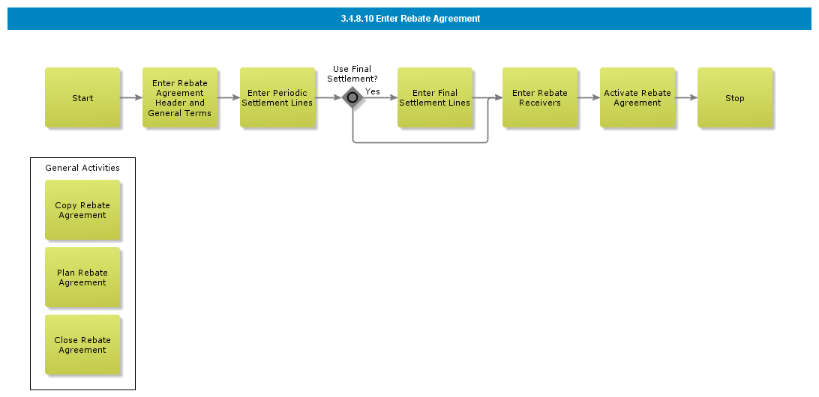

Objective
Write the objective here.

Background information
Write the background here.

Steps

Calculate and Handle Commissions

Introduction
Write introduction here.
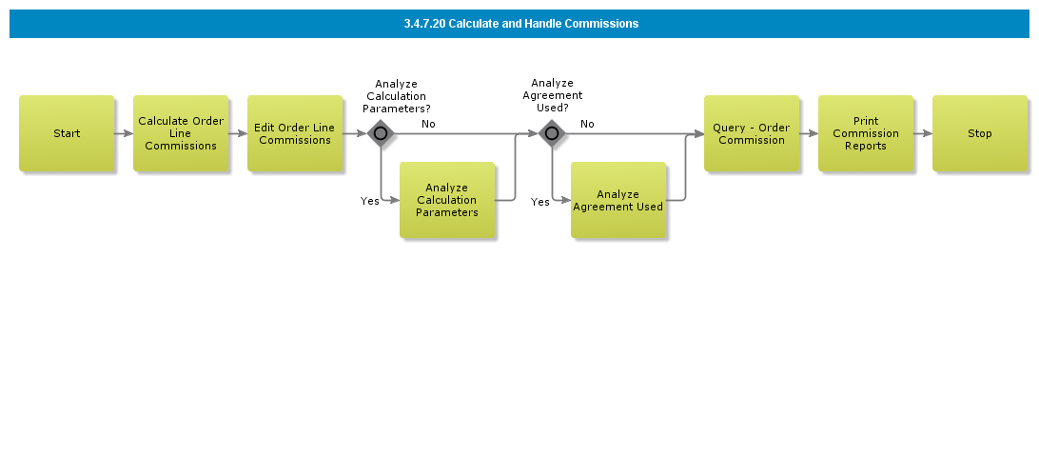

Objective
Write the objective here.

Background information
Write the background here.

Steps

Enter External Commission Agreement

Introduction
Write introduction here.
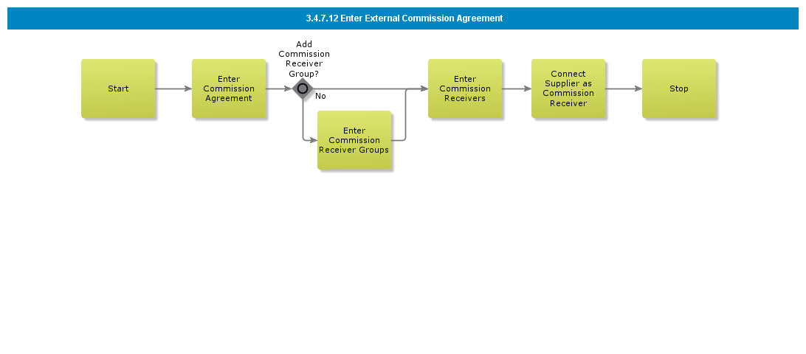

Objective
Write the objective here.

Background information
Write the background here.

Steps

Enter Internal Commission Agreement

Introduction
Write introduction here.
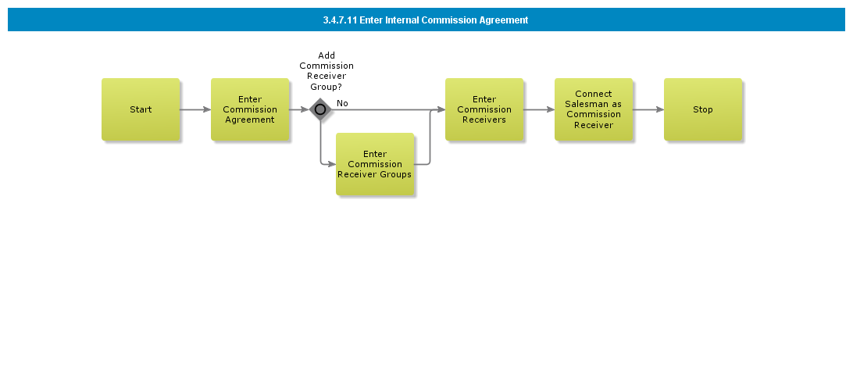

Objective
Write the objective here.

Background information
Write the background here.

Steps

Enter Commission Agreement

Introduction
Write introduction here.
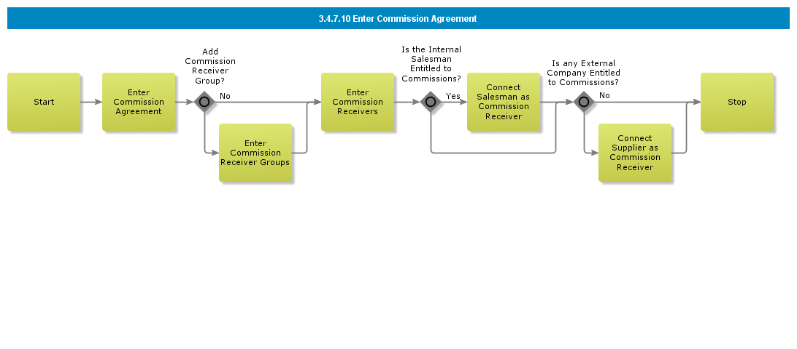

Objective
Write the objective here.

Background information
Write the background here.

Steps

Send Price List to Customer via EDI/MHS

Introduction
Write introduction here.
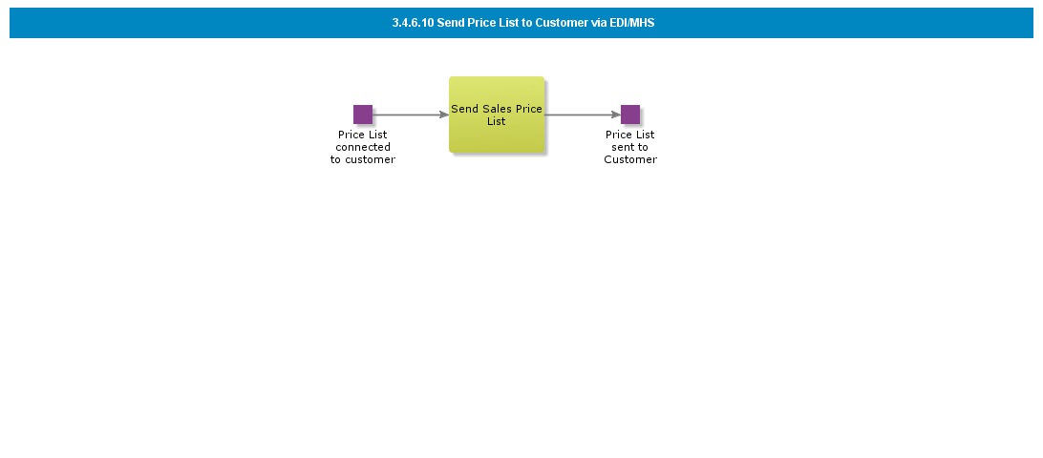

Objective
Write the objective here.

Background information
Write the background here.

Steps

Manage Assortment Campaigns without Supplier Agreement (Retail ext)

Introduction
Write introduction here.

Objective
Write the objective here.

Background information
Write the background here.

Steps

Manage Assortment Campaigns (Retail ext)

Introduction
Write introduction here.

Objective
Write the objective here.

Background information
Write the background here.

Steps

Add campaign for sales promotion

Introduction
Write introduction here.
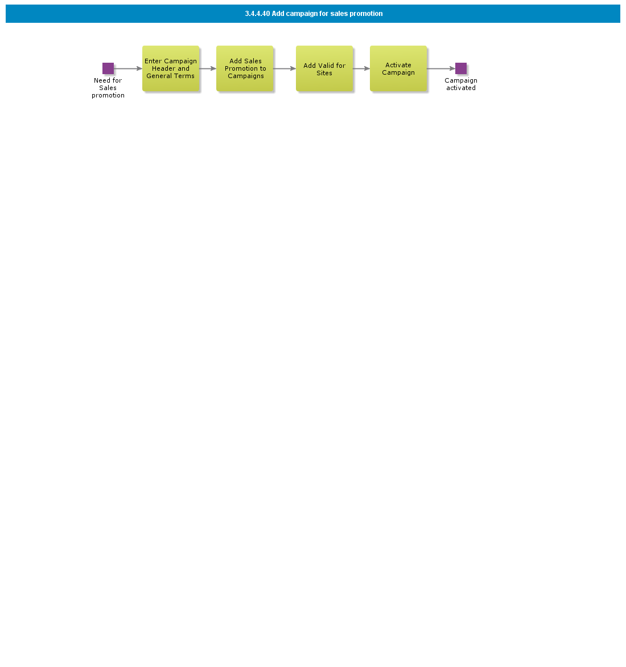

Objective
Write the objective here.

Background information
Write the background here.

Steps

Add general campaign for Assortment

Introduction
Write introduction here.

Objective
Write the objective here.

Background information
Write the background here.

Steps

Add general campaign supported with purchase agreement

Introduction
Write introduction here.
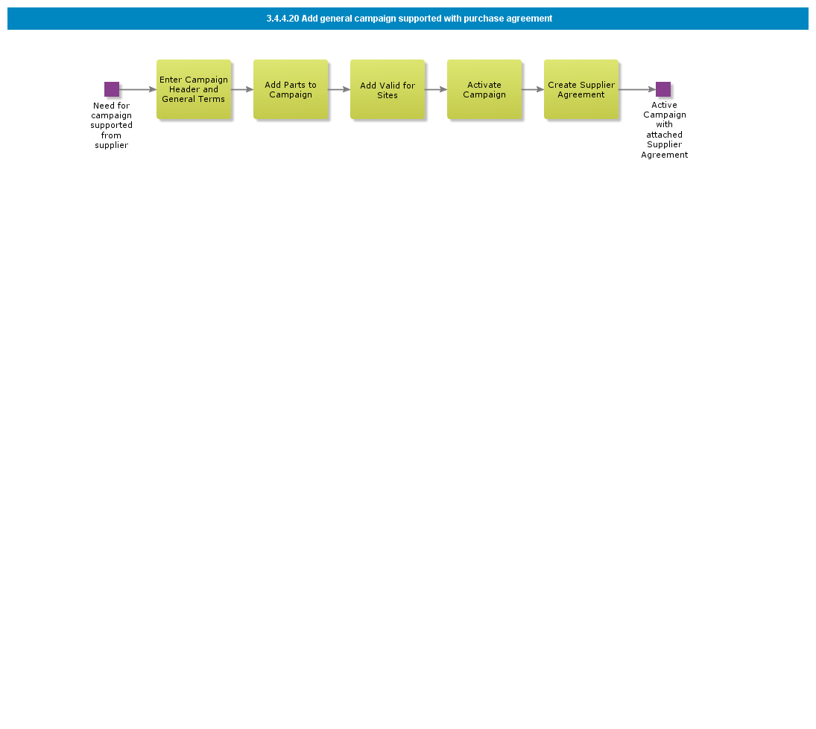

Objective
Write the objective here.

Background information
Write the background here.

Steps

Add general campaign for parts

Introduction
Write introduction here.
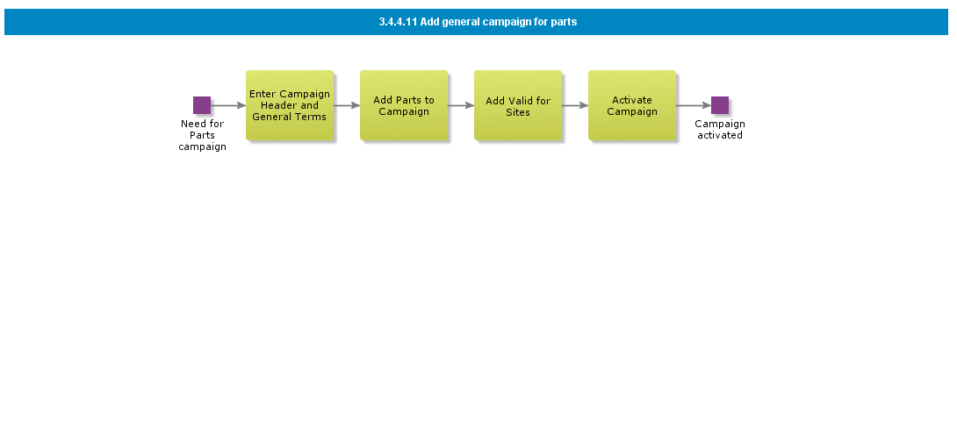

Objective
Write the objective here.

Background information
Write the background here.

Steps

Manage Campaigns

Introduction
Write introduction here.
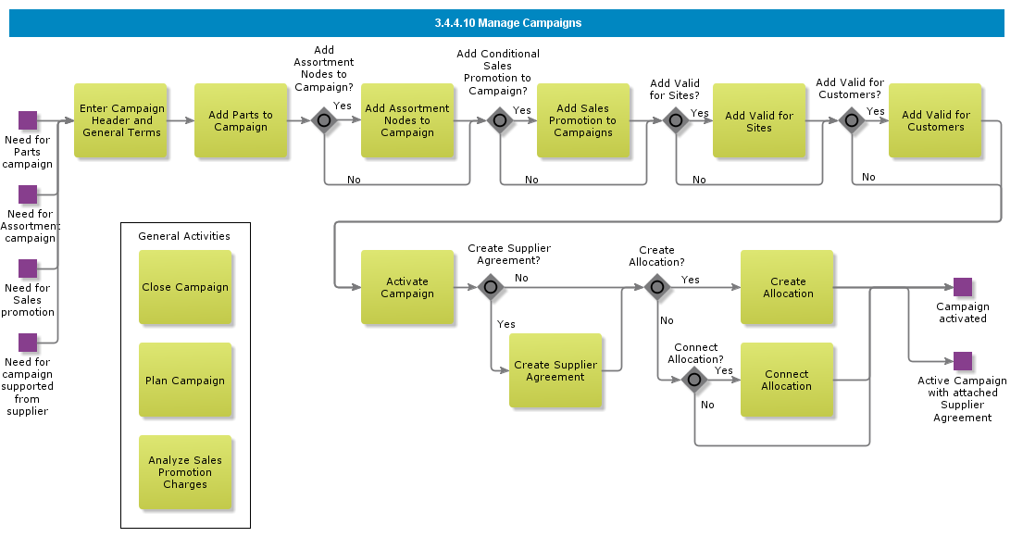

Objective
Write the objective here.

Background information
Write the background here.

Steps

Enter Customer Agreement - Deal per Assortment

Introduction
Write introduction here.

Objective
Write the objective here.

Background information
Write the background here.

Steps

Enter Customer Agreement - Discount for Sales group

Introduction
Write introduction here.
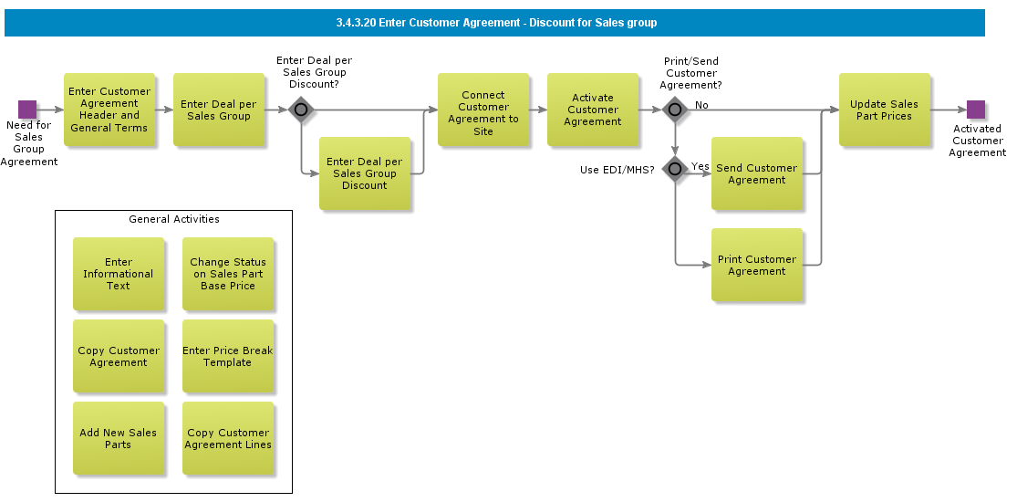

Objective
Write the objective here.

Background information
Write the background here.

Steps

Enter Customer Agreement for Part

Introduction
Write introduction here.
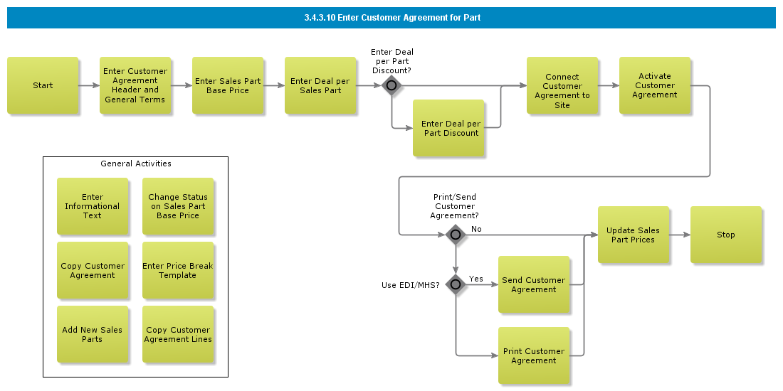

Objective
Write the objective here.

Background information
Write the background here.

Steps

Maintain Price Lists

Introduction
Write introduction here.
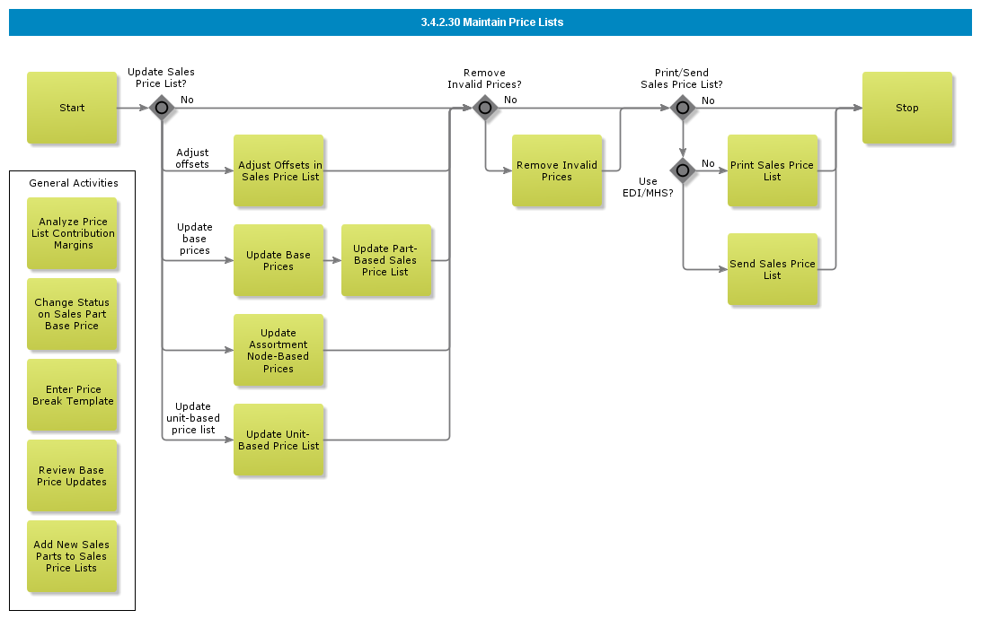

Objective
Write the objective here.

Background information
Write the background here.

Steps

Enter Price Lists, CTO Basic

Introduction
Write introduction here.

Objective
Write the objective here.

Background information
Write the background here.

Steps

Enter Price Lists, CTO

Introduction
Write introduction here.

Objective
Write the objective here.

Background information
Write the background here.

Steps

Update Cost based Price List

Introduction
Write introduction here.
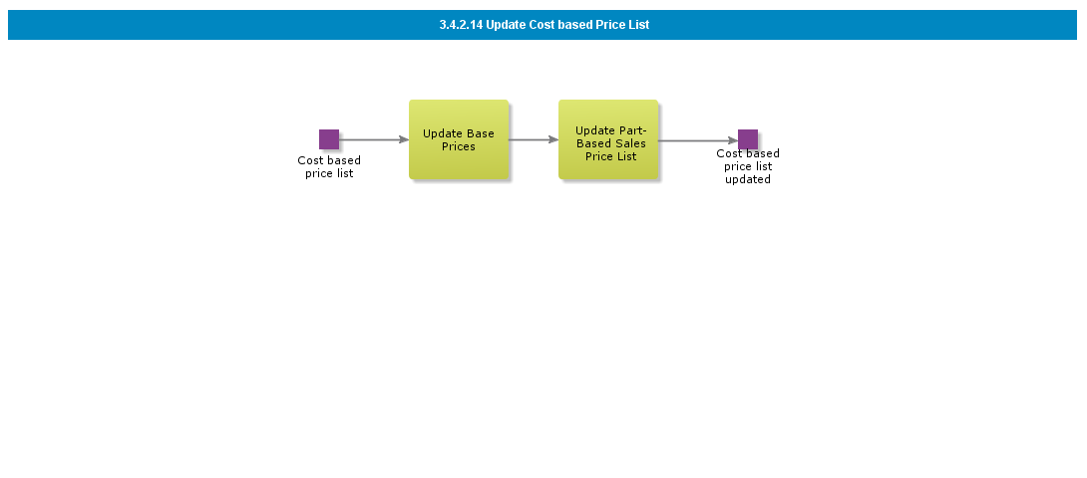

Objective
Write the objective here.

Background information
Write the background here.

Steps

Enter Cost Based Price List

Introduction
Write introduction here.
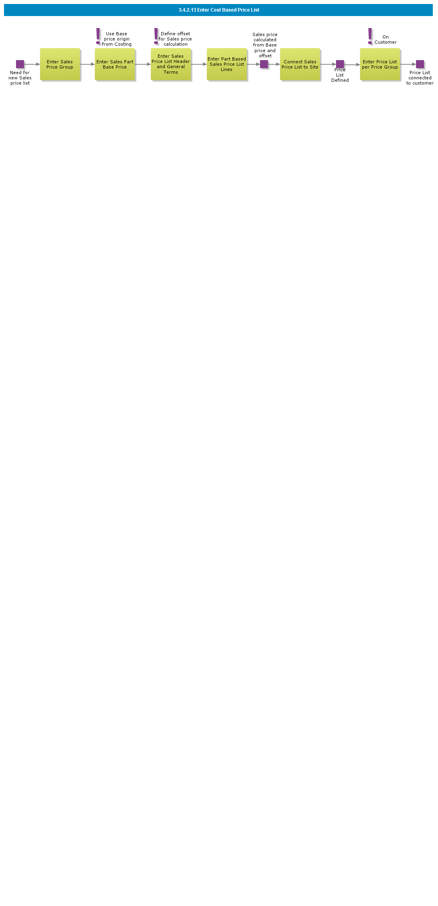

Objective
Write the objective here.

Background information
Write the background here.

Steps

Enter Assortment Based Price List

Introduction
Write introduction here.
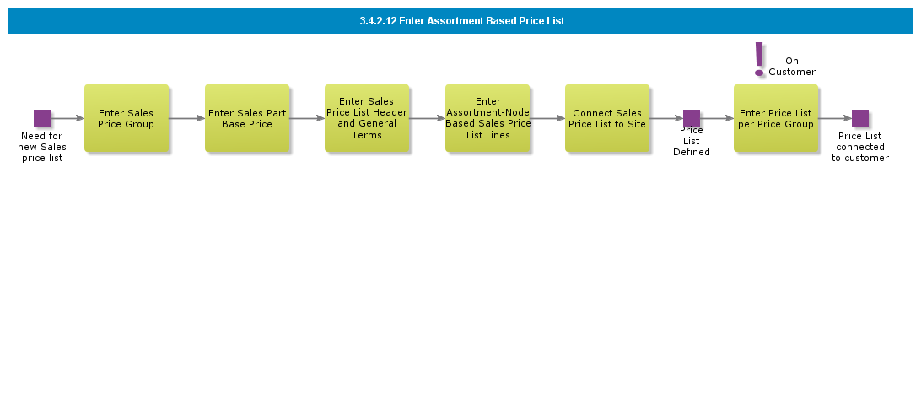

Objective
Write the objective here.

Background information
Write the background here.

Steps

Enter Unit based Price List

Introduction
Write introduction here.
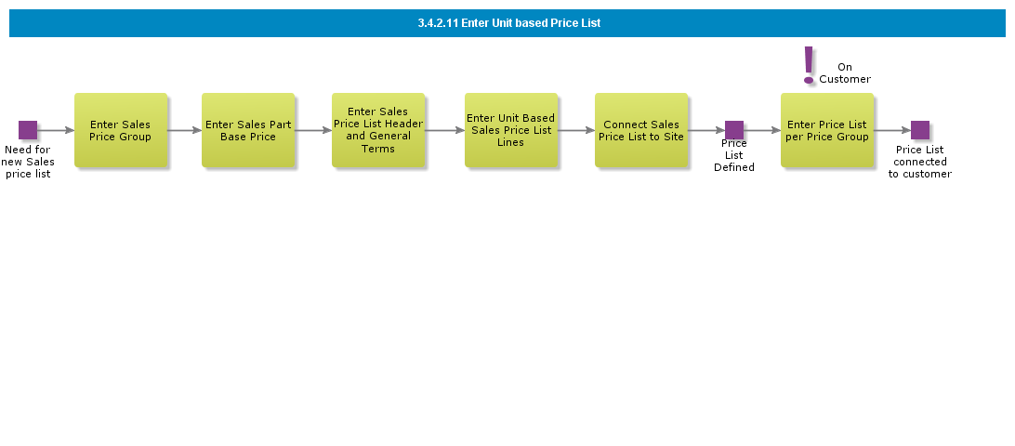

Objective
Write the objective here.

Background information
Write the background here.

Steps

Enter Price List

Introduction
Write introduction here.
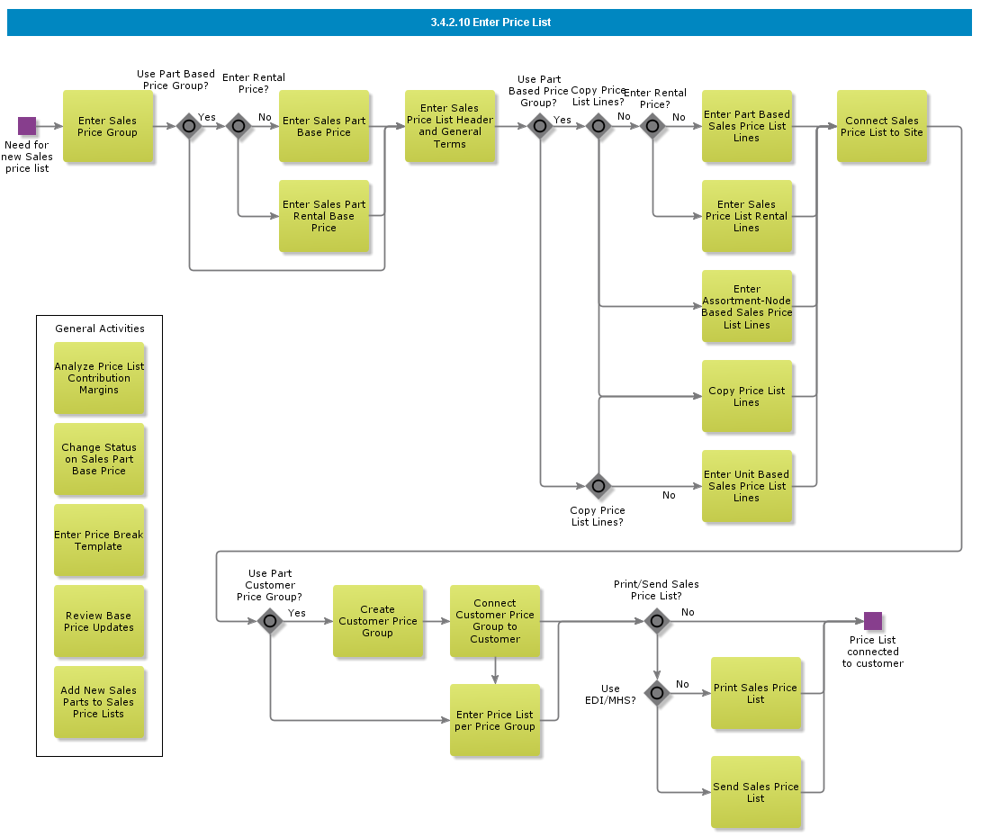

Objective
Write the objective here.

Background information
Write the background here.

Steps

Manage Standard Prices

Introduction
Write introduction here.
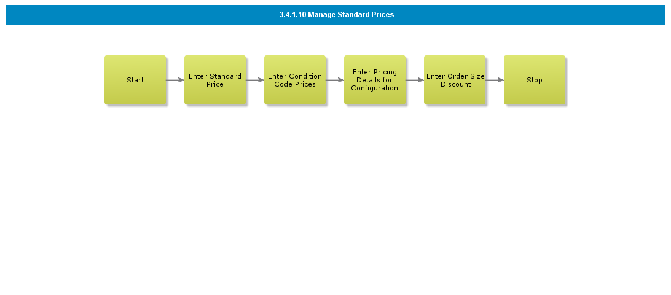

Objective
Write the objective here.

Background information
Write the background here.

Steps

Define Customer Credit Control

Introduction
Write introduction here.
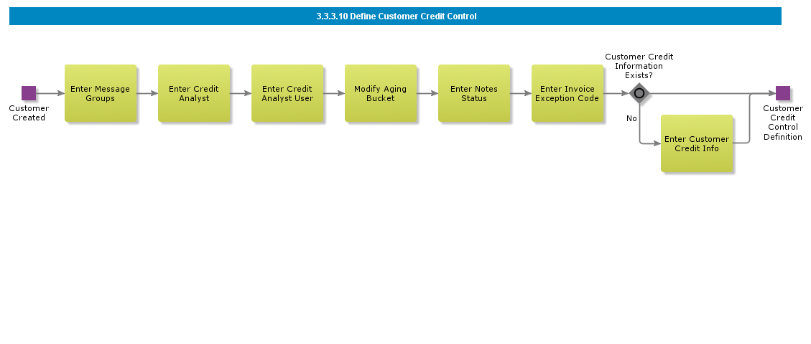

Objective
Write the objective here.

Background information
Write the background here.

Steps

Manually Update Customer

Introduction
Write introduction here.
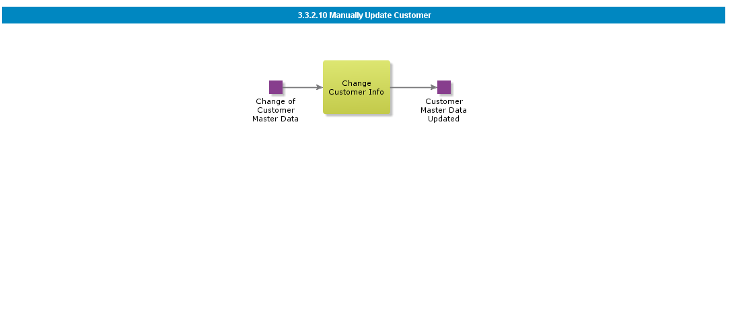

Objective
Write the objective here.

Background information
Write the background here.

Steps

Create Internal Customer based on Template

Introduction
Write introduction here.
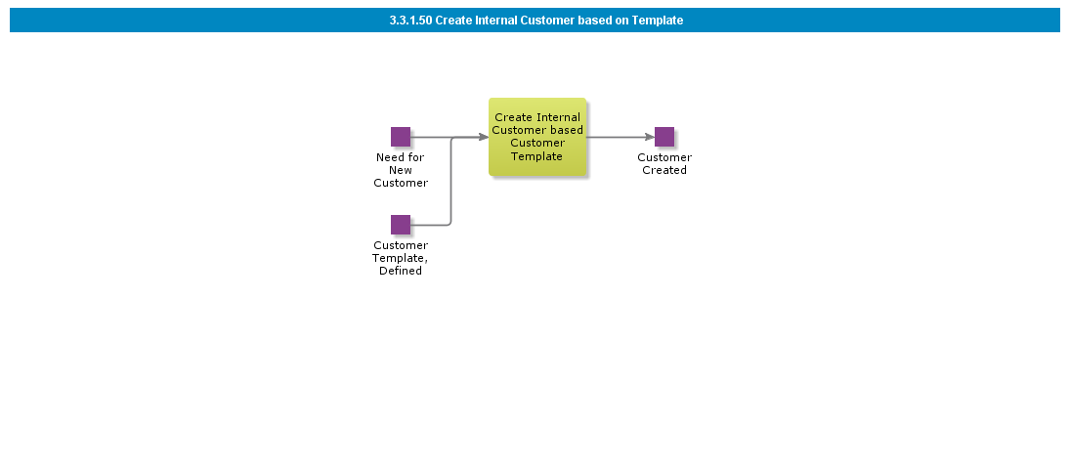

Objective
Write the objective here.

Background information
Write the background here.

Steps

Create Customer and Customer Hierarchy

Introduction
Write introduction here.

Objective
Write the objective here.

Background information
Write the background here.

Steps

Create Internal Customer

Introduction
Write introduction here.
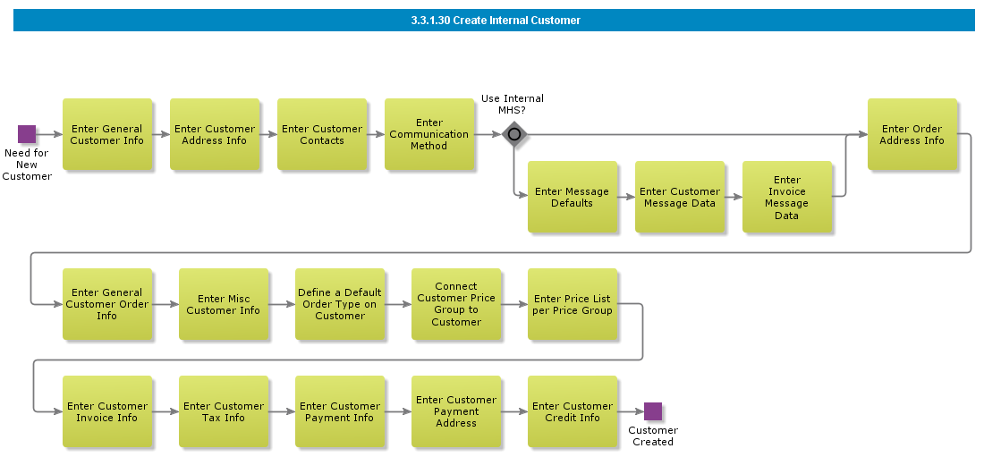

Objective
Write the objective here.

Background information
Write the background here.

Steps

Create Customer from Sales & Marketing (CRM)

Introduction
Write introduction here.
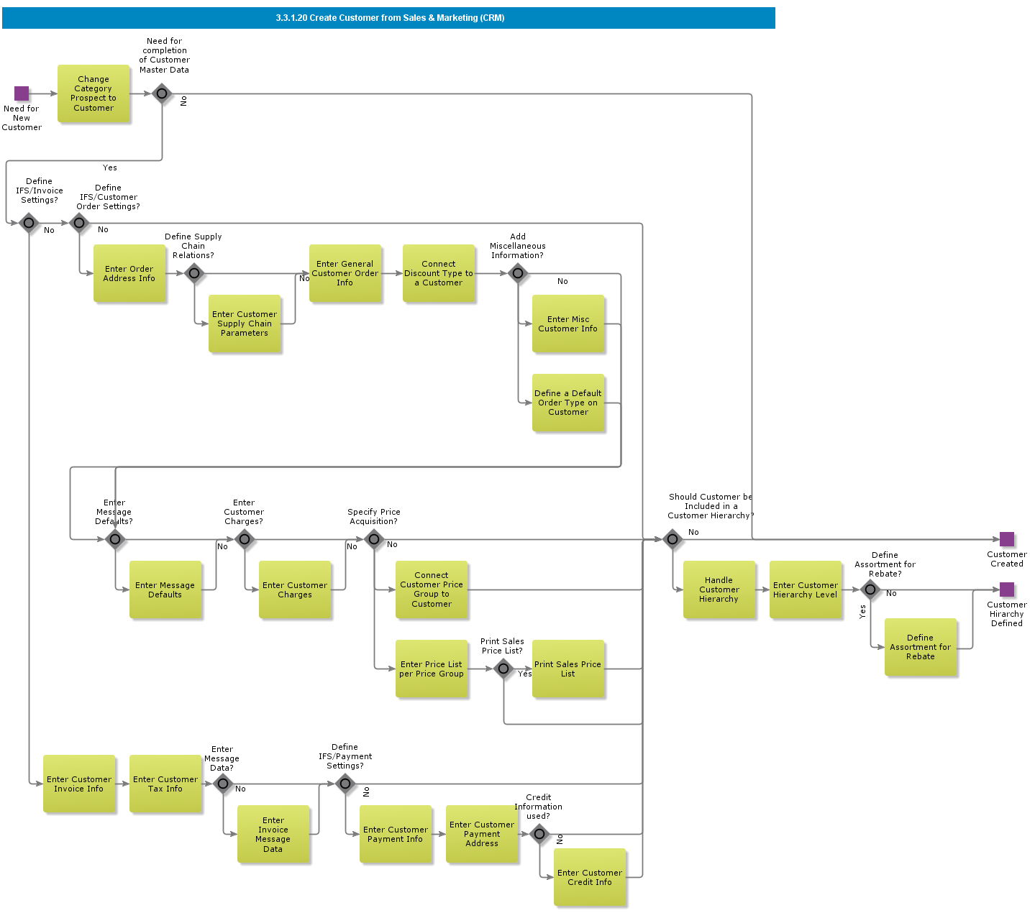

Objective
Write the objective here.

Background information
Write the background here.

Steps

Manually Create Customer

Introduction
Write introduction here.
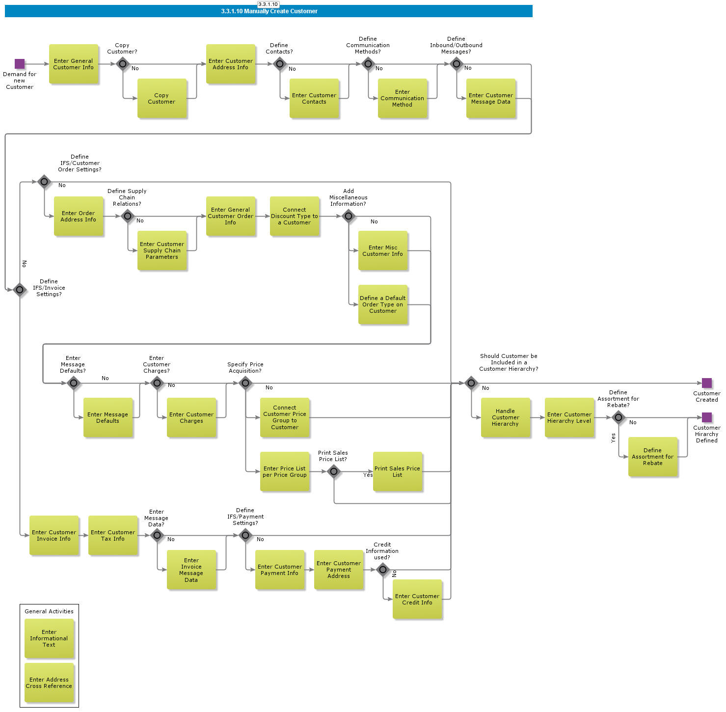

Objective
Write the objective here.

Background information
Write the background here.

Steps

BDR Schedule Reservation

Introduction
Write introduction here.

Objective
Write the objective here.

Background information
Write the background here.

Steps

Change/update price

Introduction
Write introduction here.
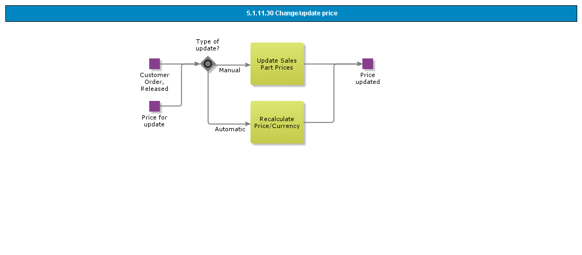

Objective
Write the objective here.

Background information
Write the background here.

Steps

Change Delivery Information

Introduction
Write introduction here.
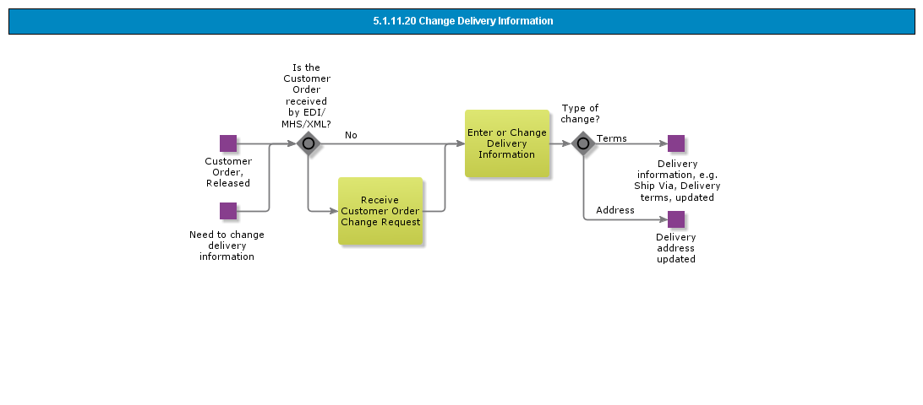

Objective
Write the objective here.

Background information
Write the background here.

Steps

Change Delivery date/qty

Introduction
Write introduction here.
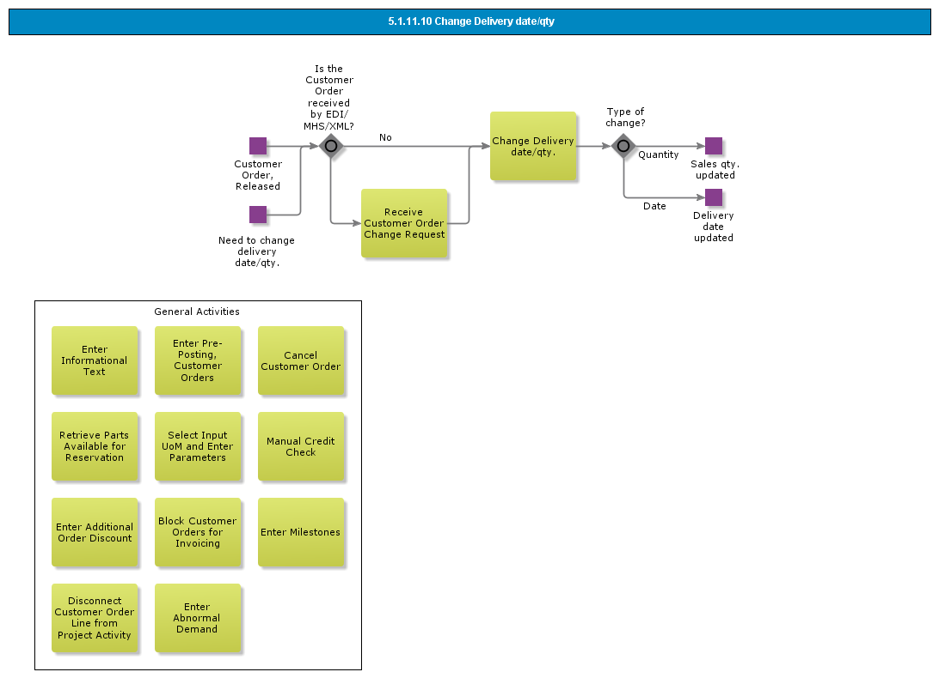

Objective
Write the objective here.

Background information
Write the background here.

Steps

Run Automatic Reservation of Box Order Line, Started Manually (Retail ext)

Introduction
Write introduction here.

Objective
Write the objective here.

Background information
Write the background here.

Steps

Run Automatic Reservation of Customer Order Line, Started Manually

Introduction
Write introduction here.

Objective
Write the objective here.

Background information
Write the background here.

Steps

Run Automatic Reservation of Customer Order, Started by Order Type

Introduction
Write introduction here.

Objective
Write the objective here.

Background information
Write the background here.

Steps

Run Automatic Reservation of Customer Order, Started Manually

Introduction
Write introduction here.

Objective
Write the objective here.

Background information
Write the background here.

Steps

Run Automatic Reservation of a Batch of Customer Orders per Site, Started by Scheduled Task

Introduction
Write introduction here.

Objective
Write the objective here.

Background information
Write the background here.

Steps

Run Automatic Reservation of a Batch of Customer Orders per Site, Started Manually

Introduction
Write introduction here.

Objective
Write the objective here.

Background information
Write the background here.

Steps

Manually Reserve Customer Order Line

Introduction
Write introduction here.
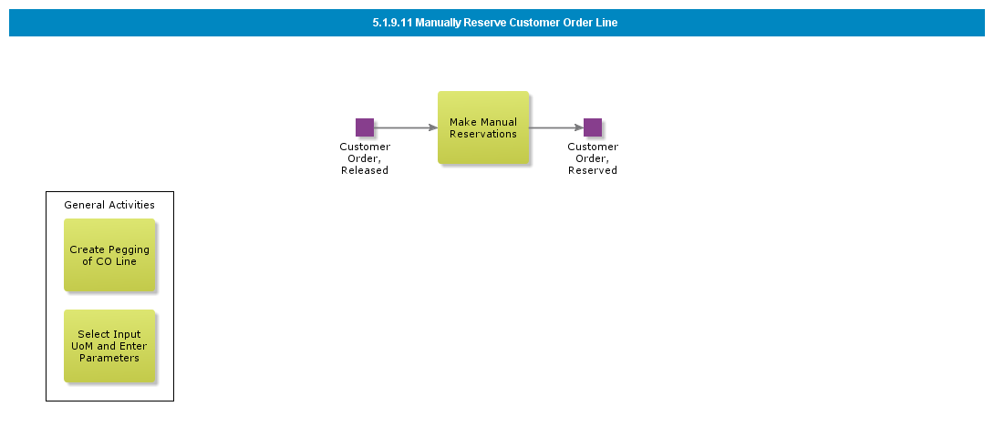

Objective
Write the objective here.

Background information
Write the background here.

Steps

Reserve Customer Order (Std)

Introduction
Write introduction here.
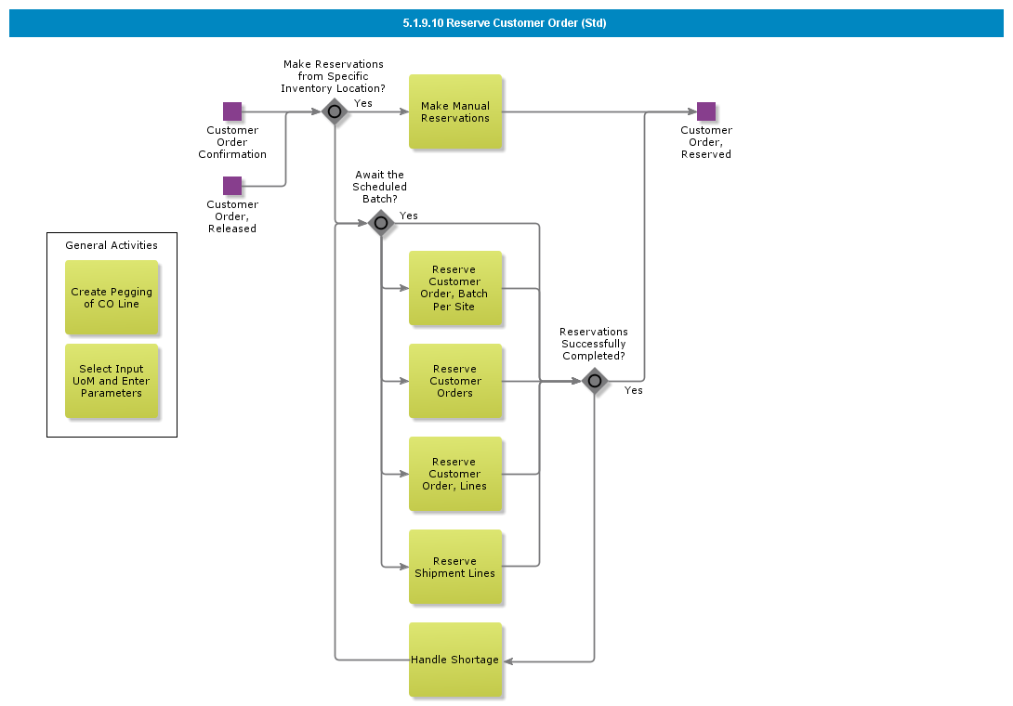

Objective
Write the objective here.

Background information
Write the background here.

Steps

Handle Customer Order, Additional Activities (std)

Introduction
Write introduction here.
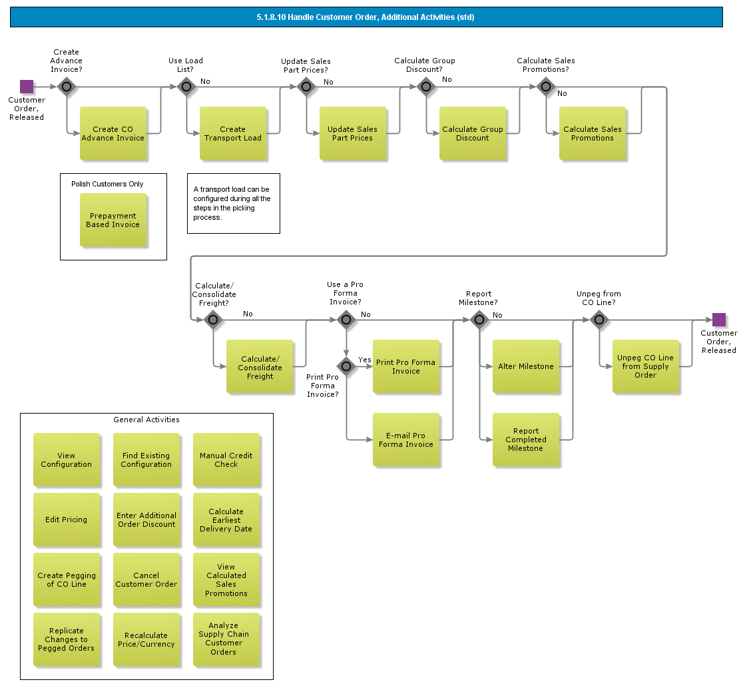

Objective
Write the objective here.

Background information
Write the background here.

Steps

Release Customer Order

Introduction
Write introduction here.
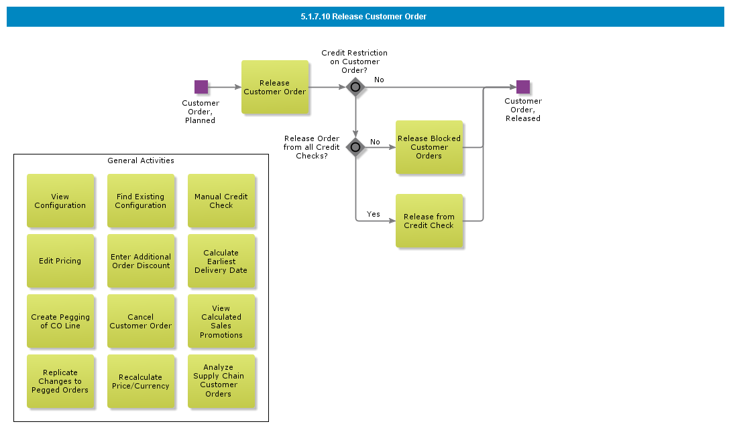

Objective
Write the objective here.

Background information
Write the background here.

Steps

Send Customer Order Confirmation via EDI

Introduction
Write introduction here.

Objective
Write the objective here.

Background information
Write the background here.

Steps

Email Customer Order Confirmation

Introduction
Write introduction here.
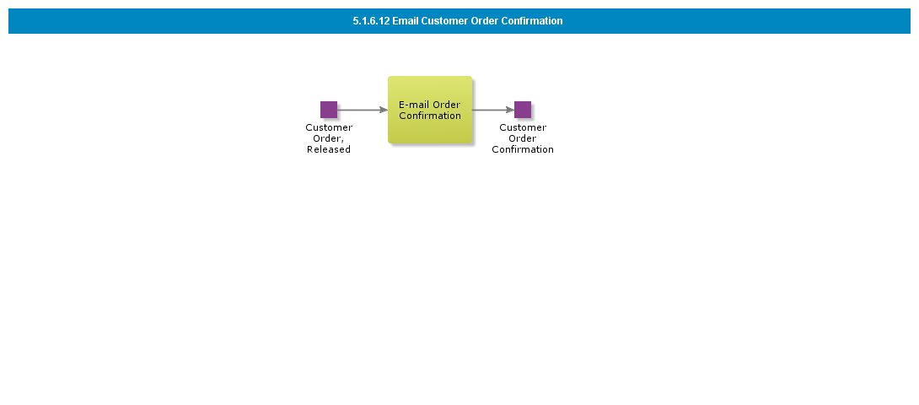

Objective
Write the objective here.

Background information
Write the background here.

Steps

Print Customer Order Confirmation

Introduction
Write introduction here.
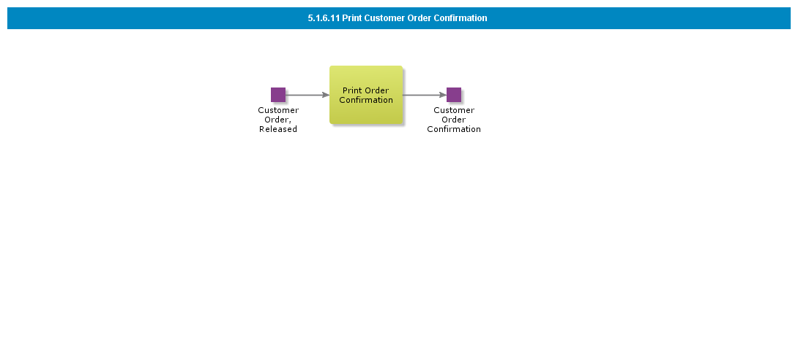

Objective
Write the objective here.

Background information
Write the background here.

Steps

Confirm Customer Order

Introduction
Write introduction here.
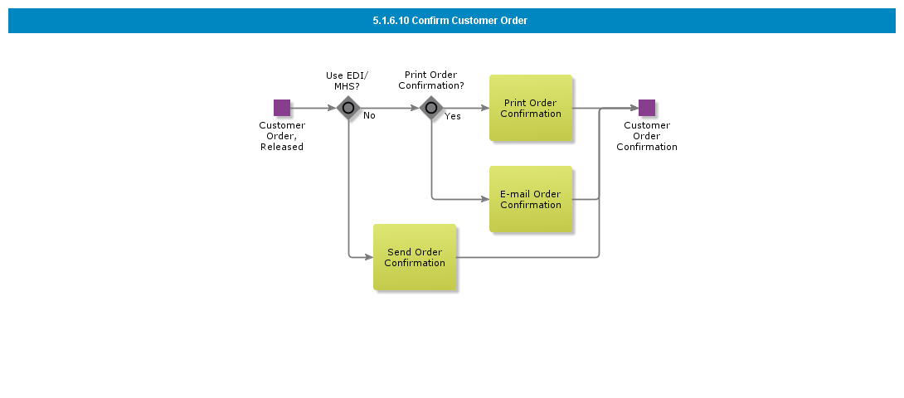

Objective
Write the objective here.

Background information
Write the background here.

Steps

BDR for Charges

Introduction
Write introduction here.
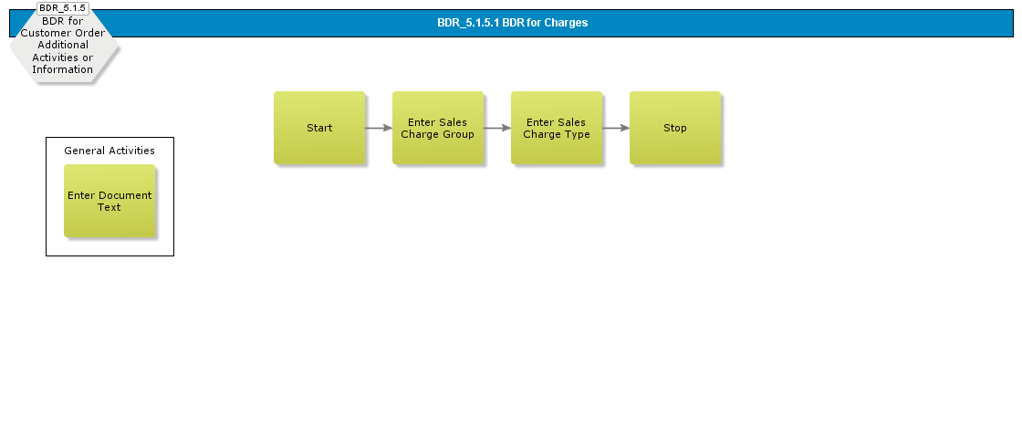

Objective
Write the objective here.

Background information
Write the background here.

Steps

Enter Customer Order CTO, Additional Activities or Information

Introduction
Write introduction here.

Objective
Write the objective here.

Background information
Write the background here.

Steps

Source Non-sourced Customer Order Lines

Introduction
Write introduction here.
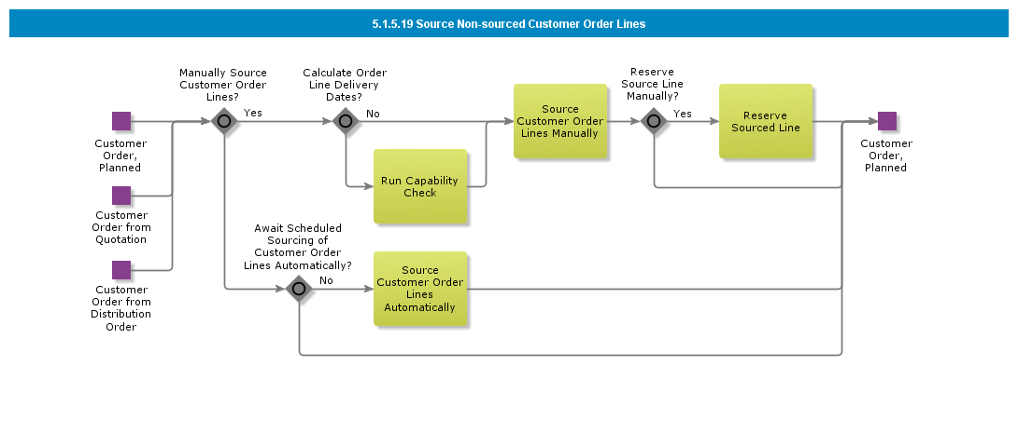

Objective
Write the objective here.

Background information
Write the background here.

Steps

Stage Billing on Customer Order

Introduction
Write introduction here.
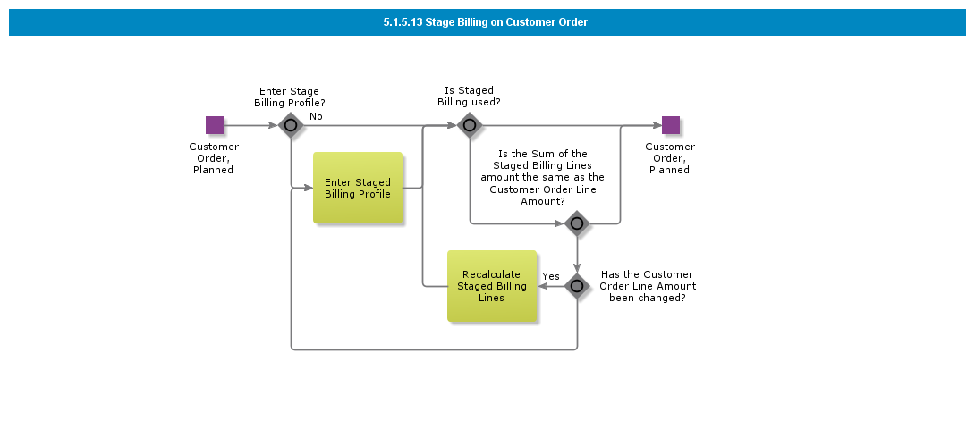

Objective
Write the objective here.

Background information
Write the background here.

Steps

Handle Tax, Discount and/or Charges

Introduction
Write introduction here.
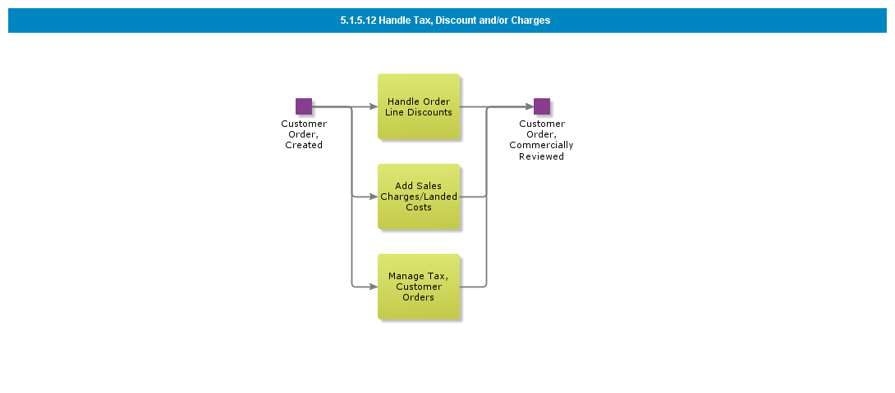

Objective
Write the objective here.

Background information
Write the background here.

Steps

Connect Customer Order Line to Project Activity

Introduction
Write introduction here.

Objective
Write the objective here.

Background information
Write the background here.

Steps

Enter Customer Order, Additional Activities or Information

Introduction
Write introduction here.
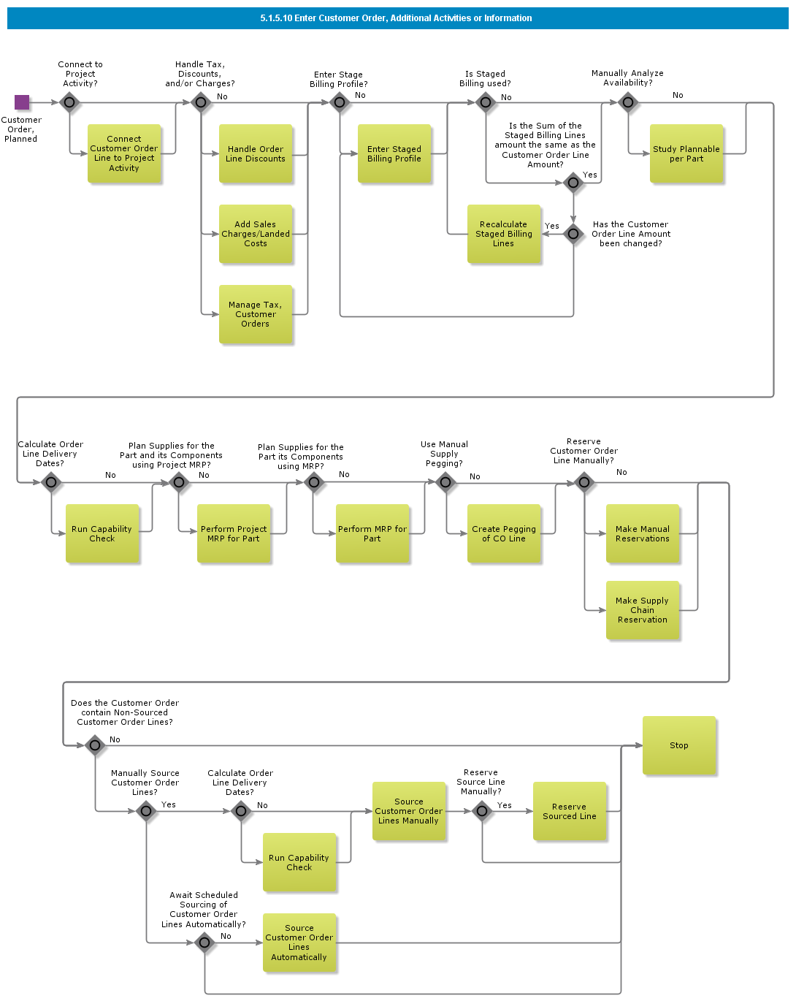

Objective
Write the objective here.

Background information
Write the background here.

Steps

Receive Customer Order Change Request from EDI/MHS/XML

Introduction
Write introduction here.

Objective
Write the objective here.

Background information
Write the background here.

Steps

Receive Customer Order from EDI/MHS/XML

Introduction
Write introduction here.

Objective
Write the objective here.

Background information
Write the background here.

Steps

Manually Create Customer Order, CTO

Introduction
Write introduction here.

Objective
Write the objective here.

Background information
Write the background here.

Steps

Manually Create Customer Order, Basic

Introduction
Write introduction here.
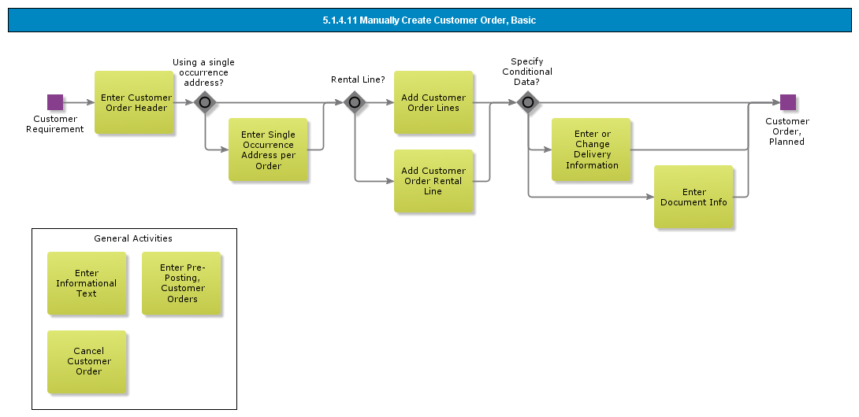

Objective
Write the objective here.

Background information
Write the background here.

Steps

Enter Customer Order

Introduction
Write introduction here.
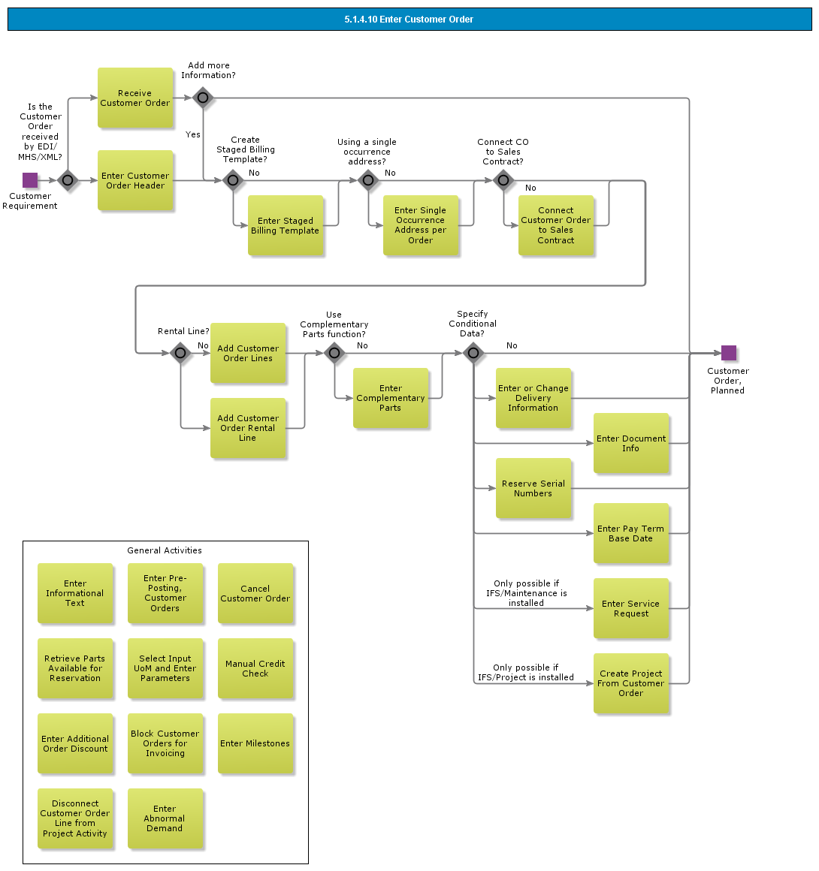

Objective
Write the objective here.

Background information
Write the background here.

Steps

BDR for Delivery Confirmation

Introduction
Write introduction here.
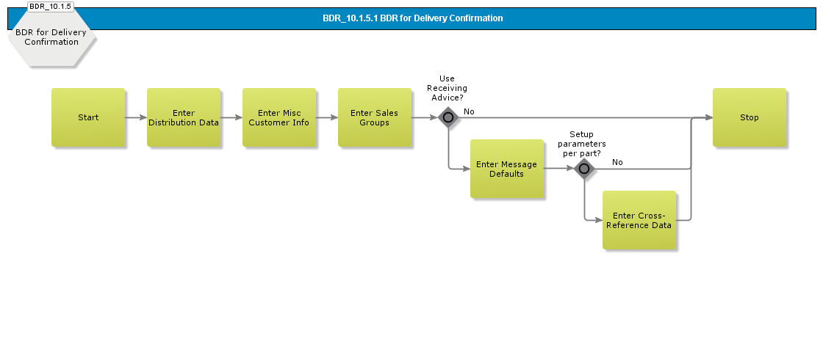

Objective
Write the objective here.

Background information
Write the background here.

Steps

BDR for Customer Consignment Stock

Introduction
Write introduction here.
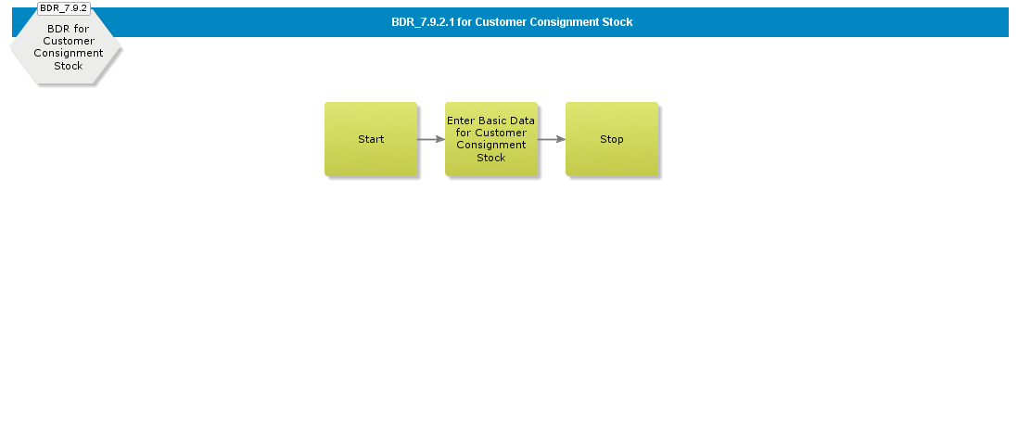

Objective
Write the objective here.

Background information
Write the background here.

Steps

BDR for Sales Quotation

Introduction
Write introduction here.
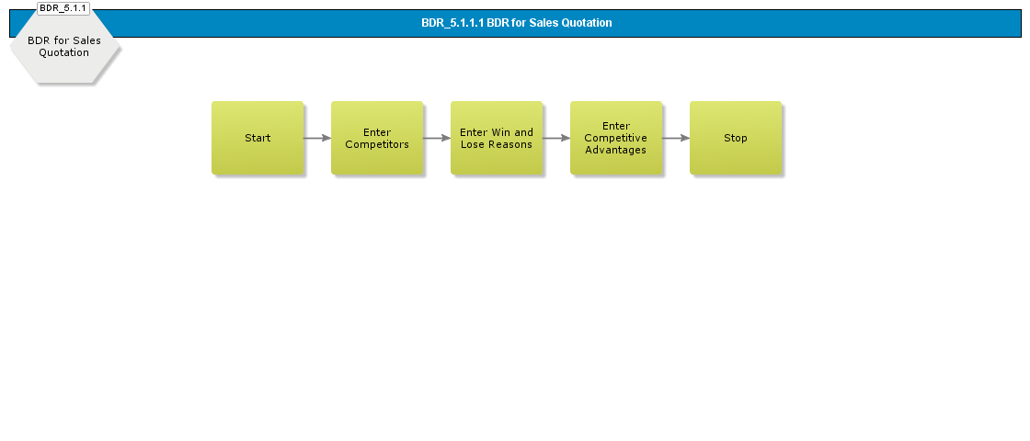

Objective
Write the objective here.

Background information
Write the background here.

Steps

BDR for Sourcing

Introduction
Write introduction here.
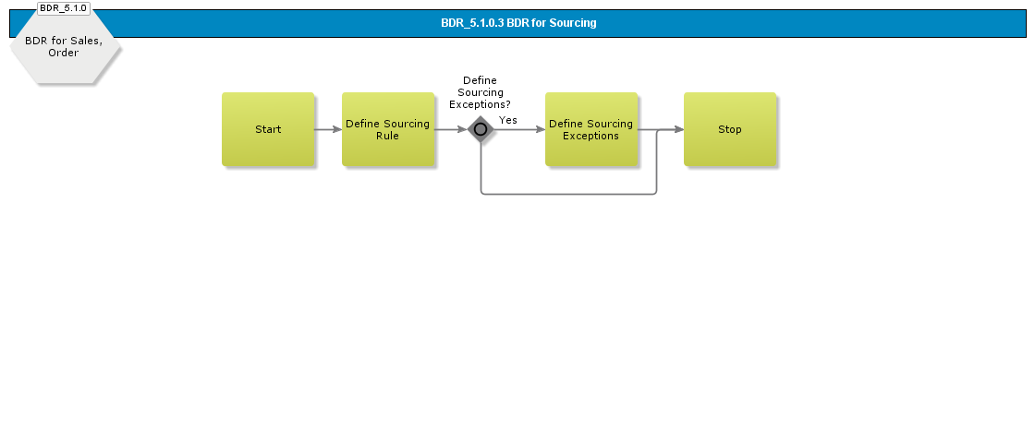

Objective
Write the objective here.

Background information
Write the background here.

Steps

BDR for Shipping by Route

Introduction
Write introduction here.
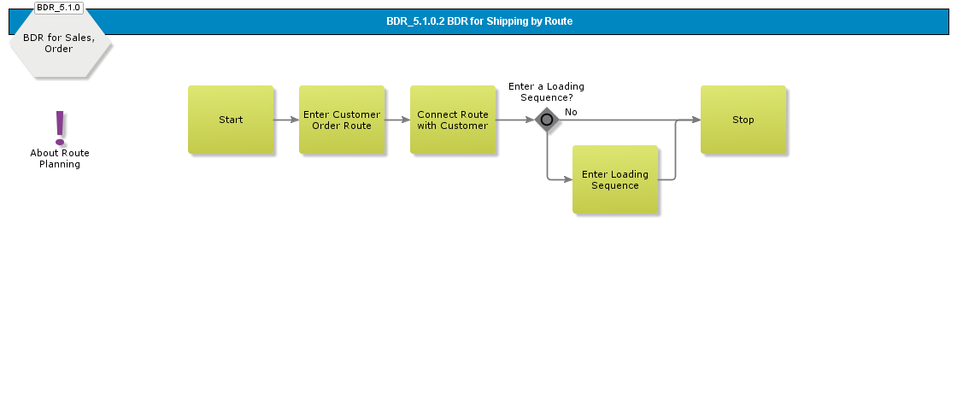

Objective
Write the objective here.

Background information
Write the background here.

Steps

BDR for Sales

Introduction
Write introduction here.
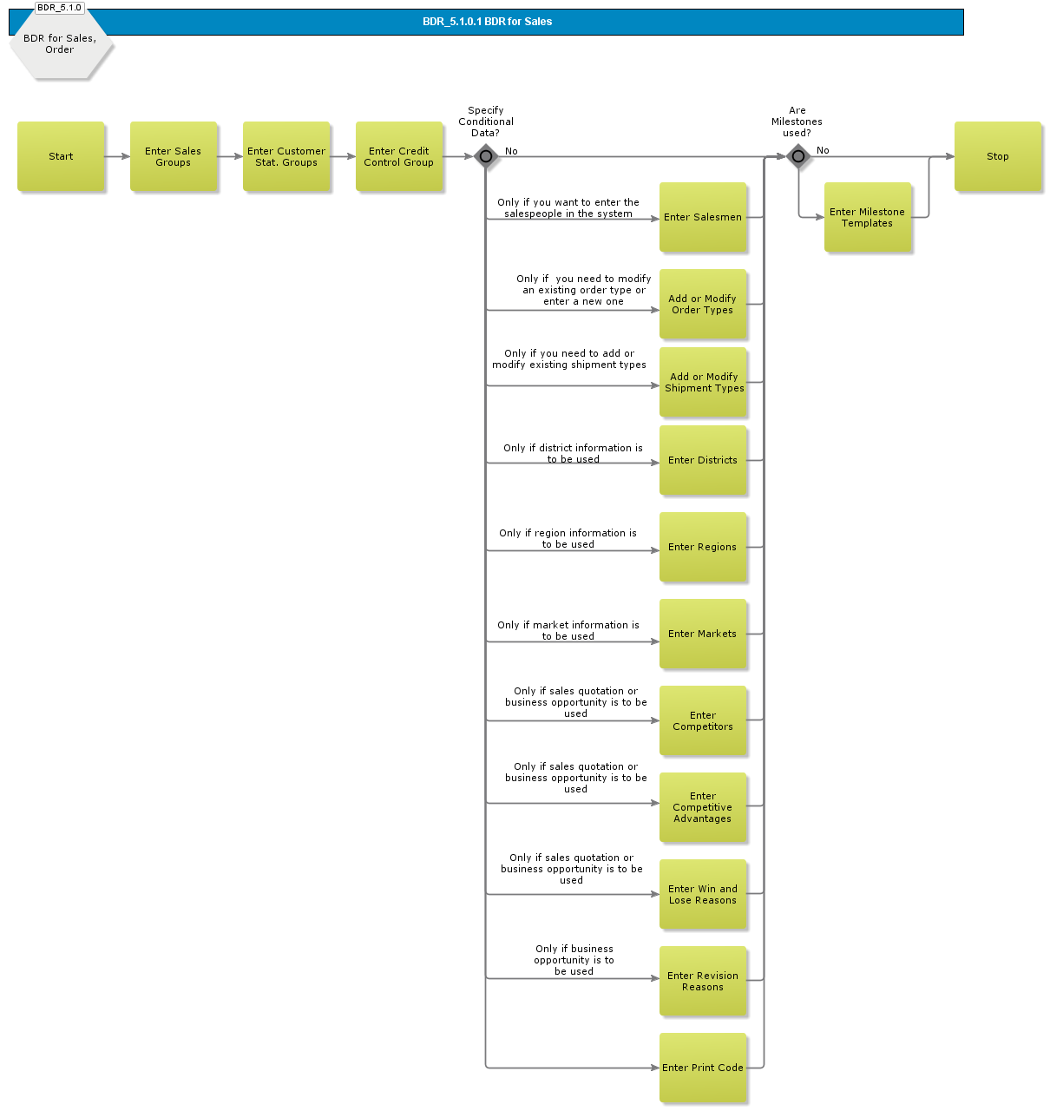

Objective
Write the objective here.

Background information
Write the background here.

Steps

BDR for Freight

Introduction
Write introduction here.
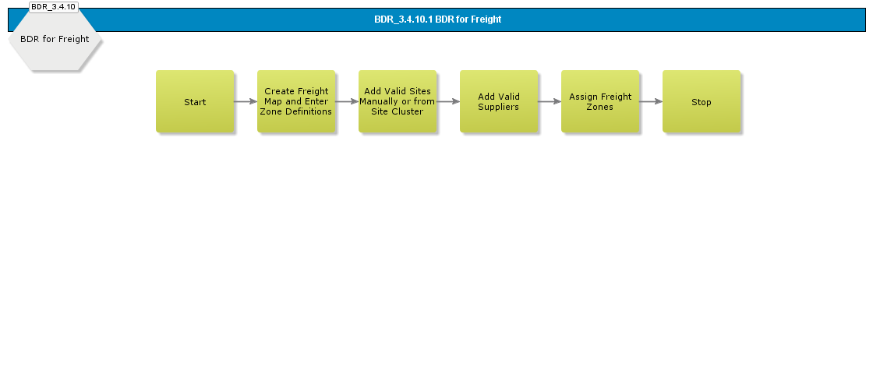

Objective
Write the objective here.

Background information
Write the background here.

Steps

BDR for Pricing

Introduction
Write introduction here.
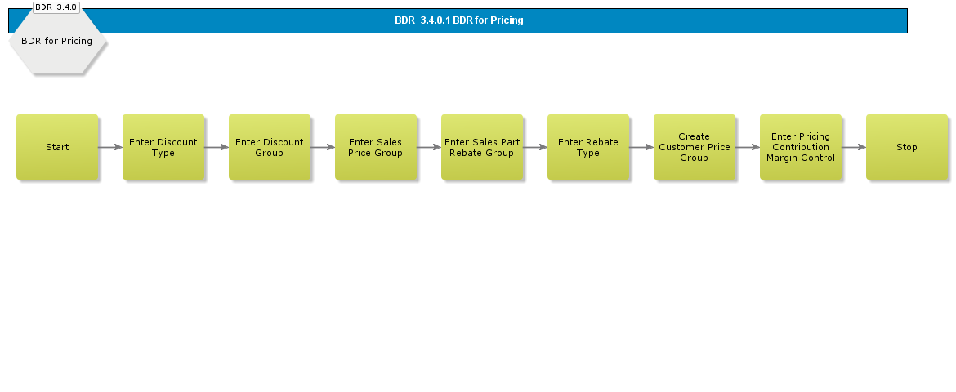

Objective
Write the objective here.

Background information
Write the background here.

Steps

BDR for Supply Chain Relations

Introduction
Write introduction here.
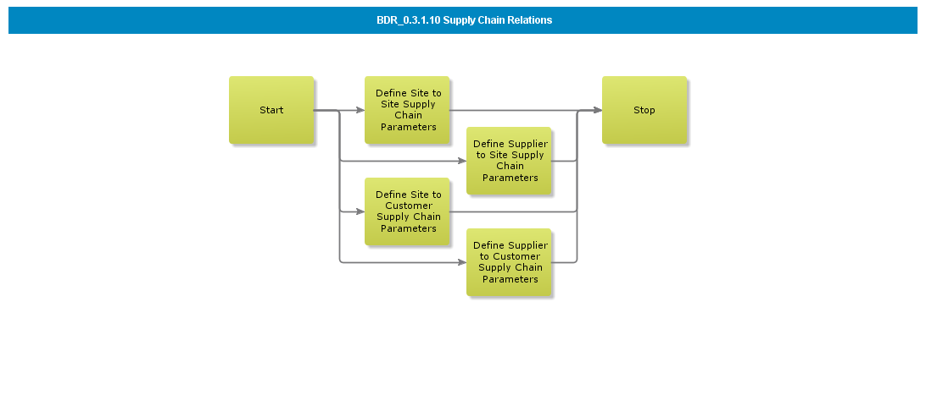

Objective
Write the objective here.

Background information
Write the background here.

Steps

Acme Procurement Management

Acme Process Purchase Order
The procurement process can handle quotations, requisitions, and purchase orders, including sending and confirming the purchase orders. It also handles delivery surveillance and sends out reminders when needed. The procurement process can be performed in four different ways:

- Purchase requisition to create a purchase order, either to create a purchase order directly, or preceded by a request for quotation. Request for quotation to create a purchase order. Direct entry of purchase order. Supplier agreement release to create a purchase order. The purchase requisition and purchase order can also be externally generated by order proposal, customer order, MRP, Master Scheduling, and Next Level Demand. Moreover, a purchase order can be created through supplier scheduling, but this will be described in a separate process document.

The Procurement process includes a supporting process, which handles supplier agreements. There are two ways in which this process can be performed:

- You can use a request for quotation and convert the most favorable quotation to a supplier agreement. You can create a supplier agreement directly, by manually entering the information. If the company consists of several departments that frequently need to purchase products, use of a requisition could diminish significant administration time because one or several users at each department are allowed to enter a purchase requisition. This purchase requisition can be handled easily by the purchaser or purchase department. Whenever the purchase requisition is entered, the purchasing department will be in charge of converting the requisitions into purchase orders and executing the purchase. In order to control what is ordered on the requisition, you can use the purchase authorization routine, which requires one or more specified users to authorize the requisition before the buyer can convert it into a purchase order.

The purchase requisition can be used in three different variants:

- Using the general flow, use the processes Enter Purchase Requisition, Handle Purchase Requisition and Handle Purchase Order. Using the express flow, use the express variants of the processes Enter Purchase Requisition and Handle Purchase Requisition. The express purchase requisition is used when a purchase order is needed on short notice, e.g., when purchasing some urgently needed spare parts from the local hardware store. When authorizing an express requisition, a purchase order is automatically created, released, and printed. You can use a purchase requisition to send order requests for a quotation. To do so, use the processes Enter Purchase Requisition, Handle Purchase Requisition, Handle Order Quotation and Handle Purchase Order.

BDR for Manage Purchase

Enter Purchase Requisition
The purpose of this sub process is to support manually created purchase demand.

- The input are an independent demand and the output are a registered purchase requisition including specification for needed parts or services.
- You can enter one of three different kinds of parts: inventory registered purchase parts, non-inventory registered purchase parts, and no-number parts, i.e., parts that are not entered in the system's part records.

Handle Purchase Requisition
The purpose of this sub-process is to transfer an requisition to purchase order. The input are manually or system generated purchase order requisitions and out-put are a planned purchase order.

- Once you have entered the purchase requisition entry, you must release the requisition before it can be further processed. If using the authorization routine, a specified user must authorize the requisition before it can be converted into a purchase order. A supplier must have been specified on the requisition line before you can convert the requisition into a purchase order.

If required, you can convert lines on the purchase requisition into a request for order quotation. Using this option, no suppliers need to be specified on the requisition lines and no authorization is required.
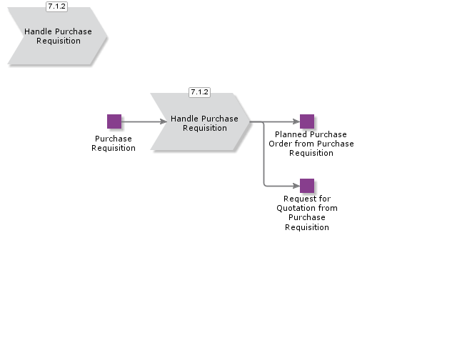

Purchase Authorization

Handle Purchase Order
The purpose of this sub process is to process the purchase order.

- The input are a purchase order created manually or from purchase order requisition and output are to finalized purchase order released and/or send to supplier.

Create Supplier Agreement Release

Print and/or Send Purchase Order

Purchase Order Confirmation

Supplier Material Function

Manage and Monitor Purchase Order
The purpose of this sub process is manage any changes of existing purchase order.

- The input are any need for change and output are an updated order released and/or send to supplier.

Authorization Rule Setup

Handle Purchase Order Change Order

Acme Process Supplier Management
The main purpose of this process is to create new suppliers, phase out existing suppliers or update information on existing suppliers.

- The main input of demands on new suppliers is initiated in the processes Strategic supplier/sourcing management and Supplier Quotation management.
- Level of Supplier data required is related to type of supplier relation, EDI based etc.
- Supplier classification can be structured according to your specific requirements and also be connected to categorization models like the Kraljic Matrix.
- Registration of new suppliers can be executed in an effective way by use of pre-defined supplier templates.

Create Supplier
The purpose of this process are to set-up and define supplier master data and information. The set-up are later used as default data if required in operational processes.
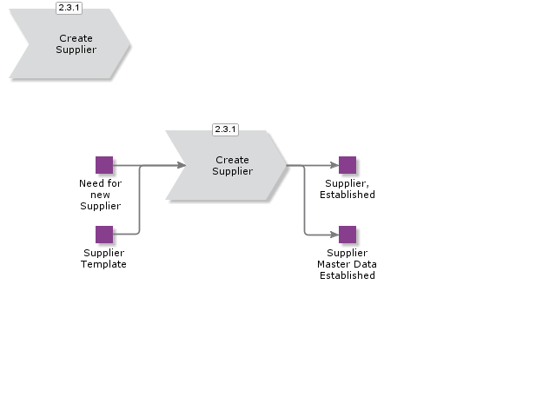

Manage Supplier
The purpose of this process are to maintain supplier master data and information when required.
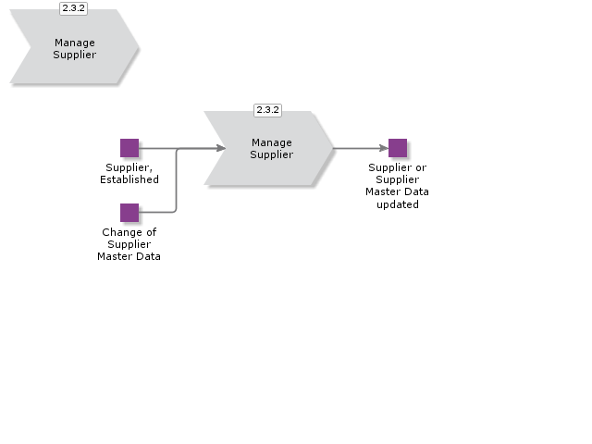

Acme Process Supplier Agreement Management
You can use supplier agreements when you and your supplier have agreed on terms for a purchase part or for a supplier assortment.

There are two different kinds of supplier agreements: blanket purchase orders and purchase agreements.

The difference between them is in the way in which they are used.

A blanket purchase order is only used for supplier agreement releases.

A purchase agreement serves in the background as a basis for the price on all applicable purchase order lines, i.e., all manually and automatically generated purchase orders.

The only exceptions for the purchase agreement are supplier agreement releases (which use blanket purchase orders) and purchase orders created from an order quotation (the terms agreed in the order quotation will be used for the purchase order line)..

You can use the quotation functionality to convert the accepted quotation into a supplier agreement. The quotation to be converted into a supplier agreement can begin either as an externally generated need (from IFS/Project or IFS/Project Delivery), or can be entered manually as a request for supplier agreement quotation.

Enter Supplier Agreement
The Enter Supplier Agreement flow consists of two different activity diagrams: one for purchase agreements and one for blanket purchase orders. You can enter the supplier agreement manually in both these activity diagrams.

When you enter a supplier agreement manually, you begin by creating a supplier agreement header in which the supplier and some miscellaneous information is entered.

Before saving the supplier agreement for the first time, determine whether it is a purchase agreement or a blanket purchase order.

When you have entered the general information, continue adding periods, sites and parts.

You can include supplier assortments in purchase agreements.

You can use supplier assortments instead of parts if you receive the same discount and additional costs for several parts.

You can also include no-number parts, i.e., parts that are not entered in the part record.

The supplier agreement must be in a status that allows purchasing (most often status Active), before it can be used..
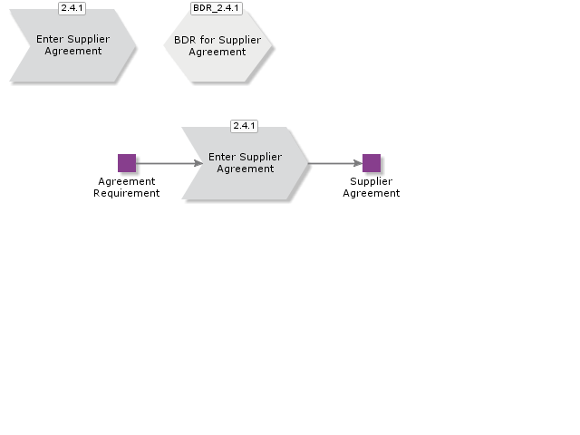

Enter Request for Supplier Agreement Quotation
You start by entering a header and the parts (or supplier assortments) to be included. After this, enter the suppliers to whom you want to send the requests, then print the requests. If the request was generated from IFS/Project or IFS/Project Delivery, the system will include the header and the part lines. All you will have to do in this case is to choose the suppliers and print the requests.
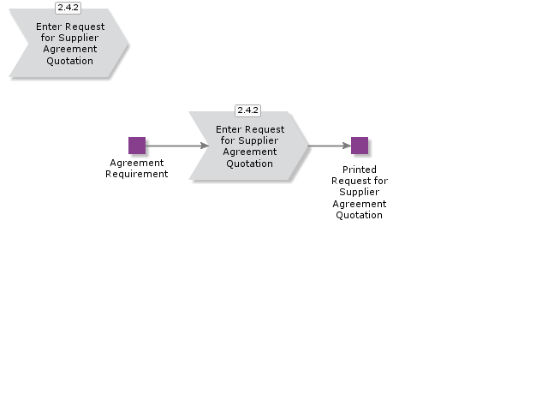

Handle Supplier Agreement Quotation
Once you have received the quotations from the suppliers, enter their terms and compare the data in order to find the most favorable quotation. When you have compared the quotations and decided which one to accept, you can create a new purchase agreement, or add on to an existing supplier agreement. Furthermore, you can print rejection letters to the suppliers whose quotations you have chosen to reject.
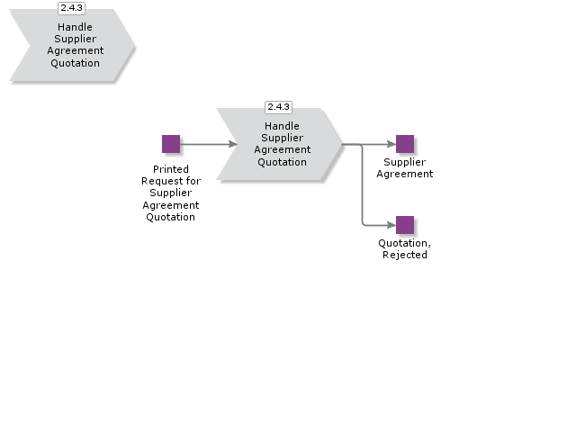

Re-Negotiate Supplier Agreement

Re-Negotiate Supplier Agreement

Introduction
Write introduction here.
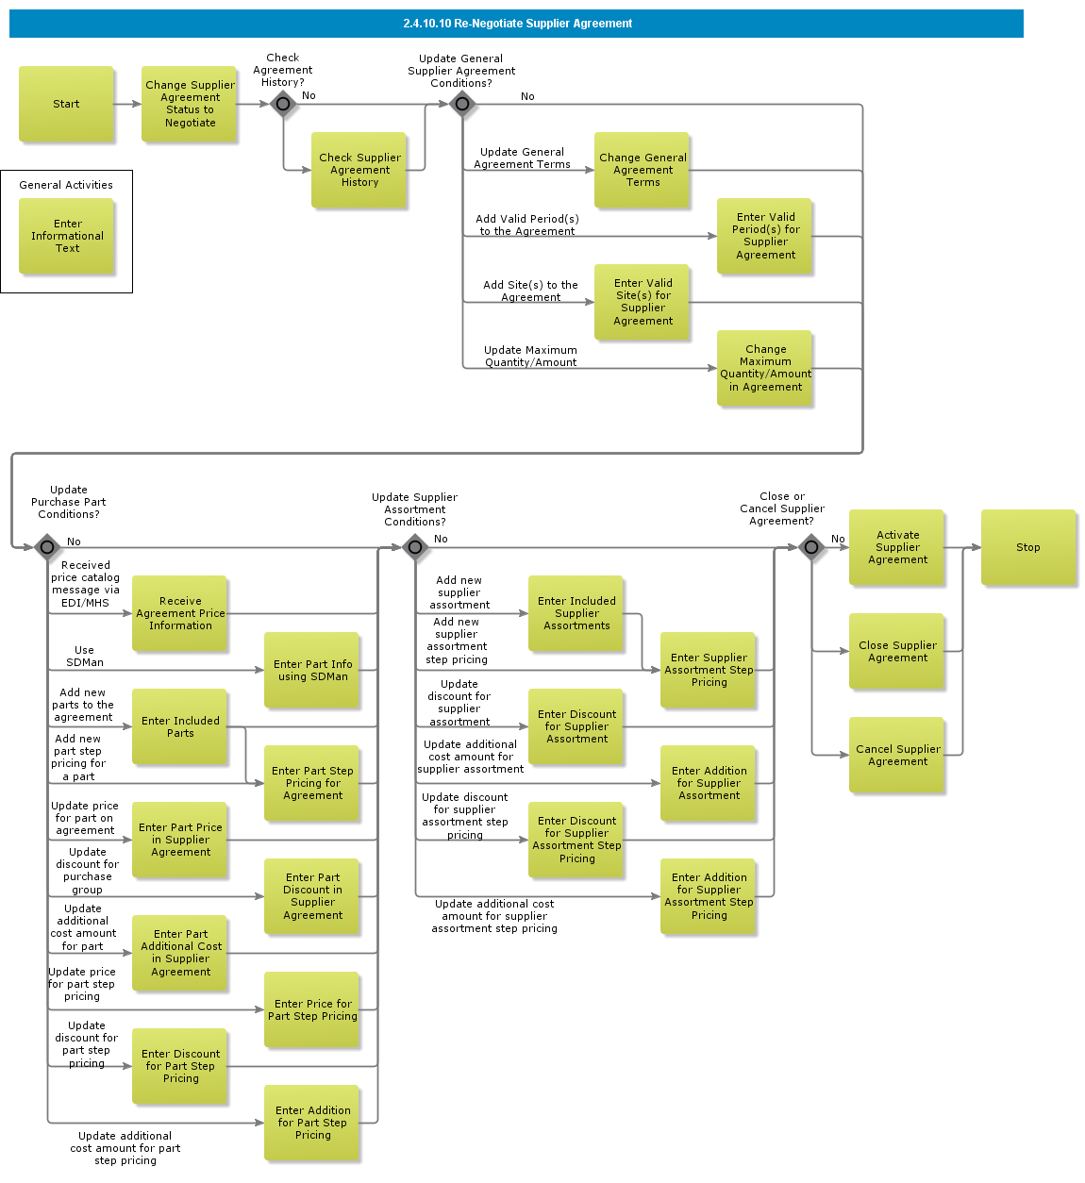

Objective
Write the objective here.

Background information
Write the background here.

Steps

Handle Supplier Agreement Quotation

Introduction
Write introduction here.
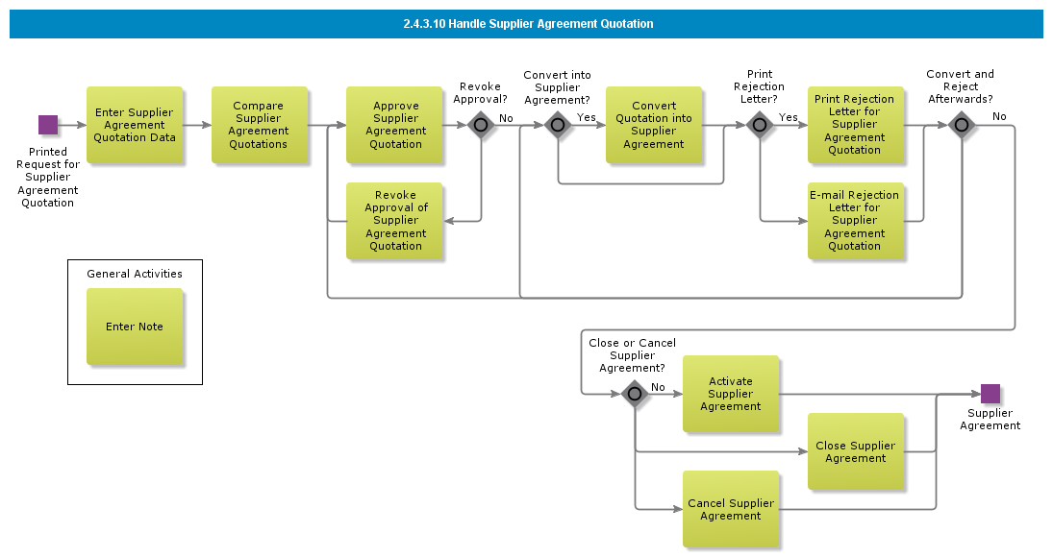

Objective
Write the objective here.

Background information
Write the background here.

Steps

Enter Request for Supplier Agreement Quotation

Introduction
Write introduction here.
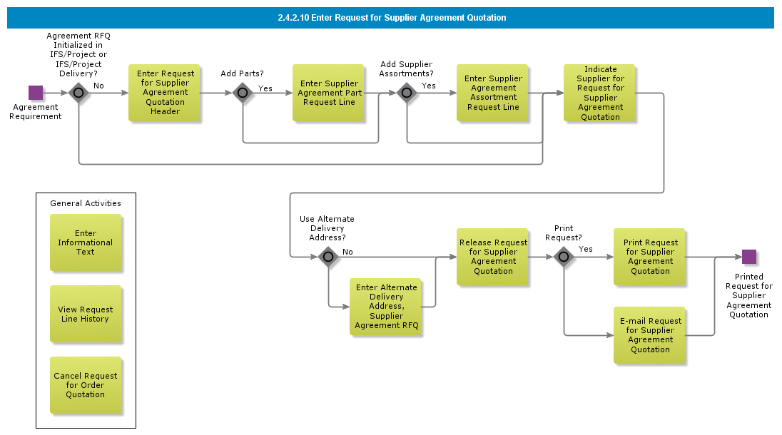

Objective
Write the objective here.

Background information
Write the background here.

Steps

Create Part and Manage Agreement Prices from eBuyer (Scand ext.)

Introduction
Write introduction here.

Objective
Write the objective here.

Background information
Write the background here.

Steps

Create and manage Agreement prices and terms, EDI import (PRICAT)

Introduction
Write introduction here.

Objective
Write the objective here.

Background information
Write the background here.

Steps

Create and manage Agreement prices and terms, excel import (SDMan)

Introduction
Write introduction here.
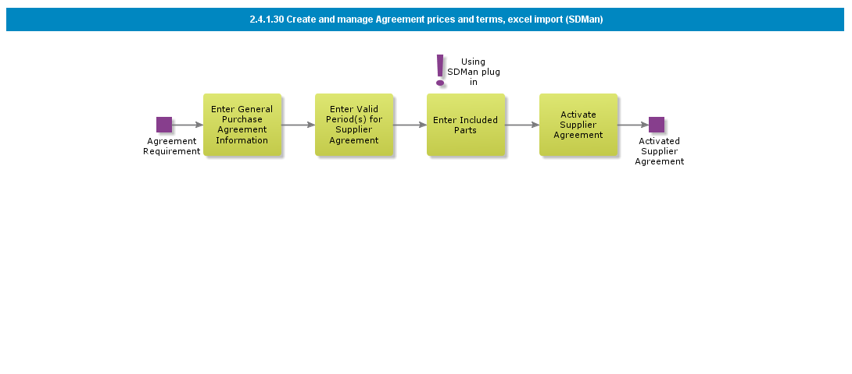

Objective
Write the objective here.

Background information
Write the background here.

Steps

Enter Blanket Purchase Order

Introduction
Write introduction here.
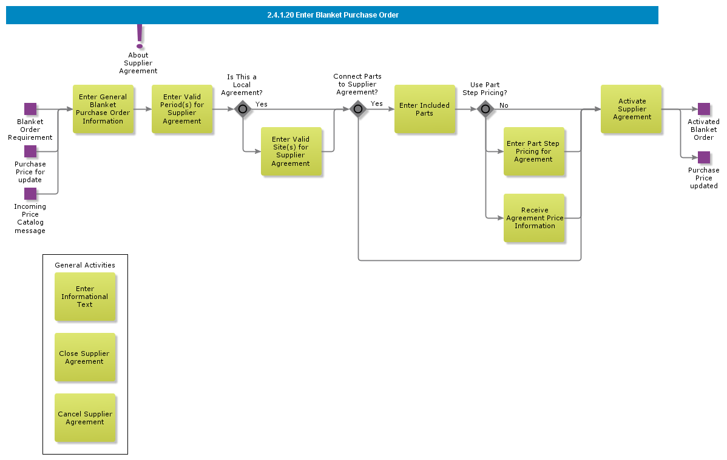

Objective
Write the objective here.

Background information
Write the background here.

Steps

Enter Purchase Agreement

Introduction
Write introduction here.
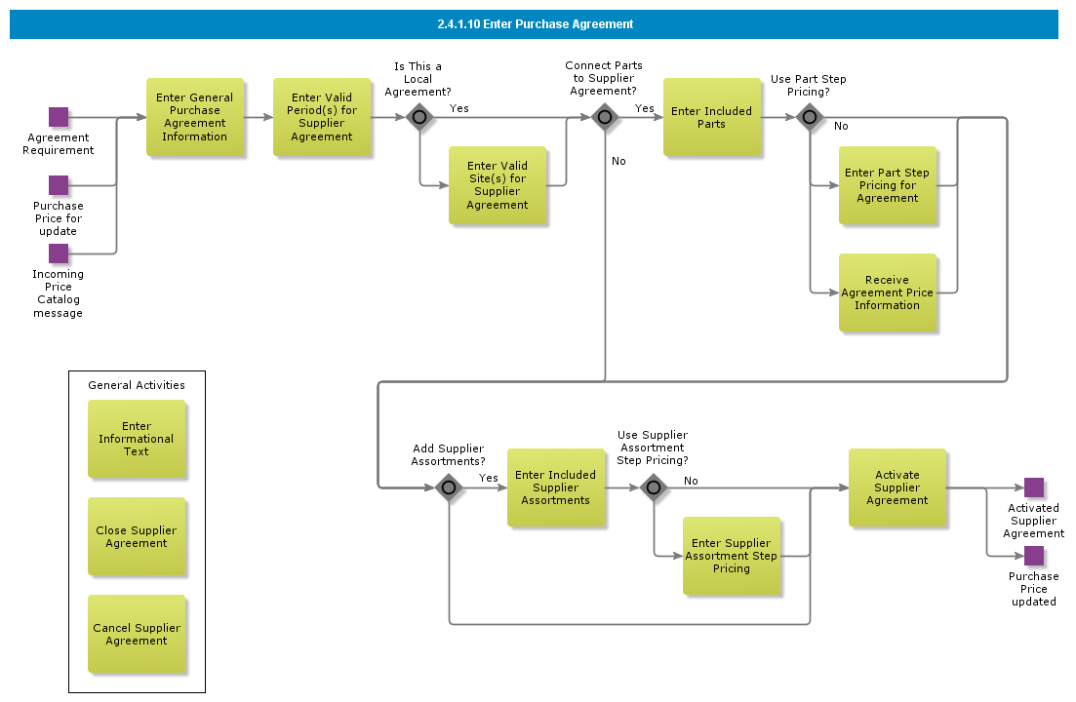

Objective
Write the objective here.

Background information
Write the background here.

Steps

Approve supplier for Quality/Environmental std.

Introduction
Write introduction here.
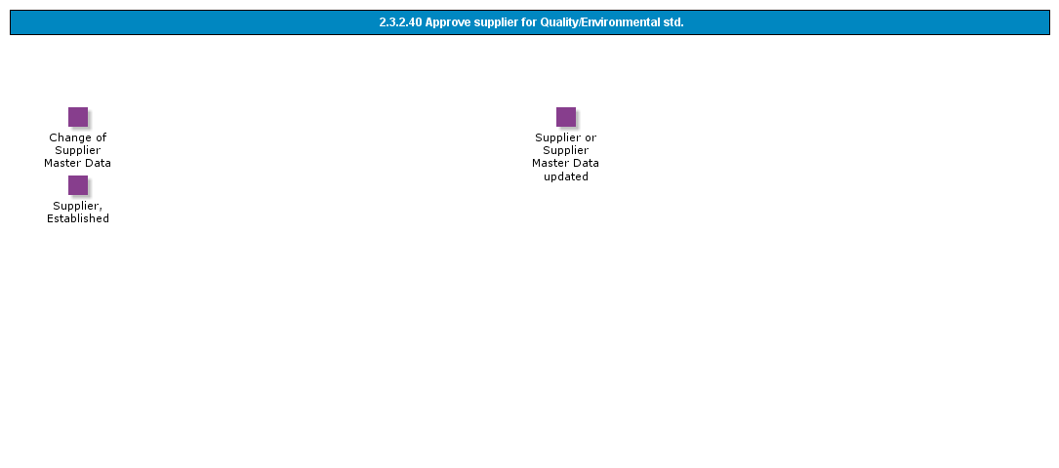

Objective
Write the objective here.

Background information
Write the background here.

Steps

Add supplier to Approved suppliers list

Introduction
Write introduction here.
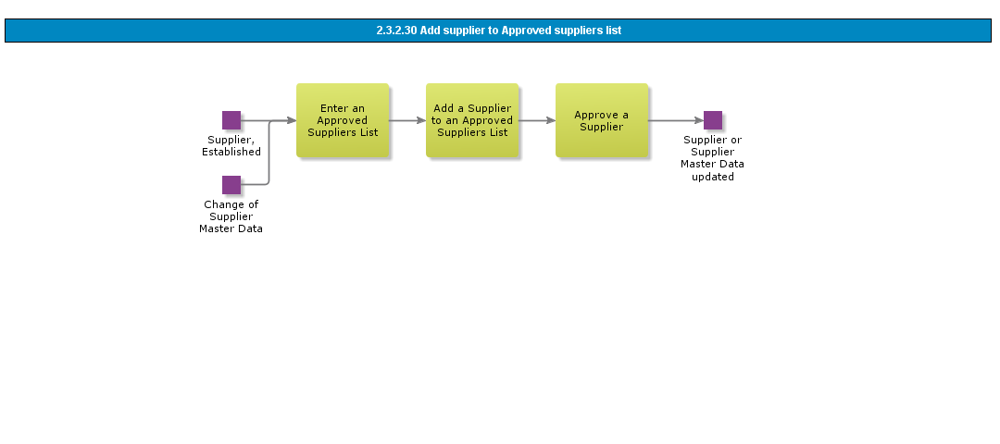

Objective
Write the objective here.

Background information
Write the background here.

Steps

Replace Supplier for parts - batch

Introduction
Write introduction here.
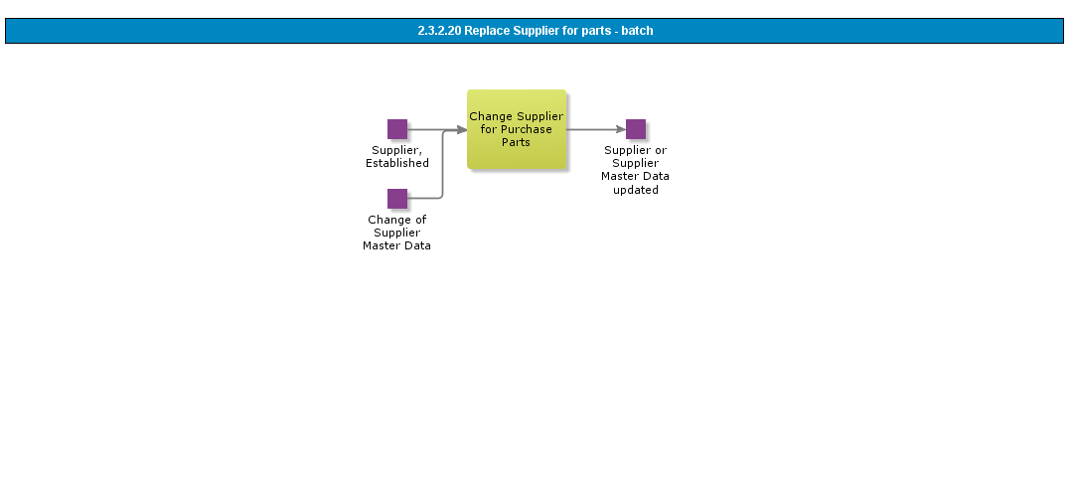

Objective
Write the objective here.

Background information
Write the background here.

Steps

Phase out Supplier

Introduction
Write introduction here.
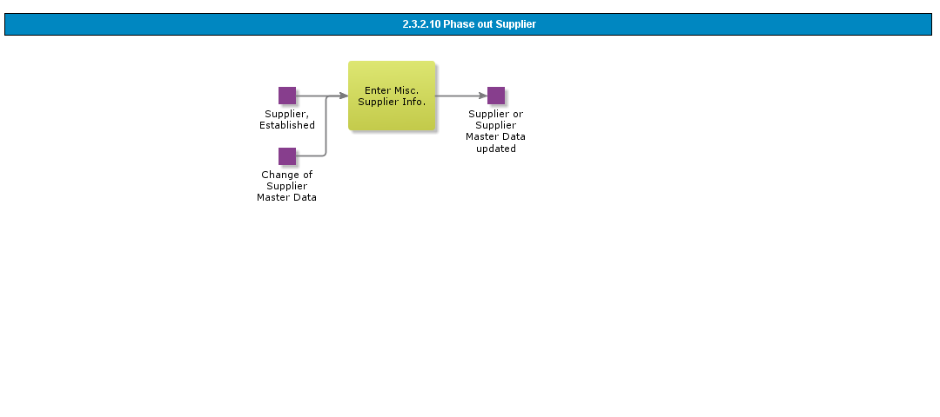

Objective
Write the objective here.

Background information
Write the background here.

Steps

Create Internal Supplier based on template

Introduction
Write introduction here.
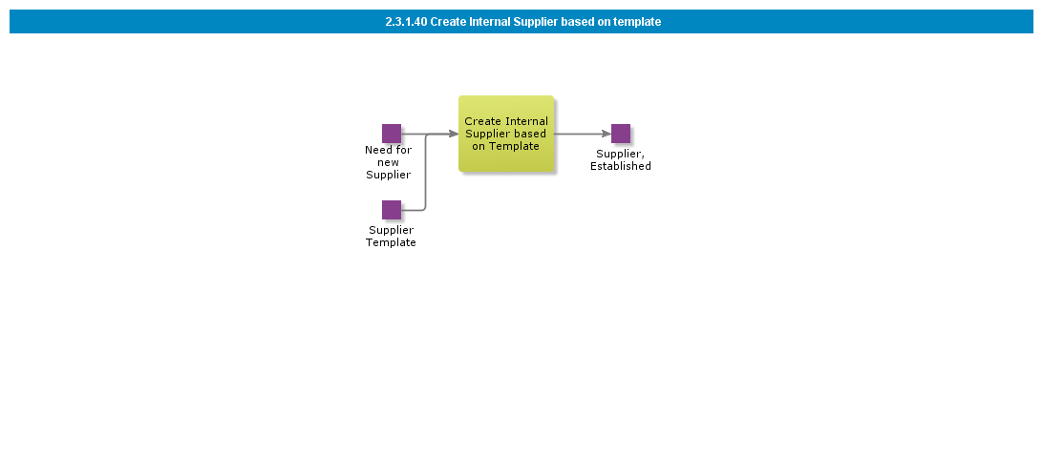

Objective
Write the objective here.

Background information
Write the background here.

Steps

Create Internal Supplier

Introduction
Write introduction here.
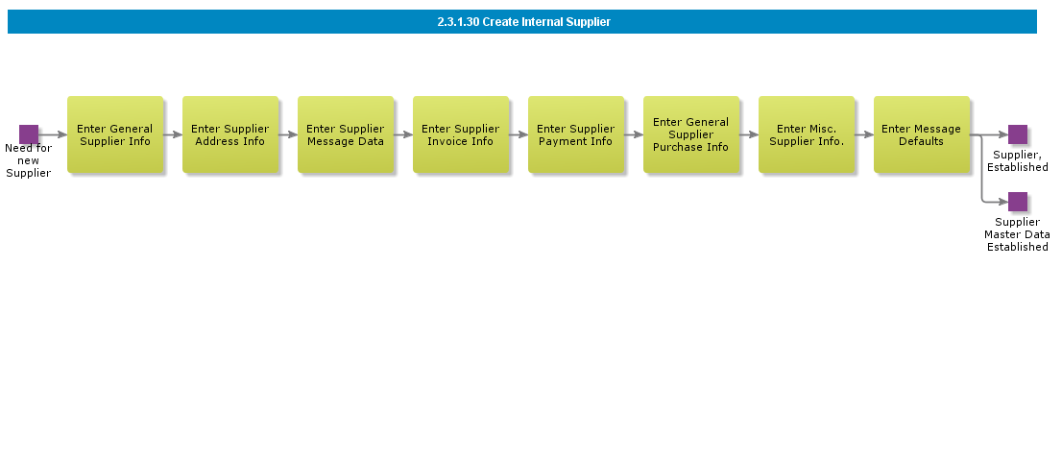

Objective
Write the objective here.

Background information
Write the background here.

Steps

Create Supplier for EDI collaboration

Introduction
Write introduction here.

Objective
Write the objective here.

Background information
Write the background here.

Steps

Create External Supplier

Introduction
Write introduction here.
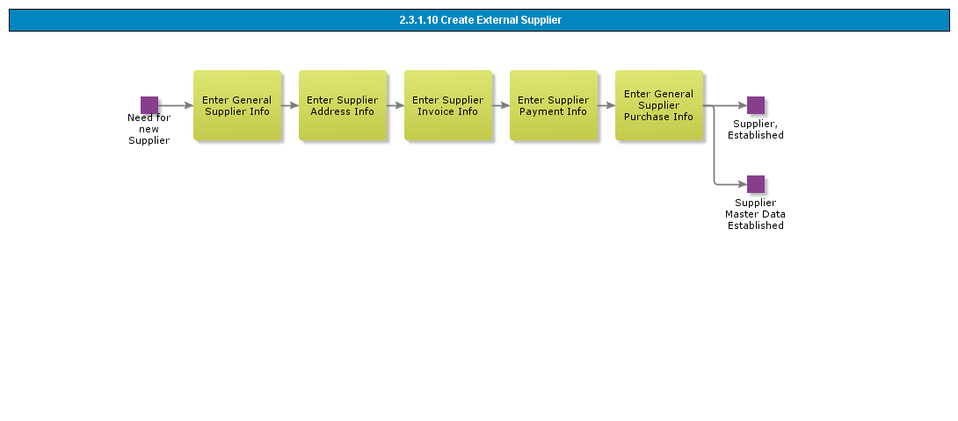

Objective
Write the objective here.

Background information
Write the background here.

Steps

Handle Purchase Order Change Order

Introduction
Write introduction here.
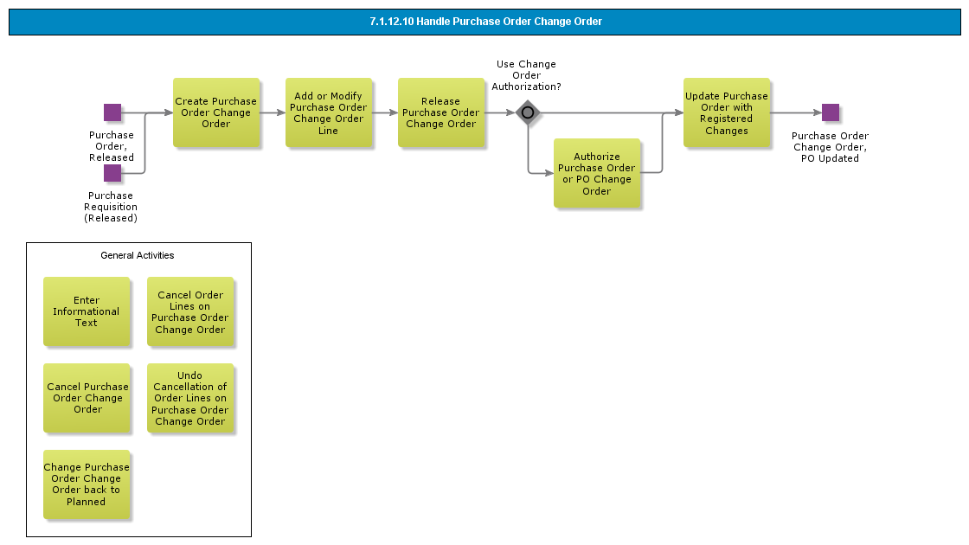

Objective
Write the objective here.

Background information
Write the background here.

Steps

Purchase Order Authorization Rule Setup

Introduction
Write introduction here.

Objective
Write the objective here.

Background information
Write the background here.

Steps

Purchase Requisition Authorization Rule Setup

Introduction
Write introduction here.
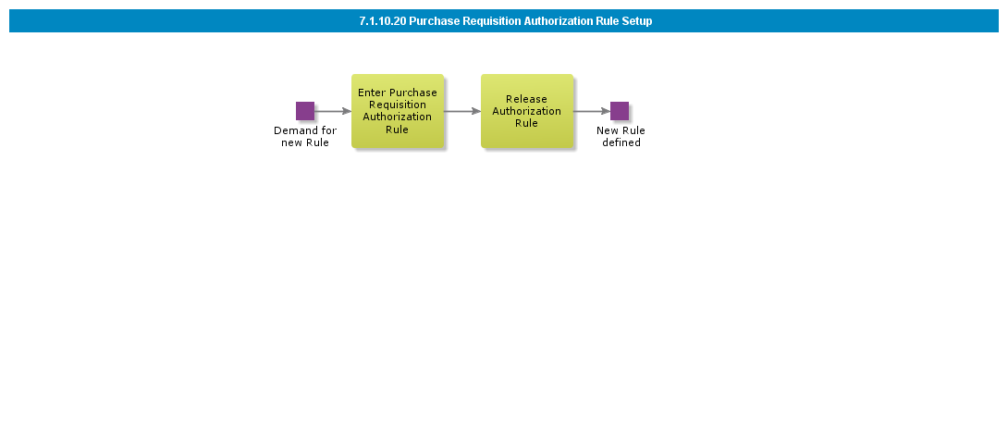

Objective
Write the objective here.

Background information
Write the background here.

Steps

Purchase Order Authorization Rules Setup

Introduction
Write introduction here.

Objective
Write the objective here.

Background information
Write the background here.

Steps

Purchase Order Requisition Authorization Rules Setup

Introduction
Write introduction here.
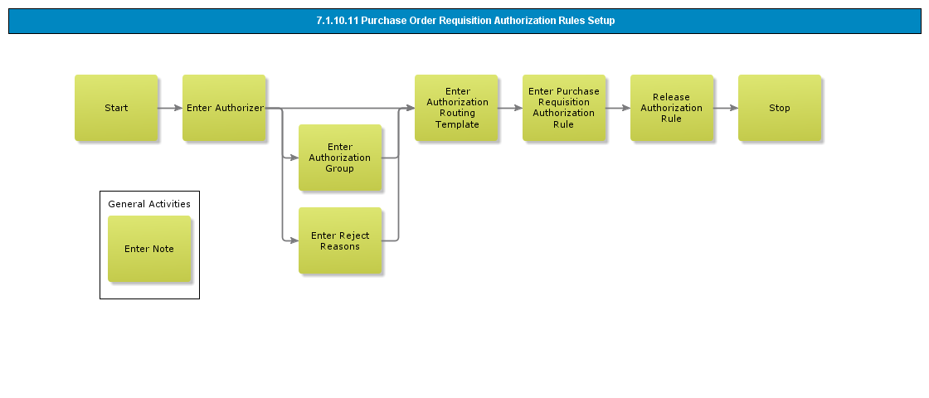

Objective
Write the objective here.

Background information
Write the background here.

Steps

Basic Data for Authorization Rules

Introduction
Write introduction here.
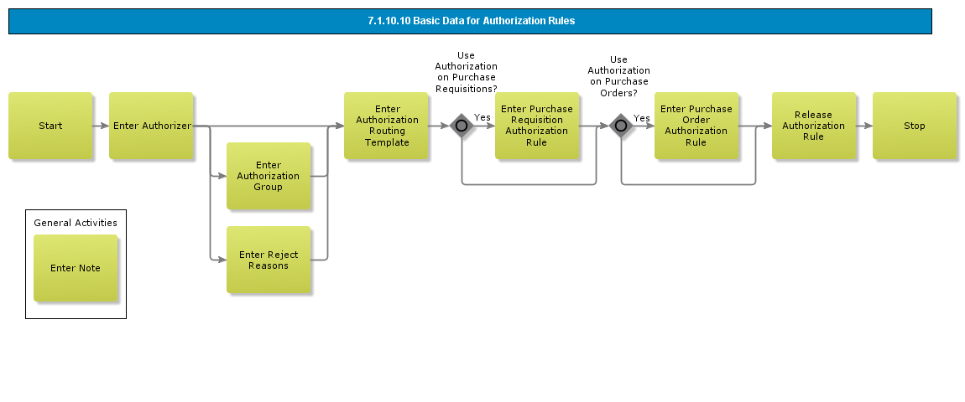

Objective
Write the objective here.

Background information
Write the background here.

Steps

Receive of Direct Delivery

Introduction
Write introduction here.
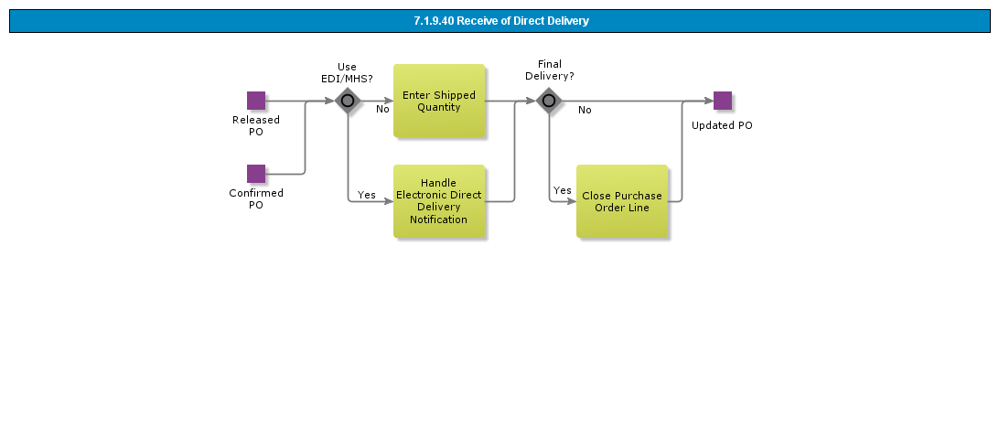

Objective
Write the objective here.

Background information
Write the background here.

Steps

Change Purchase Order with revision control

Introduction
Write introduction here.
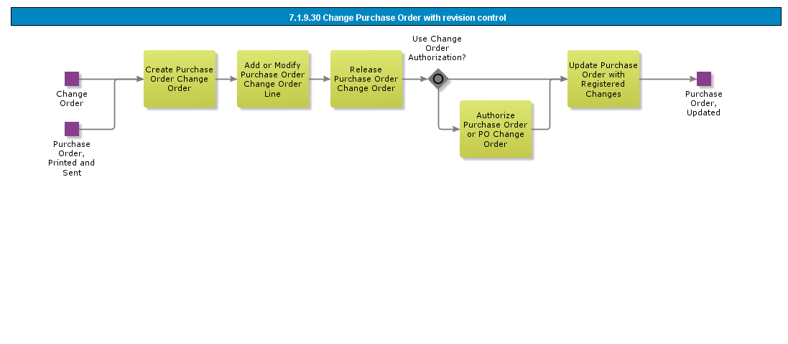

Objective
Write the objective here.

Background information
Write the background here.

Steps

Change Purchase Order without revision control

Introduction
Write introduction here.
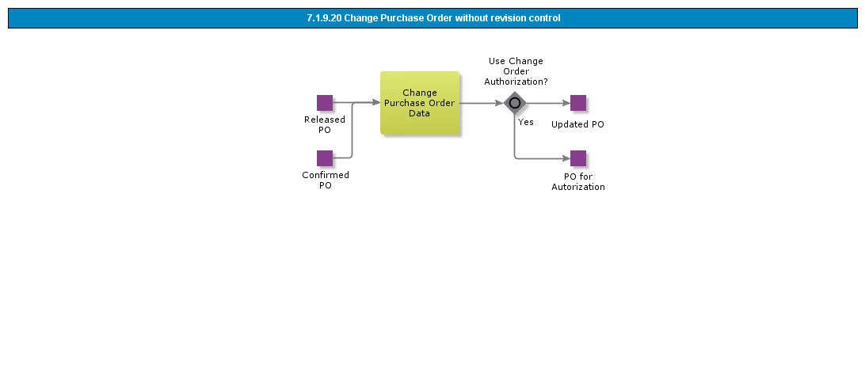

Objective
Write the objective here.

Background information
Write the background here.

Steps

Monitoring Purchase Order with Confirmation from Supplier

Introduction
Write introduction here.
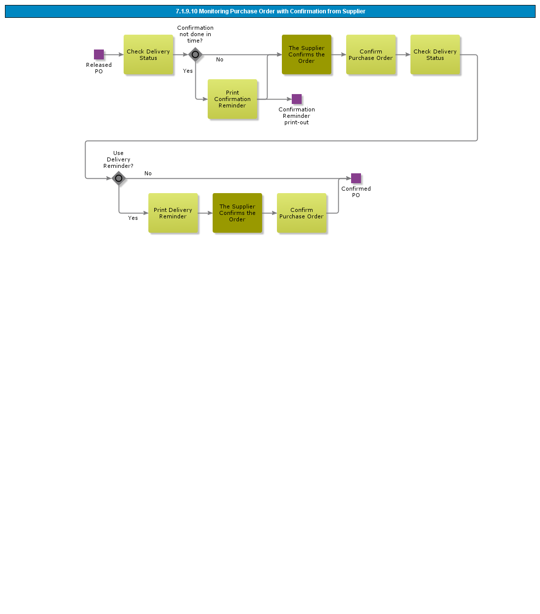

Objective
Write the objective here.

Background information
Write the background here.

Steps

Handle Supplier Material Function

Introduction
Write introduction here.
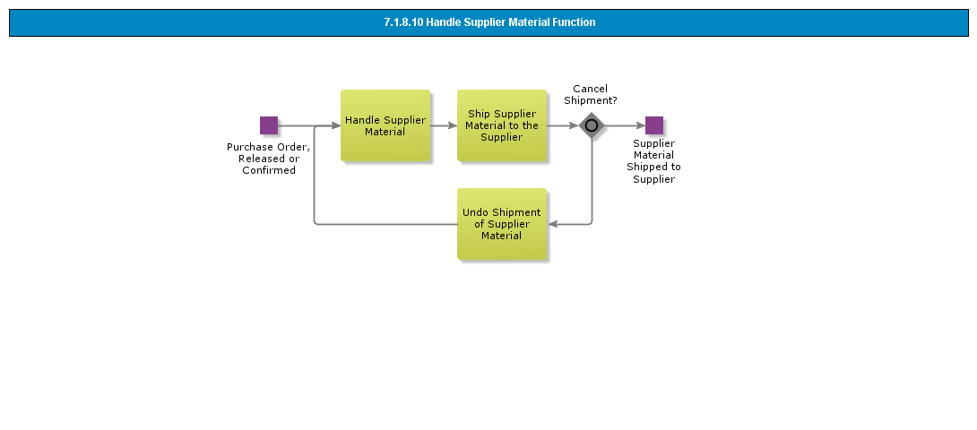

Objective
Write the objective here.

Background information
Write the background here.

Steps

Confirm Purchase Order

Introduction
Write introduction here.
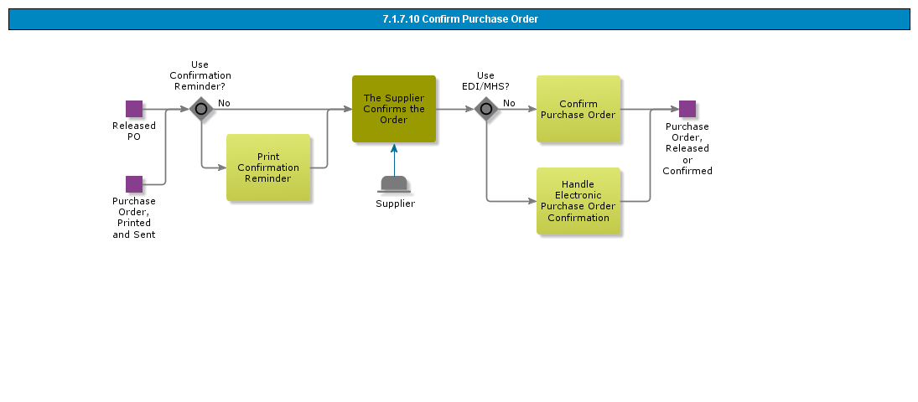

Objective
Write the objective here.

Background information
Write the background here.

Steps

Send Purchase Order to B2B Portal

Introduction
Write introduction here.
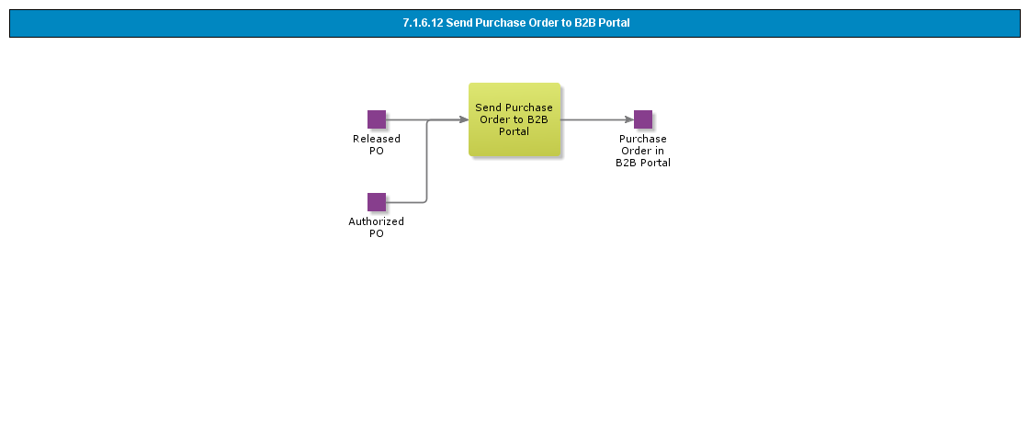

Objective
Write the objective here.

Background information
Write the background here.

Steps

Print/Send/E-mail Purchase Order

Introduction
Write introduction here.
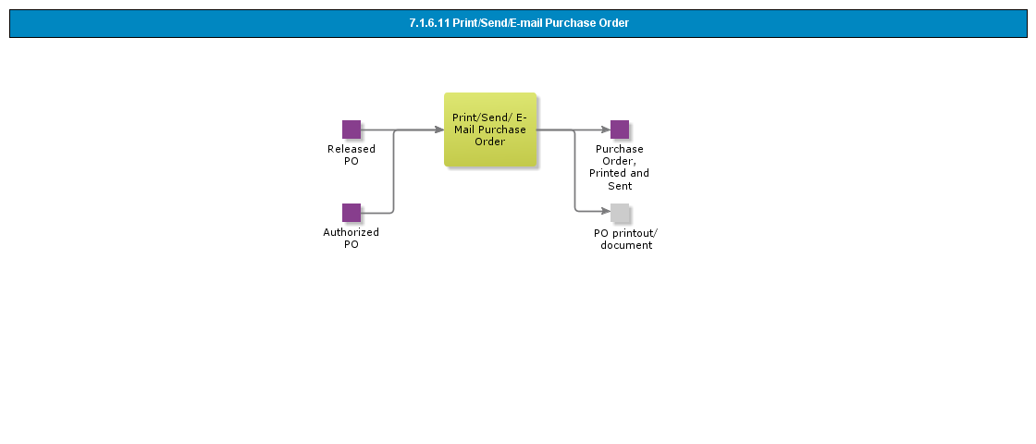

Objective
Write the objective here.

Background information
Write the background here.

Steps

Print / Send Purchase Order

Introduction
Write introduction here.
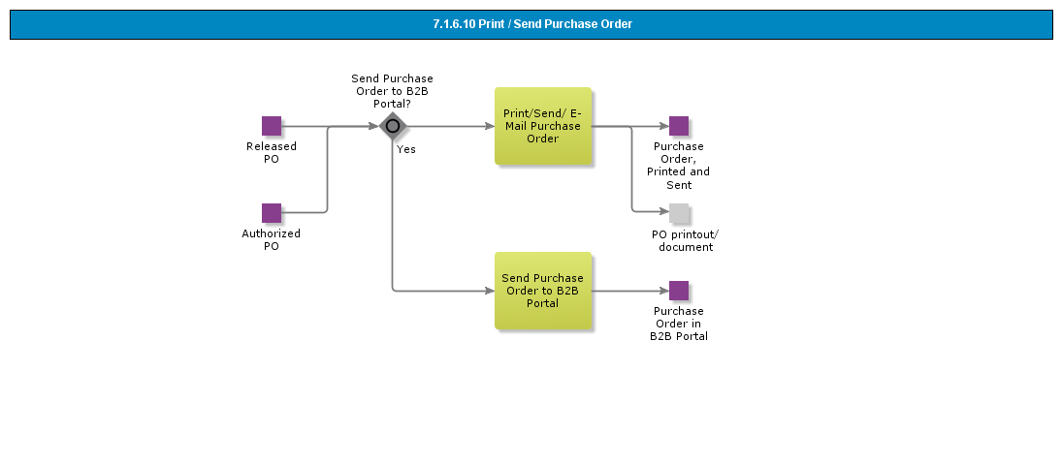

Objective
Write the objective here.

Background information
Write the background here.

Steps

Create Supplier Agreement Release

Introduction
Write introduction here.
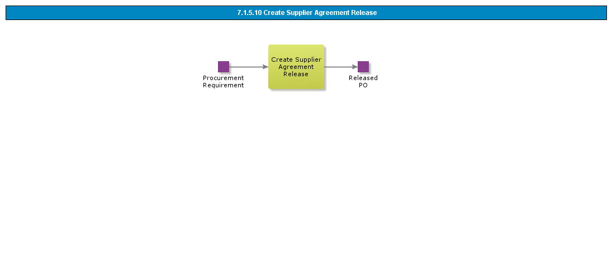

Objective
Write the objective here.

Background information
Write the background here.

Steps

Process Purchase Order for External Service Order

Introduction
Write introduction here.

Objective
Write the objective here.

Background information
Write the background here.

Steps

Process Subcontracting Purchase Order

Introduction
Write introduction here.

Objective
Write the objective here.

Background information
Write the background here.

Steps

Process Purchase Order from Quotation

Introduction
Write introduction here.

Objective
Write the objective here.

Background information
Write the background here.

Steps

Modify Purchase Order Terms or Alternate Delivery Address

Introduction
Write introduction here.
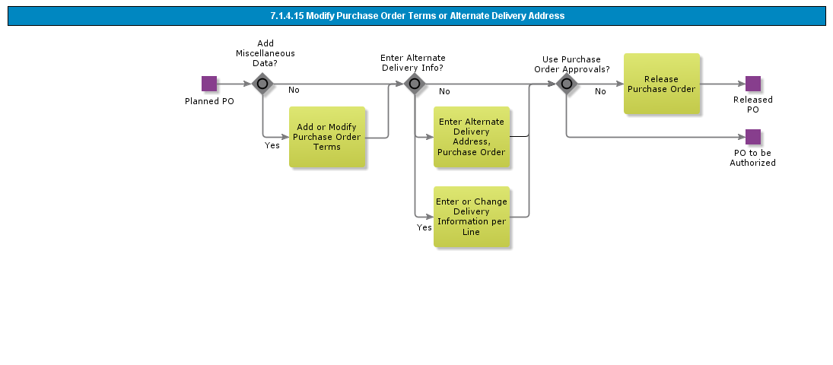

Objective
Write the objective here.

Background information
Write the background here.

Steps

Handle Purchase Order (Basic)

Introduction
Write introduction here.
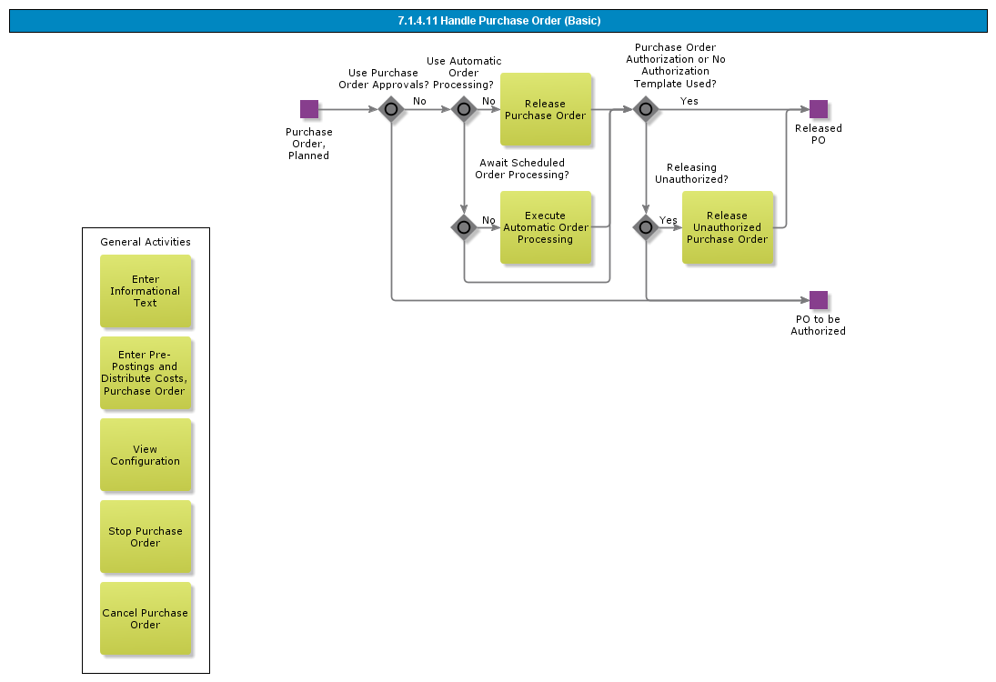

Objective
Write the objective here.

Background information
Write the background here.

Steps

Handle Purchase Order

Introduction
Write introduction here.
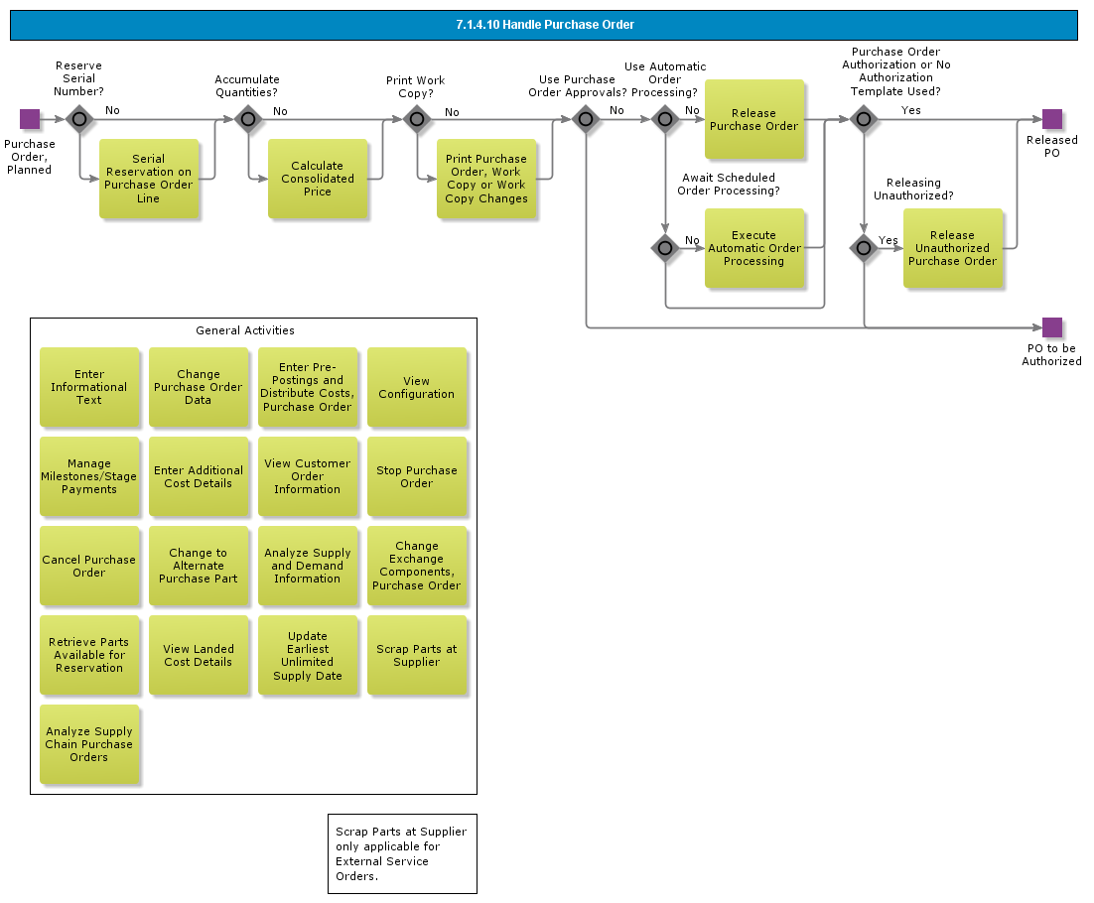

Objective
Write the objective here.

Background information
Write the background here.

Steps

Authorize Purchase Requisition, Automatic Order Processing

Introduction
Write introduction here.

Objective
Write the objective here.

Background information
Write the background here.

Steps

Authorize Purchase Order

Introduction
Write introduction here.

Objective
Write the objective here.

Background information
Write the background here.

Steps

Authorize Purchase Order Requsistion

Introduction
Write introduction here.

Objective
Write the objective here.

Background information
Write the background here.

Steps

Process Centralized Purchase Requisitions into one Purchase Order

Introduction
Write introduction here.
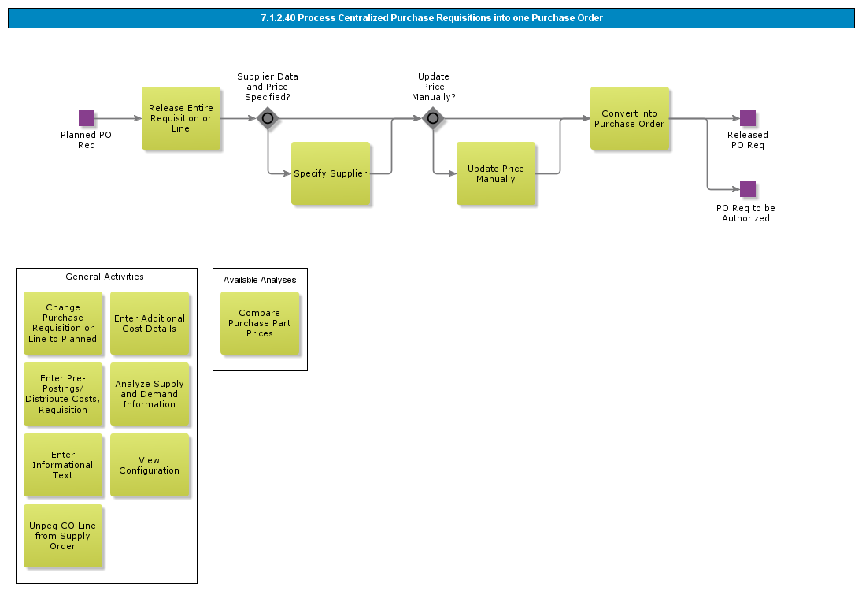

Objective
Write the objective here.

Background information
Write the background here.

Steps

Handle Purchase Requisition, Automatic Order Processing

Introduction
Write introduction here.
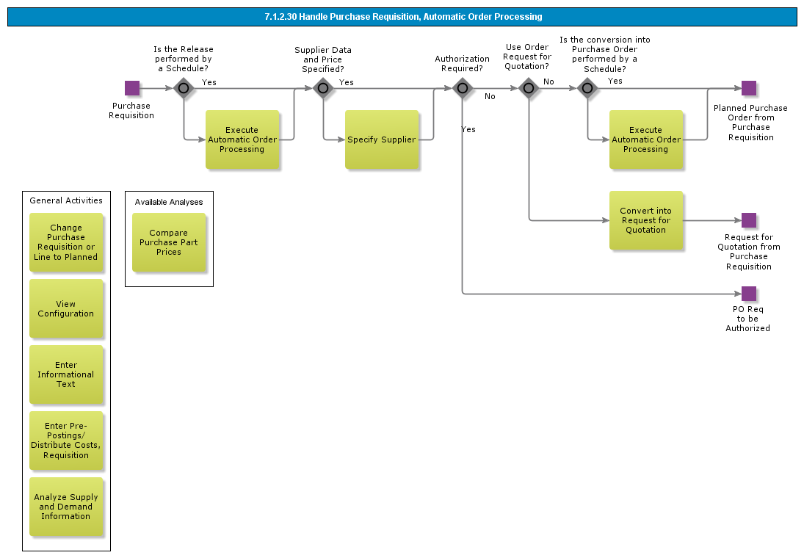

Objective
Write the objective here.

Background information
Write the background here.

Steps

Handle Express Purchase Order Requisition

Introduction
Write introduction here.
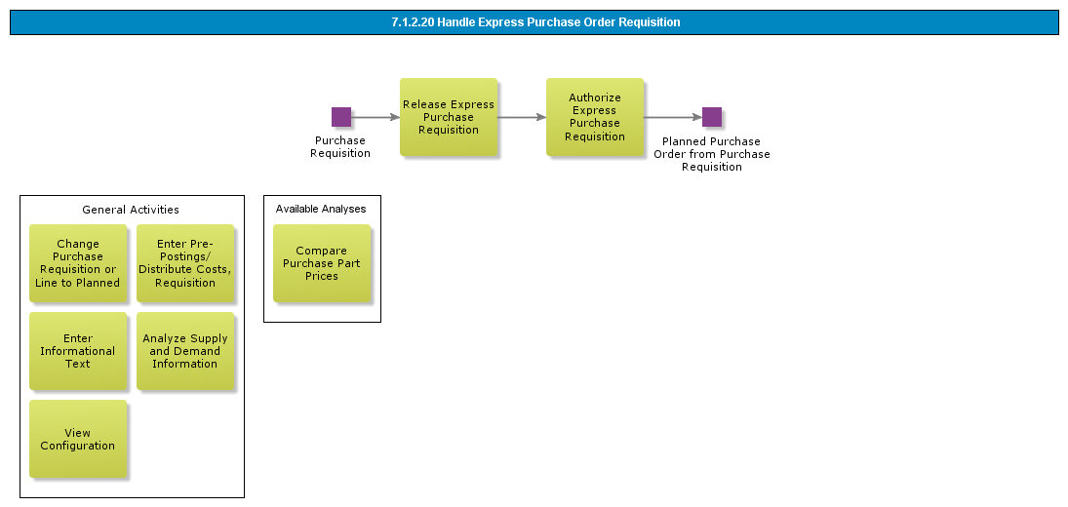

Objective
Write the objective here.

Background information
Write the background here.

Steps

Process PO Requisition to Quotation

Introduction
Write introduction here.
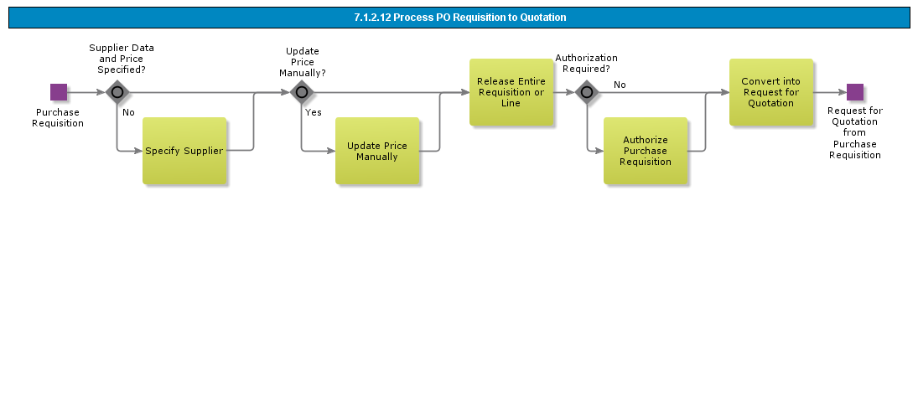

Objective
Write the objective here.

Background information
Write the background here.

Steps

Process Purchase Order Requisition

Introduction
Write introduction here.
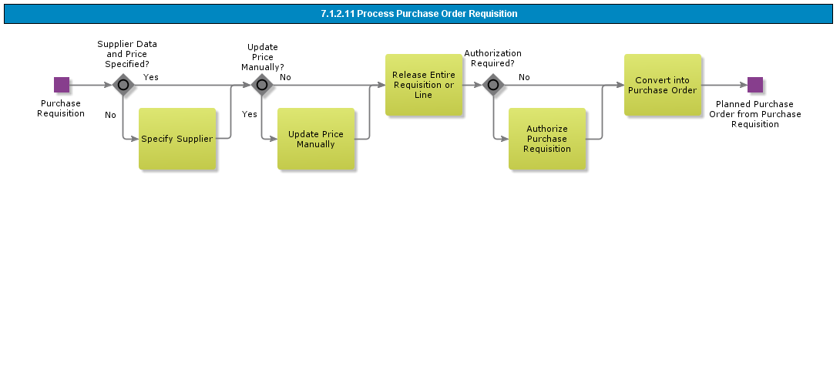

Objective
Write the objective here.

Background information
Write the background here.

Steps

Handle Purchase Requisition

Introduction
Write introduction here.
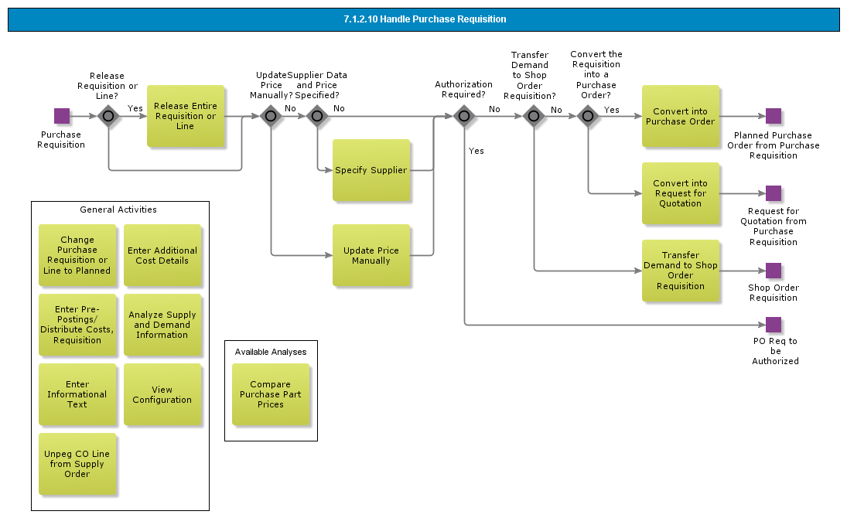

Objective
Write the objective here.

Background information
Write the background here.

Steps

Enter Purchase Requisition with eBuyer

Introduction
Write introduction here.
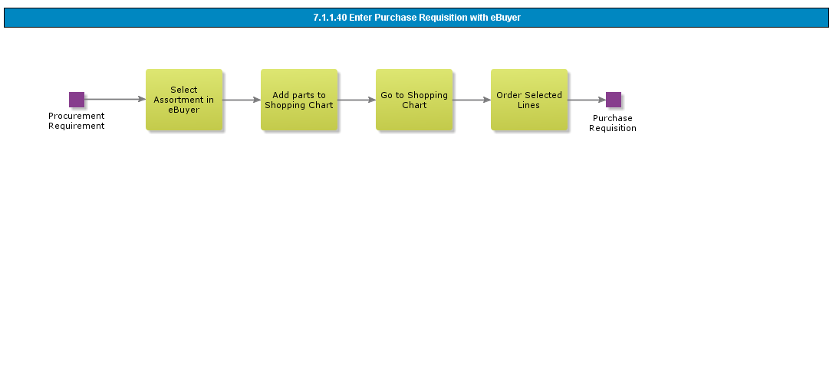

Objective
Write the objective here.

Background information
Write the background here.

Steps

Enter Purchase Order Requisition for External Services with pre-posting

Introduction
Write introduction here.

Objective
Write the objective here.

Background information
Write the background here.

Steps

Enter Purchase Order Requisition for External Services

Introduction
Write introduction here.

Objective
Write the objective here.

Background information
Write the background here.

Steps

Enter Express PO Requisition

Introduction
Write introduction here.
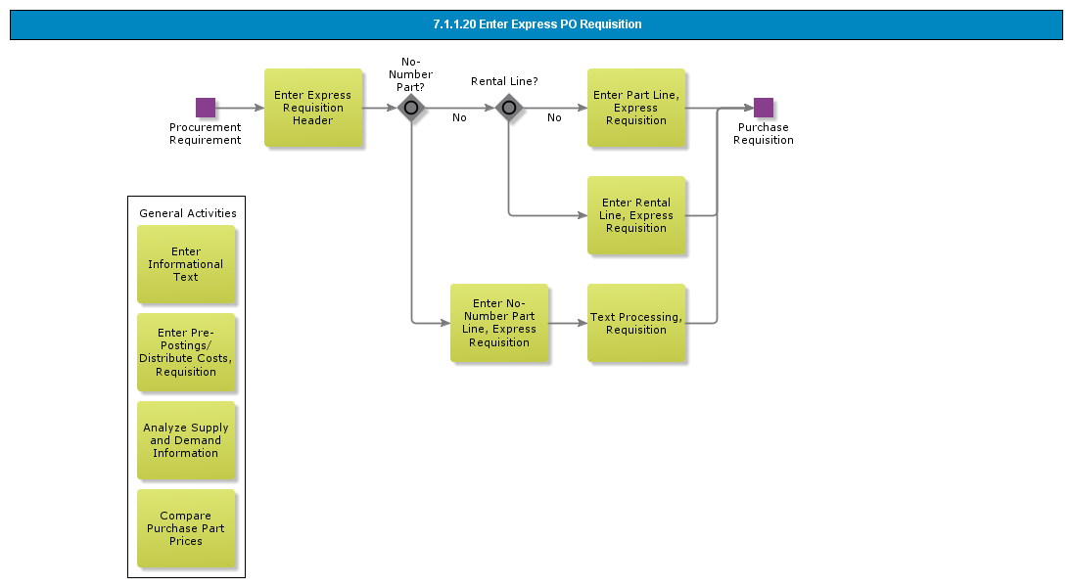

Objective
Write the objective here.

Background information
Write the background here.

Steps

Enter Purchase Order Requisition with Wizard

Introduction
Write introduction here.
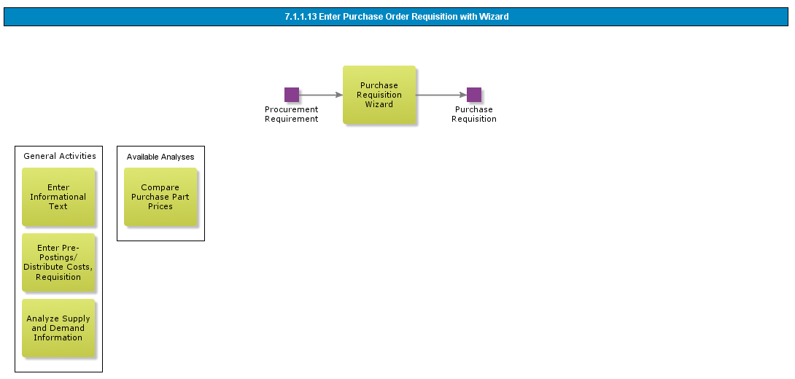

Objective
Write the objective here.

Background information
Write the background here.

Steps

Enter Purchase Order Requisition with Pre-Posting

Introduction
Write introduction here.
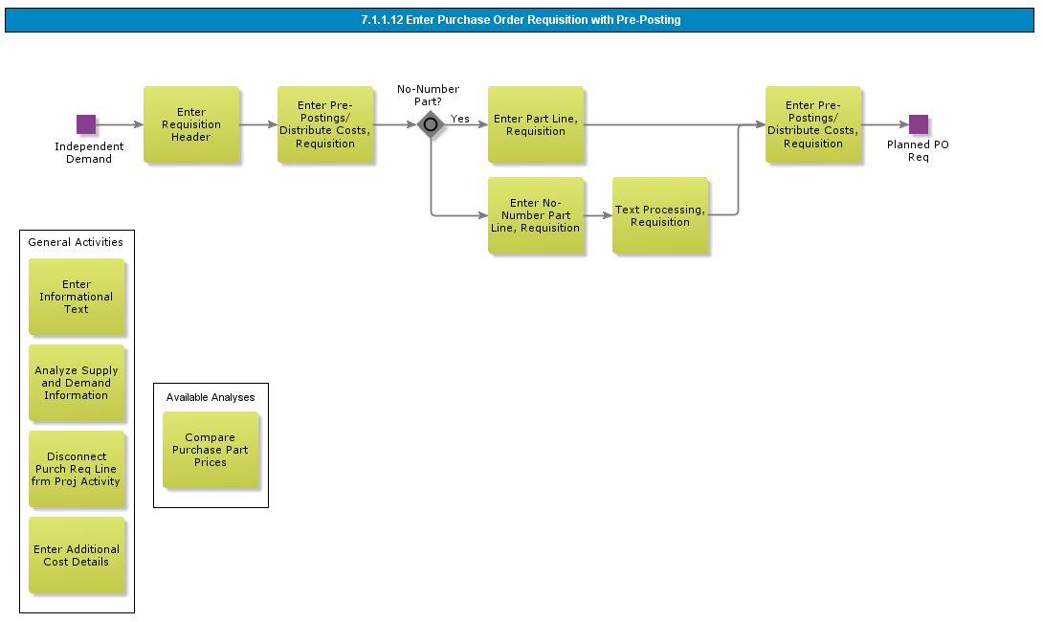

Objective
Write the objective here.

Background information
Write the background here.

Steps

Enter Purchase Order Requisition

Introduction
Write introduction here.
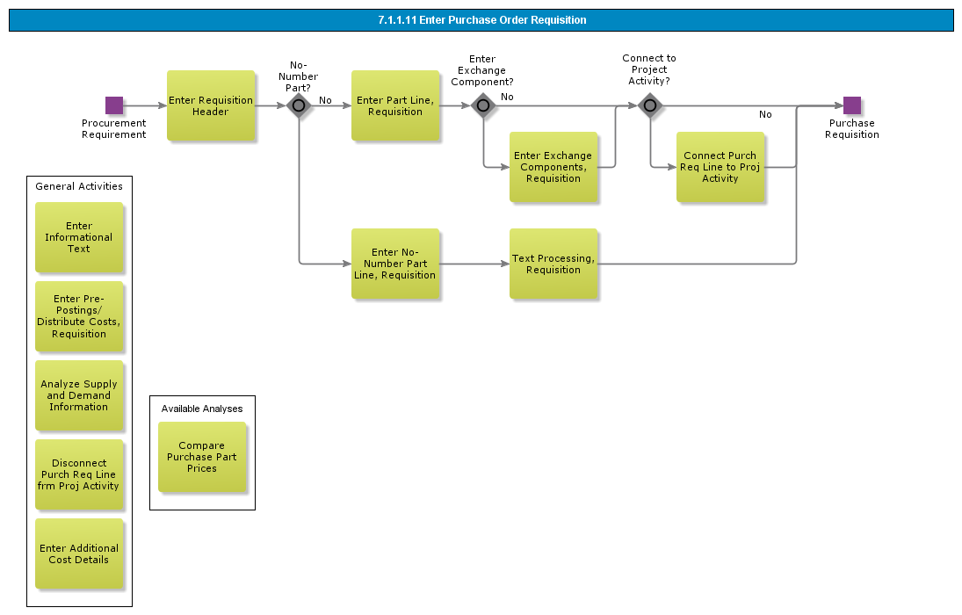

Objective
Write the objective here.

Background information
Write the background here.

Steps

Enter Purchase Order Requisition

Introduction
Write introduction here.
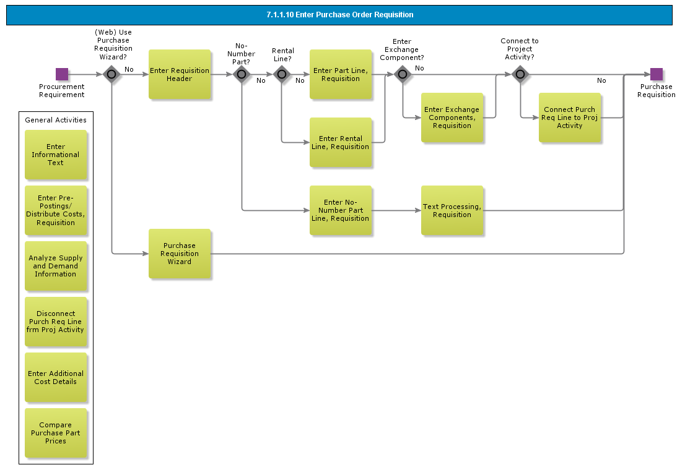

Objective
Write the objective here.

Background information
Write the background here.

Steps

BDR for Procurement

Introduction
Write introduction here.
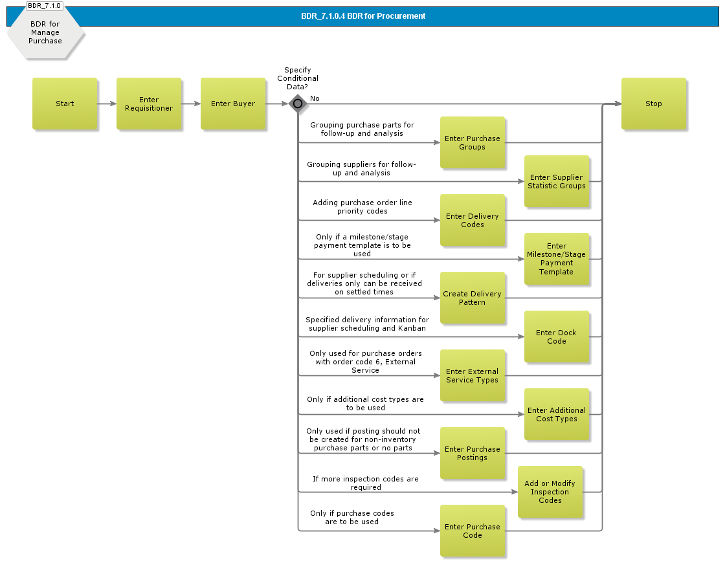

Objective
Write the objective here.

Background information
Write the background here.

Steps

BDR for Charge/No Charge

Introduction
Write introduction here.
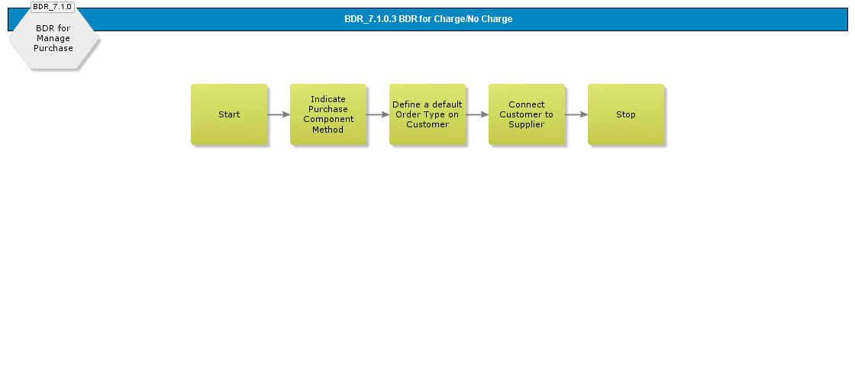

Objective
Write the objective here.

Background information
Write the background here.

Steps

BDR for Automatic Order Processing

Introduction
Write introduction here.
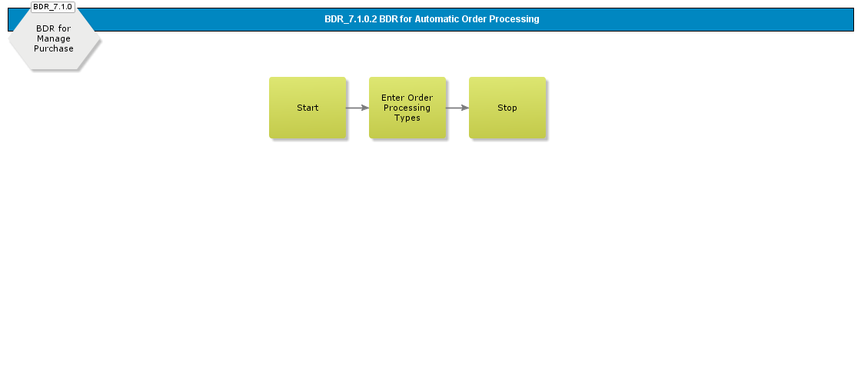

Objective
Write the objective here.

Background information
Write the background here.

Steps

BDR for Automatic Invoicing (Self Billing)

Introduction
Write introduction here.
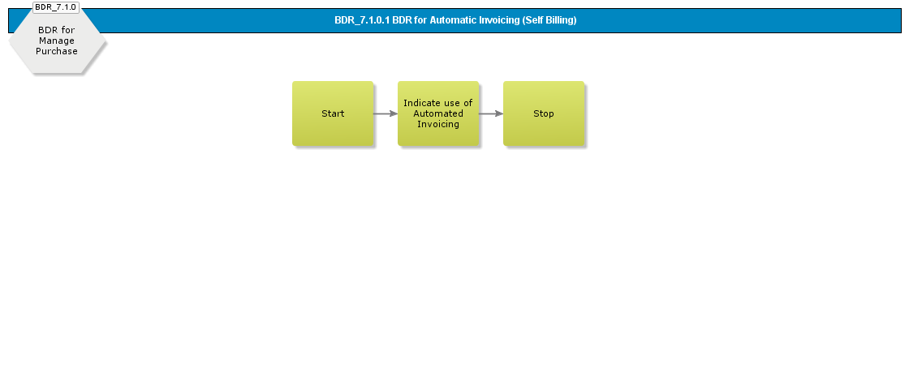

Objective
Write the objective here.

Background information
Write the background here.

Steps

BDR for Supplier Agreement

Introduction
Write introduction here.
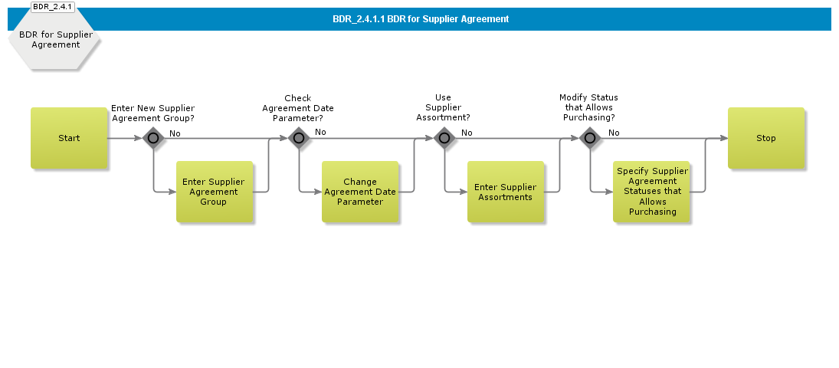

Objective
Write the objective here.

Background information
Write the background here.

Steps

BDR for Supply Chain Relations

Introduction
Write introduction here.

Objective
Write the objective here.

Background information
Write the background here.

Steps

Acme Warehouse Management

Acme Process Receipt
The receipt process handles two main processes: purchase parts that arrive at dock (with or without dispatch advice) and purchase parts that are delivered directly to the end customer. Several circumstances affect the working process, such as pallet handling, serial tracking, and lot/batch tracking.

One of the main principles in the receipt function is the receive case. The receive case functions as a guideline for the current arrival of the working process. However, the flexibility of the receipt function enables you to perform actions even if the current receive case does not include these. The possible receive cases are:

- Receive into Arrival
- Receive into Inventory
- Receive into Arrival, Perform Putaway
- Receive into Arrival, Inspect at Arrival
- Receive into Arrival, Inspect at QA
- Receive into QA, Inspect at QA
- When the purchase order line is entered, the Receive into Arrival receive case is indicated by default if there is none specified for the related supplier for the purchase part. It is common with all types of parts to be entered as Arrived once they arrive at the dock. However the procedure will vary depending on the circumstance, such as the part type and the receive case that were indicated on the purchase order line.

A quality control can be performed in relation to the receipts. Receipt lines that have an inspection demand generally originate from a purchase order line with the following receive cases: "Receive into Arrival, Inspect at Arrival," "Receive into Arrival, Inspect at QA," or "Receive into QA, Inspect at QA."

Common to all receive cases is the cancellation of arrival and receipt anywhere in the work flow. As a consequence, you can start over by entering the purchase order arrival. This is however not possible if an invoice has been matched to the receipt, if any part has been scrapped or returned, or if the connection between the receipt line and the stock location is broken (Note that on a receipt line with a scrapped or returned quantity, you can undo the scrap/return and cancel the receipt.).

BDR for Receipt Process

Report Arrival
This process object is divided into three scenarios:

- Report arrival - this scenario is normally used, except when handling dispatch advice and direct receipt of no-number parts.
- Report direct receipt of no-number parts - this is used when no-number parts should be entered as arriving directly from the purchase order. The no-part order line is entered as arrived, and the order line status is changed to Closed. You can view and cancel the receipt lines in the receipt function. Receipt history is logged for each line entered. When an inspection is required, you must continue to the Purchase Order Receipt window. The status on the receipt line is then set to To be Inspected. When you enter the inspection results, the status on the receipt line changes to Received.
- Report arrival using dispatch advice - this is used when arrivals should be done by using a dispatch advice. When reporting an arrival from a dispatch advice, you can choose between reporting an entire shipment as arrived or reporting a partial arrival of single lines.

The following receive cases use this process object:

- Receive into arrival
- Receive into inventory
- Receive into arrival, perform putaway
- Receive into arrival, inspect at arrival
- Receive into arrival, inspect at QA
- Receive into QA, inspect at QA

Serial-handling: The arrival registration is performed in different dialog boxes depending on whether the parts are serial-handled, or if serial numbers will be defined at the arrival registration or afterwards. If you are dealing with serial-handled parts and have decided to postpone the serial number assignment, enter the arrival by using the dialog box for parts without serial numbers.

Pallet-handling: Pallets are created for pallet-handled parts that are placed in a pallet arrival location. However, you can handle pallet-handled parts in the same manner as single-handled parts and then create pallets in IFS/Inventory. If the parts are divided among pallets, the quantity of parts per pallet can be modified.

Arrival Report: A printout of the arrival report in connection to the arrival registration can be produced. However, you have the option to print this later on.

Create Purchase Order from Arrival: You have the option to create a new purchase order from the arrival registration window.

This can be useful when goods arrive without an order from your company.

This occurs, for example, when a supplier refills a consignment stock located in your warehouse.

When the goods arrive, you then do not have a corresponding purchase order line on which to enter the arrival, thus a purchase order line has to be created afterwards.

Once a purchase order line is created, enter the arrival in the usual manner..
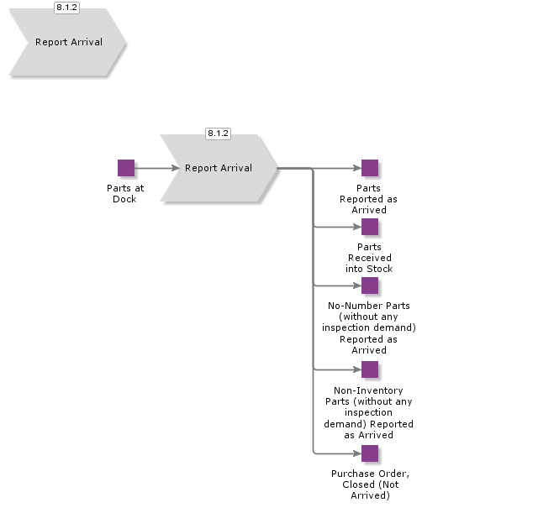

Move Into Inspection Location
This Sub process is used when receive cases is Receive into arrival, inspect at QA

Due to the receive case "Receive into arrival, inspect at arrival," the inspection should be performed and the inspection results should be entered in an inspection location, i.e., a quality assurance location. Move the parts into an inspection location. The pallets must be moved into a pallet quality location by using a pallet transport task.
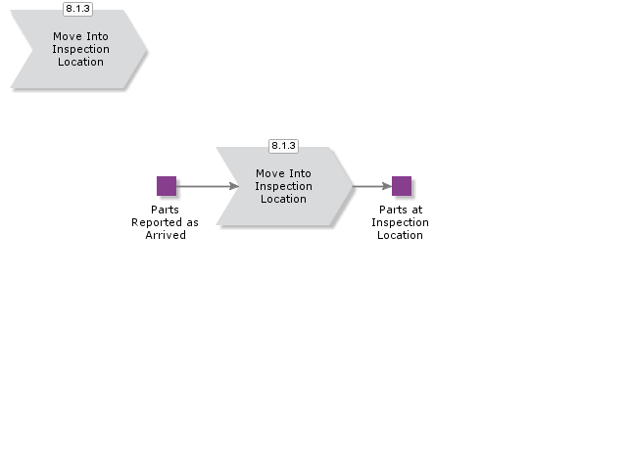

Perform Quality Inspection & Handle Discrepancies
This Sub process is used for following receive cases:

- Receive into arrival, inspect at arrival
- Receive into arrival, inspect at QA
- Receive into QA, inspect at QA

If necessary information is entered in IFS/Quality Management, you can create an analysis in the receipt function and then enter test results in the aforementioned component. Notice that these control operations are not connected to inspection codes or to the entry of inspection results in IFS/Purchasing. The testing results can be used as guidelines when entering the inspection results in IFS/Purchasing.

The inspection should then be performed and the inspection results entered.

The quantity to inspect is calculated by the inspection code.

In connection with reporting, the inspection results' faulty parts can be scrapped, returned for rework, or returned for credit.

A replacement order can be created for parts that are returned for credit.

If for some reason you have entered a scrap or return by mistake, you can undo this action.

To do so, enter an inspection approval for parts where the scrap or return is undone..

Once the quality inspection is completed, the receipt is also completed and the receipt line acquires the Received status with regards to lines with non-inventory registered purchase parts and no-number parts. Also, the receipt line with inventory registered purchase parts acquires the To be Received status.
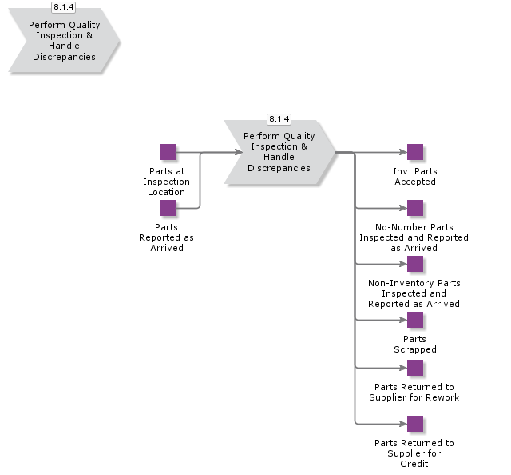

Handle Arrival
The following receive cases use this Sub process. (This Sub process can be regarded as optional since no activity is crucial for the working process.):

- Receive into arrival
- Receive into arrival, inspect at arrival
- Receive into arrival, inspect at QA
- Receive into QA, inspect at QA

Before the inventory registered purchase parts are received into a stock location, you can add or update information such as the expiration date, W/D/R number, lot/batch number, split into serials, and printing of barcode labels, depending on the settings for the part.
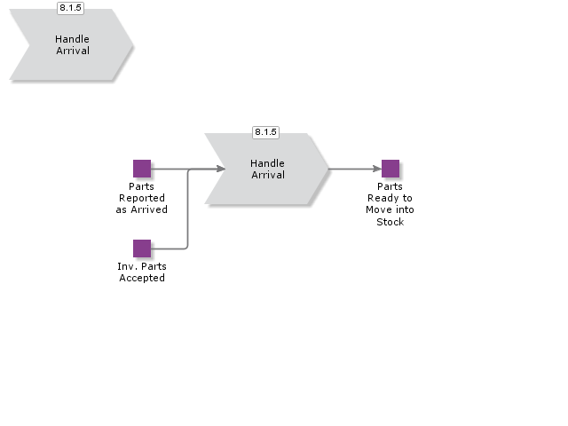

Move into Stock
The following receive cases use this Sub process:

- Receive into arrival
- Receive into arrival, perform putaway
- Receive into arrival, inspect at arrival
- Receive into arrival, inspect at QA
- Receive into QA, inspect at QA

When the arrival registration and any required inspection is performed (with or without an inspection location), the inventory registered purchase parts should be moved into one or more stock locations, e.g., a picking location. Pallet-handled parts are moved by using pallet transport tasks. The stock location type for pallet-handled parts can be pallet, pallet deep, or pallet buffer.

Once moving into a stock location, the receipt line with inventory registered purchase parts acquires the Received status and the receipt-handling is completed.

For parts with perform putaway enabled, the best possible location is found and the parts are moved to that location. Transport tasks are created.
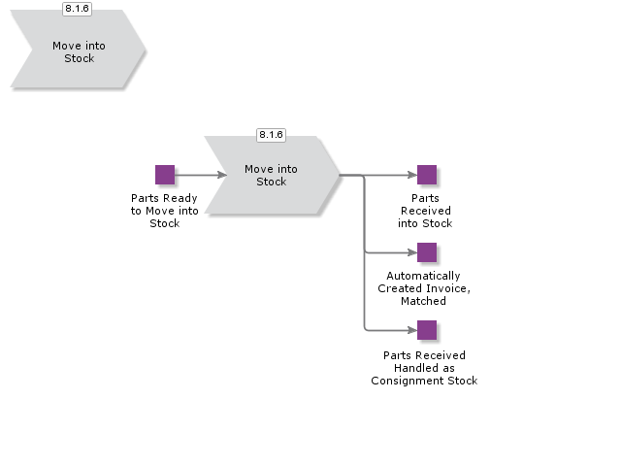

Handle Receipt for Direct Delivery
This Sub process is used when the requirement of the purchase comes from a customer order and the parts are to be sent from your supplier directly to the end customer, without passing through your warehouse. This data is entered in a specific window, and the end result being that the purchase order is closed and the customer order line receives the Delivered status, i.e., if no partial deliveries remain on either orders.

The direct delivery function is initiated when a customer order with the supply code "Purchase Order Direct" is entered and released. This generates a purchase requisition that should be released and converted to a purchase order. The purchase order then needs to be released.

When you have received the delivery note from your supplier, enter the delivered quantity and confirm the transaction. The purchase order is automatically closed and the status is changed from Released or Confirmed to Closed. The customer order receives the Delivered status and the customer can be invoiced, assuming that no partial deliveries remain on either orders. If the supplier has partially delivered an order and is unable to fully deliver this, it is possible to manually close the purchase order.
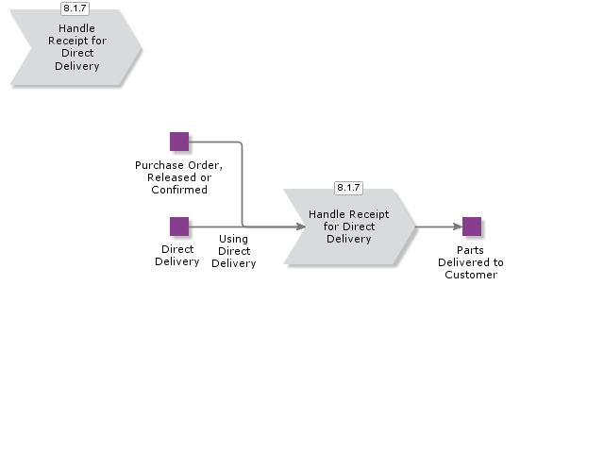

Acme Process Handle Inventory

BDR for Maintain Inventory

Handle Material Requisition

Issue Material
Once a work order has been released for execution, material transactions can be recorded against work order, which includes issues or material, un-reserving or un-issuing of issued consumables and also the addition of different material items if needed.

- As part of this process it is also possible to review the current stock availability and to raise purchase requisitions for either material items or services.

Handle Parts

Handle Counting

Acme Process Shipment
The shipment process includes one single point of entry, handling, and delivering a shipment, including printing of all necessary shipment documents.

The shipment process enables proactive shipment planning and re-planning.

The process also enables you to create preliminary shipments, containing order lines in the Released, Reserved, or Partially Delivered status from various orders.

Then, you can work with the connected order lines.

The shipment process generally includes a number of activities and different stages.

As a part of the shipment process activities, you can initiate a shipment, connect order lines to the shipment, pick and report, define a package structure, create transport labels and shipment documents, deliver and send dispatch advices..

BDR for Shipment

Create Shipment
The shipment will be the base for connecting customer order lines to the shipment, creating package structures, creating delivery notes, creating shipping documents as well as sending a dispatch advice to the customer. All this will eventually be connected to the shipment ID. You should note however, that a shipment can only have one delivery address.
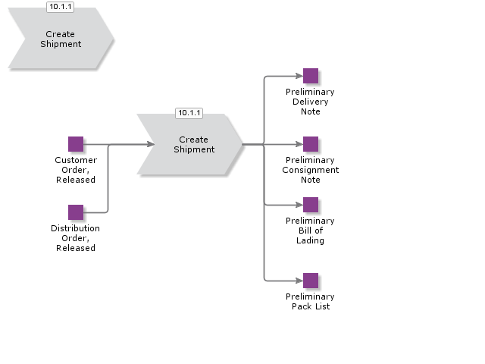

Handle Picking
This Sub process creates Pick List and the reported picked goods. You can choose wether you want to use Transport Task or not for the picking.
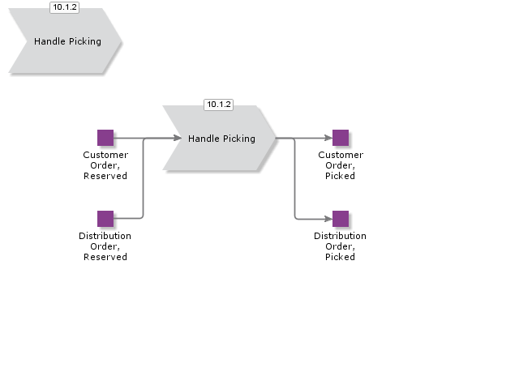

Packing of Goods

Deliver Customer Order

Deliver Customer Order Box Line (Retail ext)

Introduction
Write introduction here.

Objective
Write the objective here.

Background information
Write the background here.

Steps

Deliver Customer Order, Single Order Delivery, Pre-shipment Delivery Note

Introduction
Write introduction here.
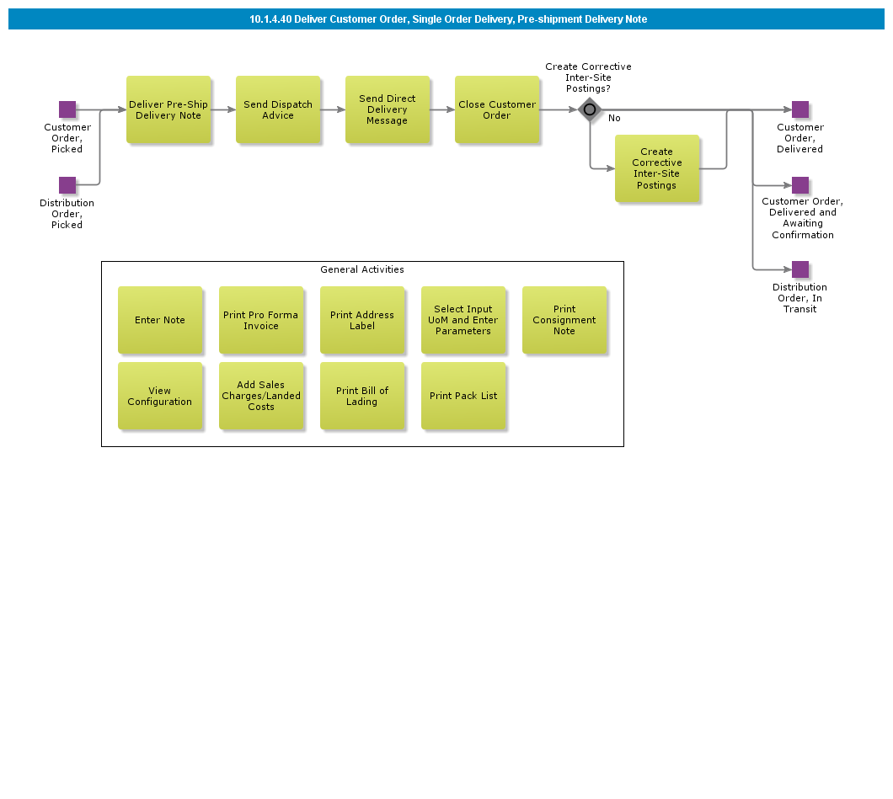

Objective
Write the objective here.

Background information
Write the background here.

Steps

Deliver Customer Order, Load List

Introduction
Write introduction here.
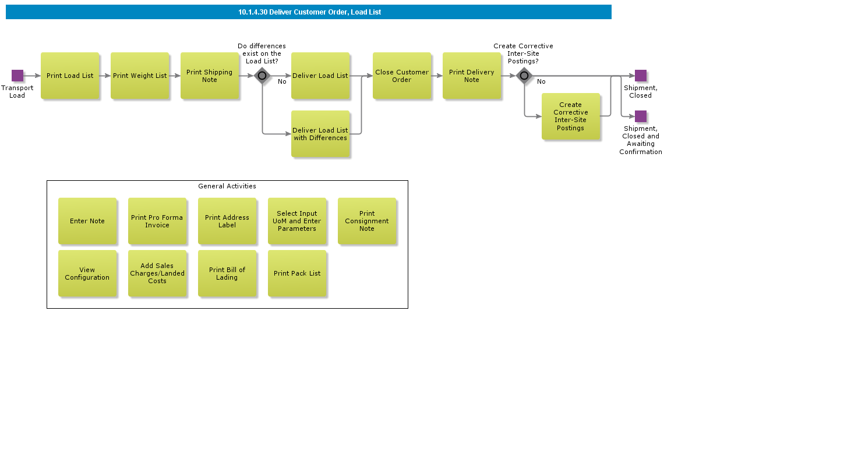

Objective
Write the objective here.

Background information
Write the background here.

Steps

Finalize Shipment

Introduction
Write introduction here.
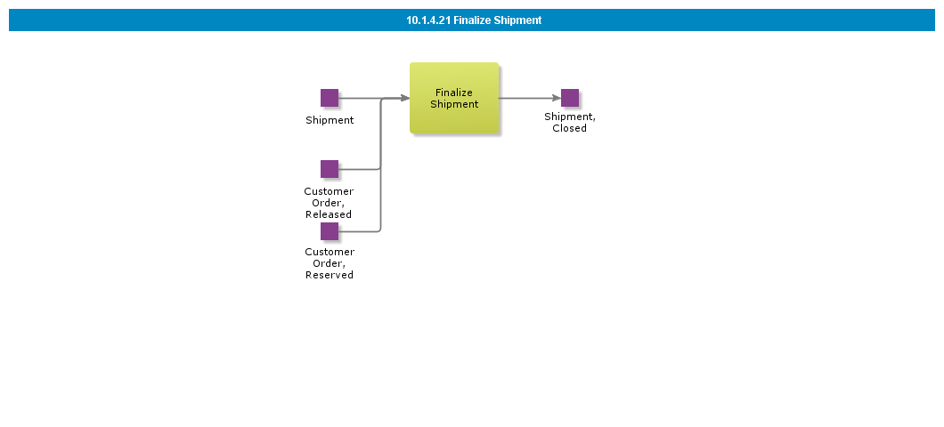

Objective
Write the objective here.

Background information
Write the background here.

Steps

Deliver Customer Order, Shipment

Introduction
Write introduction here.
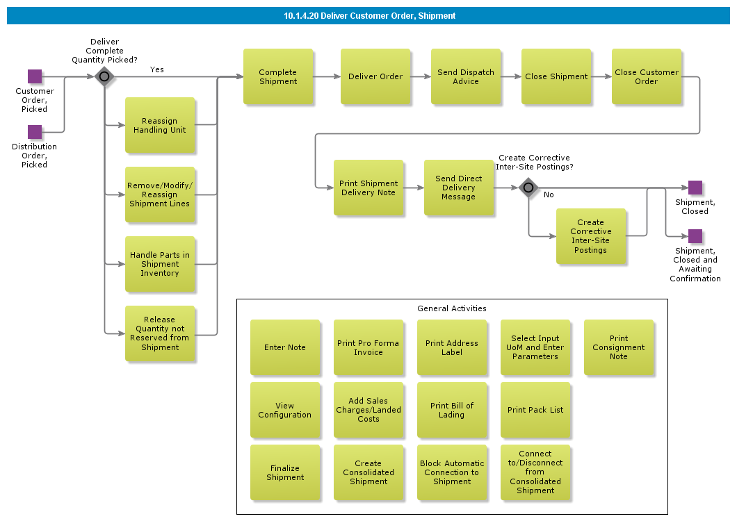

Objective
Write the objective here.

Background information
Write the background here.

Steps

Deliver Customer Order, Single Order Delivery

Introduction
Write introduction here.
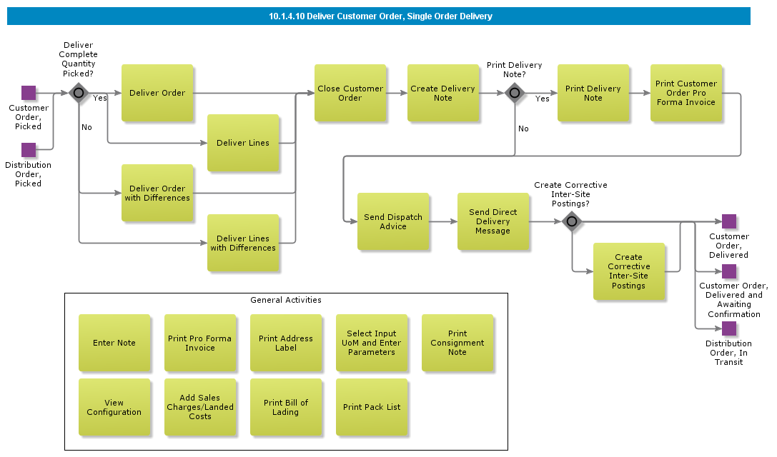

Objective
Write the objective here.

Background information
Write the background here.

Steps

Packing of Goods with Shipment

Introduction
Write introduction here.
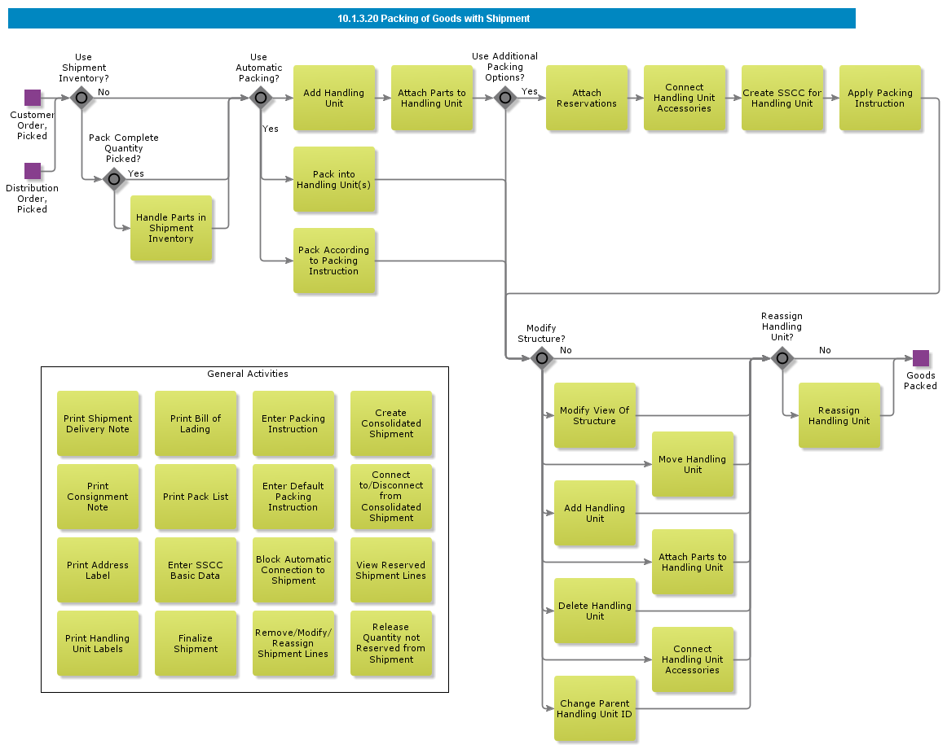

Objective
Write the objective here.

Background information
Write the background here.

Steps

Packing of Goods without Shipment

Introduction
Write introduction here.
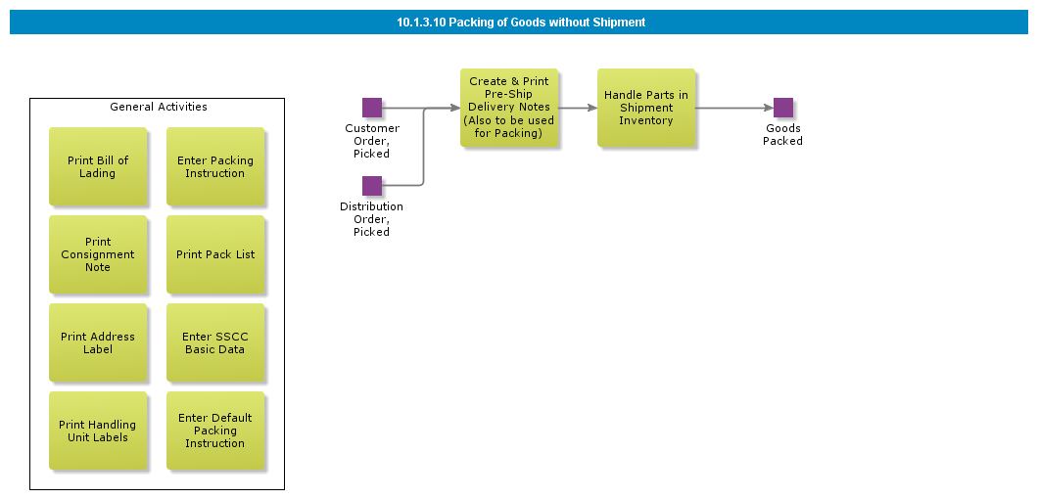

Objective
Write the objective here.

Background information
Write the background here.

Steps

Handle Picking of Boxes without Shipment (Retail ext)

Introduction
Write introduction here.

Objective
Write the objective here.

Background information
Write the background here.

Steps

Handle Picking with Shipment

Introduction
Write introduction here.
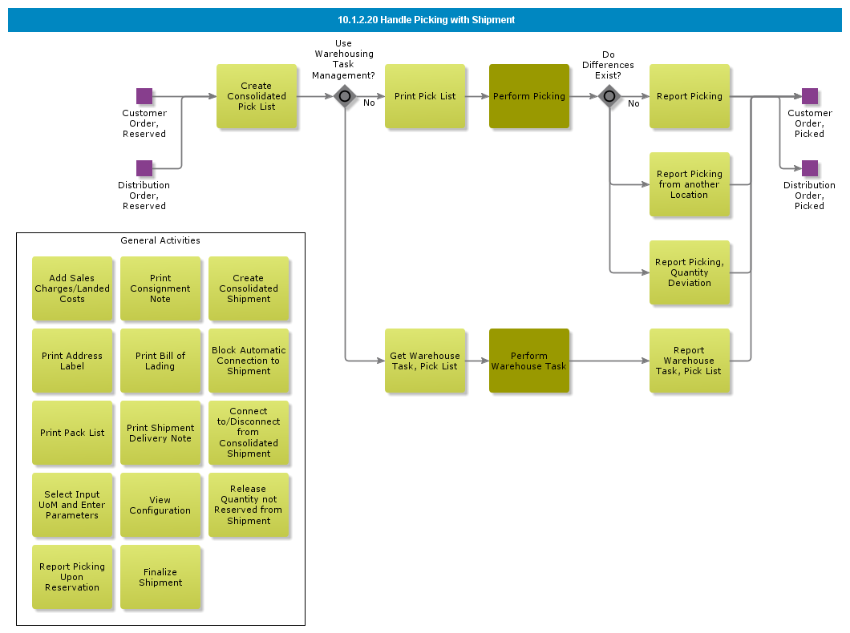

Objective
Write the objective here.

Background information
Write the background here.

Steps

Handle Picking without Shipment

Introduction
Write introduction here.
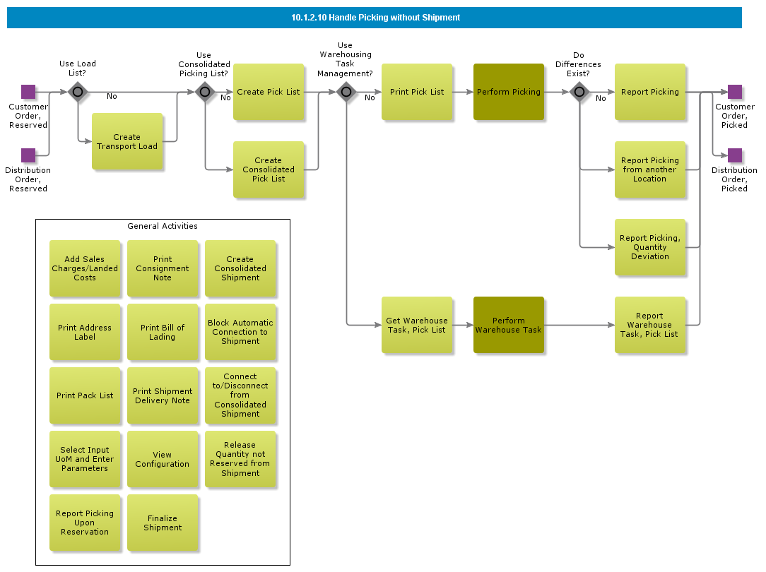

Objective
Write the objective here.

Background information
Write the background here.

Steps

Create Consolidated Shipment

Introduction
Write introduction here.
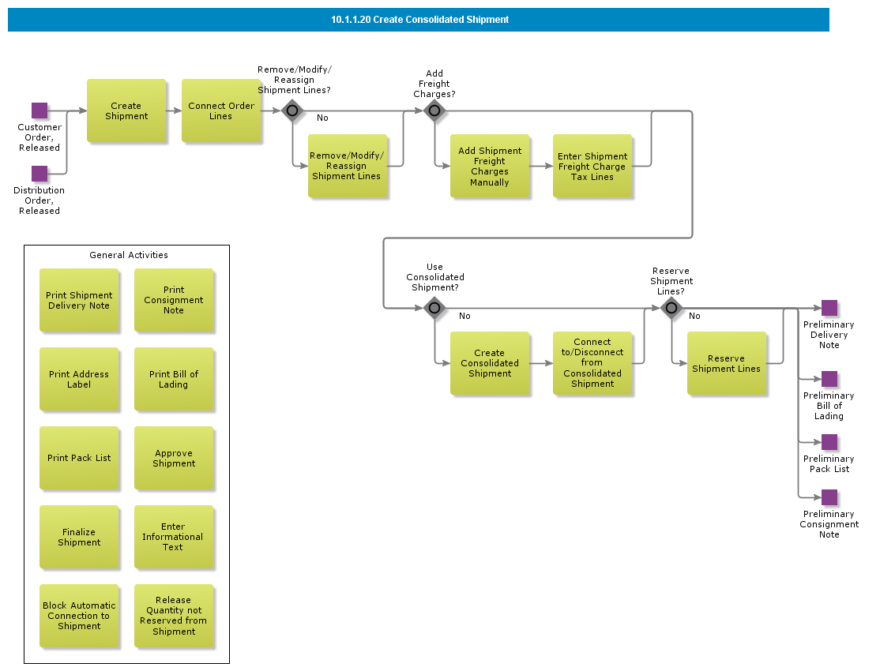

Objective
Write the objective here.

Background information
Write the background here.

Steps

Create Shipment

Introduction
Write introduction here.
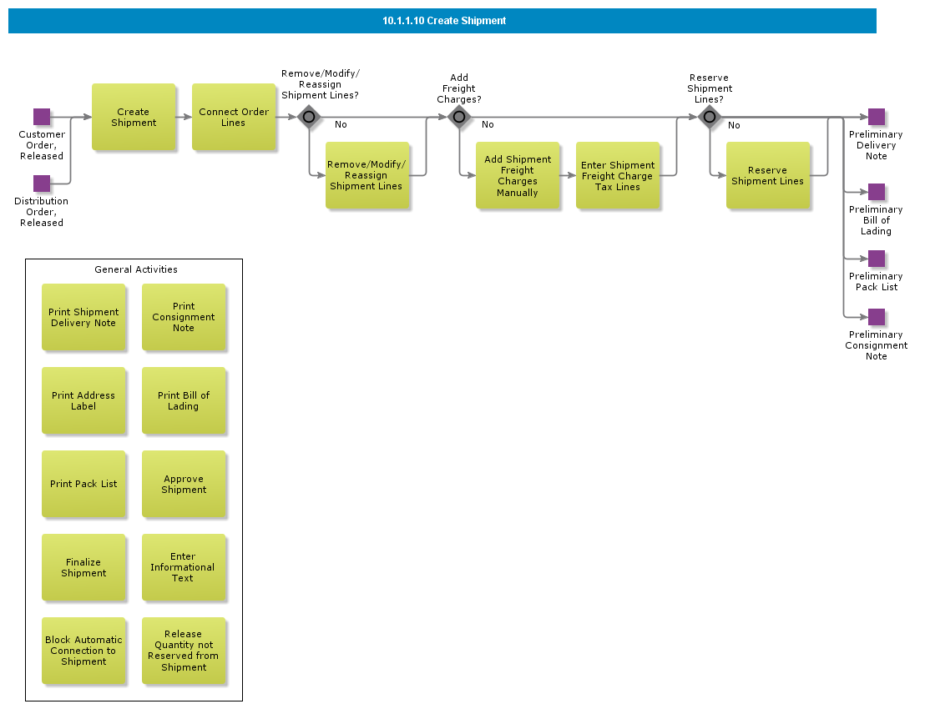

Objective
Write the objective here.

Background information
Write the background here.

Steps

BDR for SSCC

Introduction
Write introduction here.
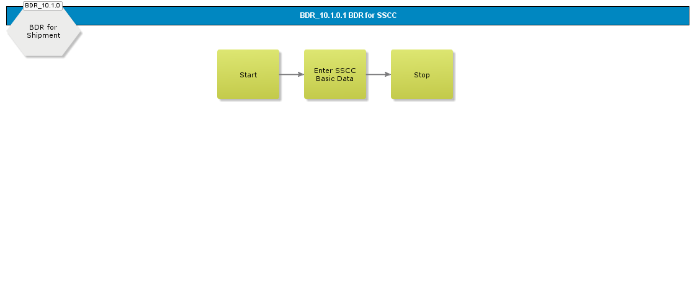

Objective
Write the objective here.

Background information
Write the background here.

Steps

BDR for Counting

Introduction
Write introduction here.
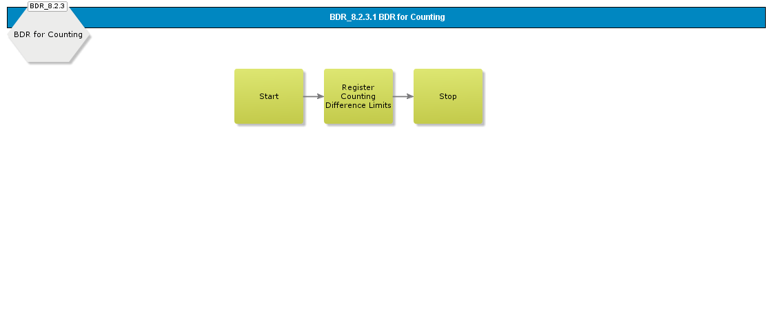

Objective
Write the objective here.

Background information
Write the background here.

Steps

Handle Counting without Count Report

Introduction
Write introduction here.
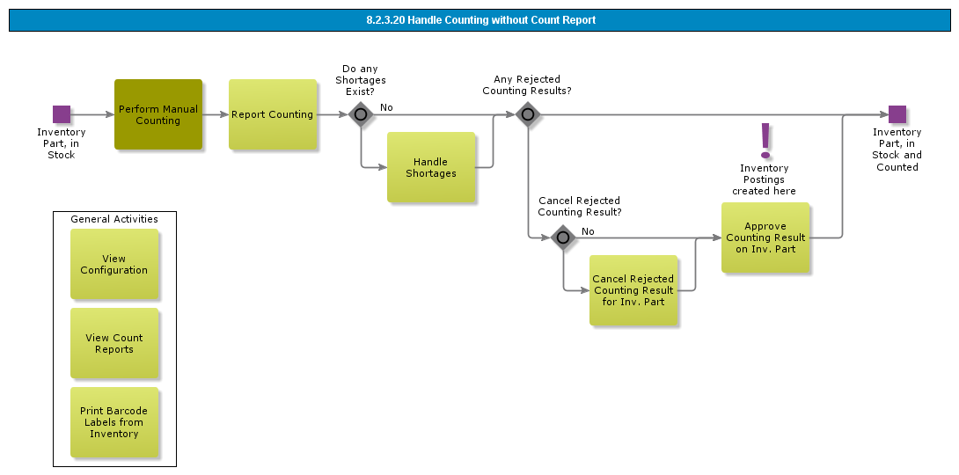

Objective
Write the objective here.

Background information
Write the background here.

Steps

Handle Counting using Count Report

Introduction
Write introduction here.
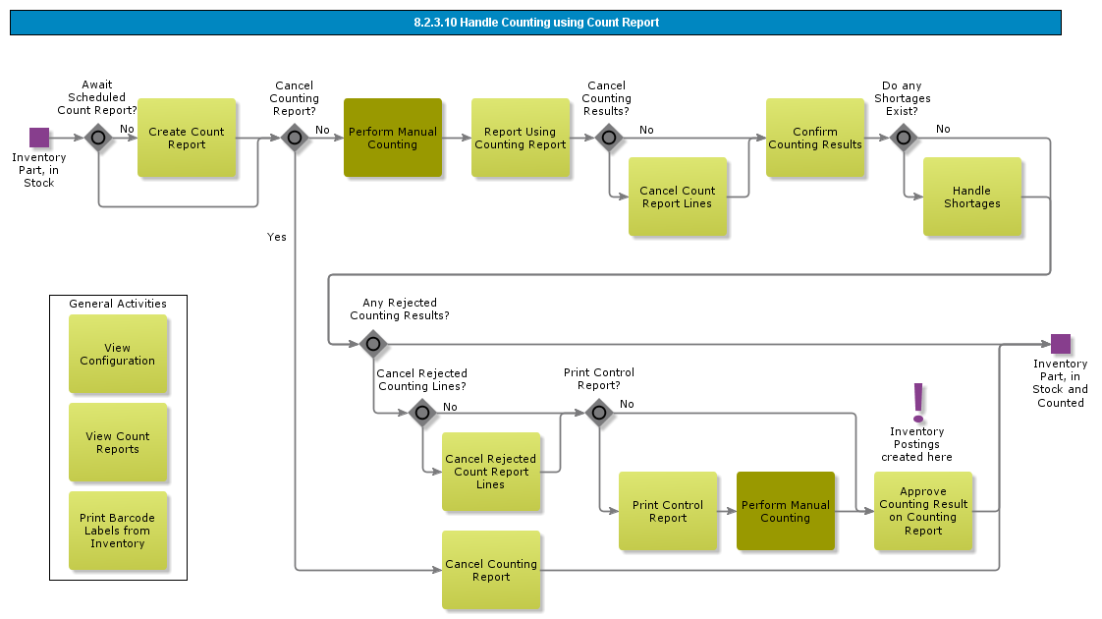

Objective
Write the objective here.

Background information
Write the background here.

Steps

Transfer To/From Project Inventory

Introduction
Write introduction here.

Objective
Write the objective here.

Background information
Write the background here.

Steps

Scrap from Stock

Introduction
Write introduction here.
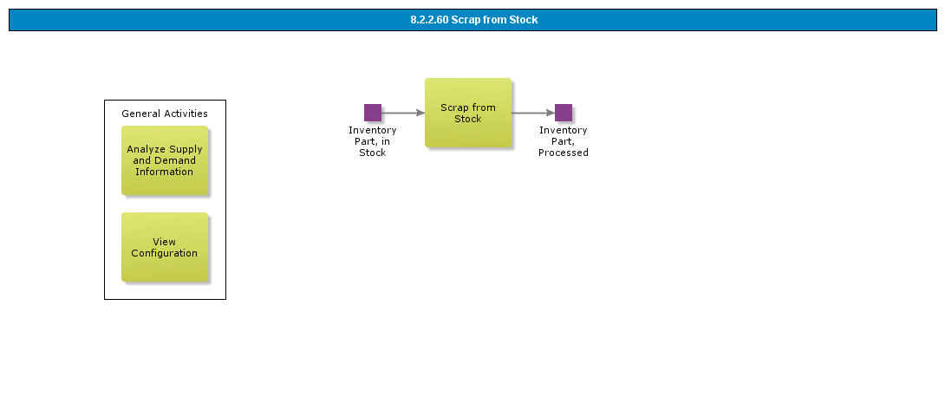

Objective
Write the objective here.

Background information
Write the background here.

Steps

Handle Direct Receipt, with Pallet handling

Introduction
Write introduction here.
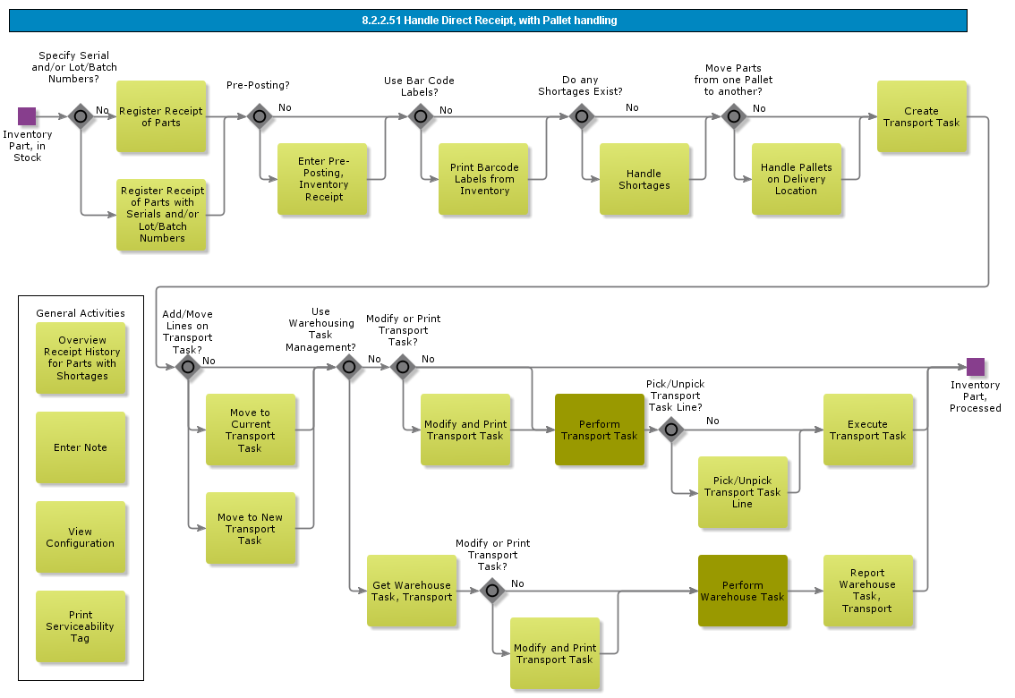

Objective
Write the objective here.

Background information
Write the background here.

Steps

Handle Direct Receipt, with No Pallet handling

Introduction
Write introduction here.
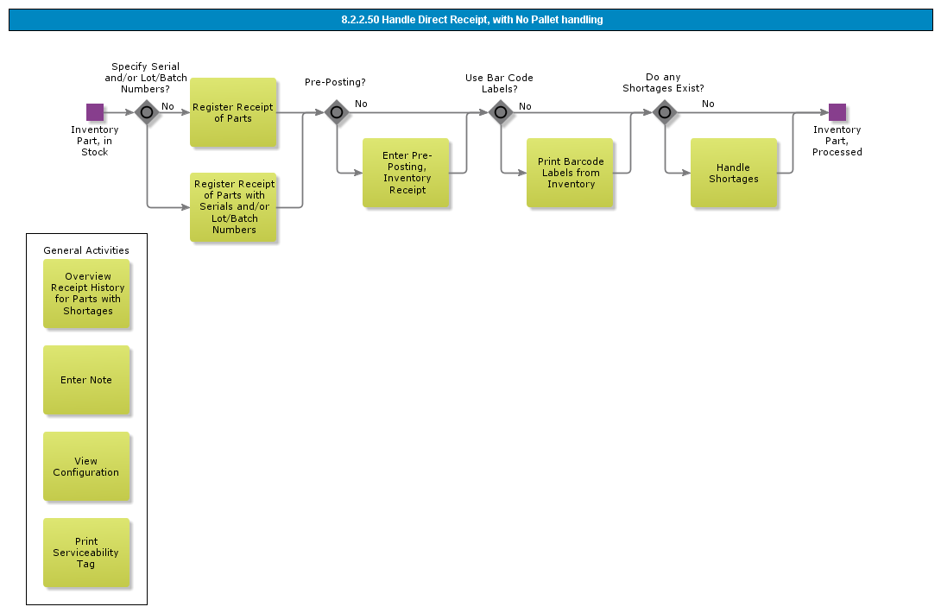

Objective
Write the objective here.

Background information
Write the background here.

Steps

Handle Direct Issue

Introduction
Write introduction here.
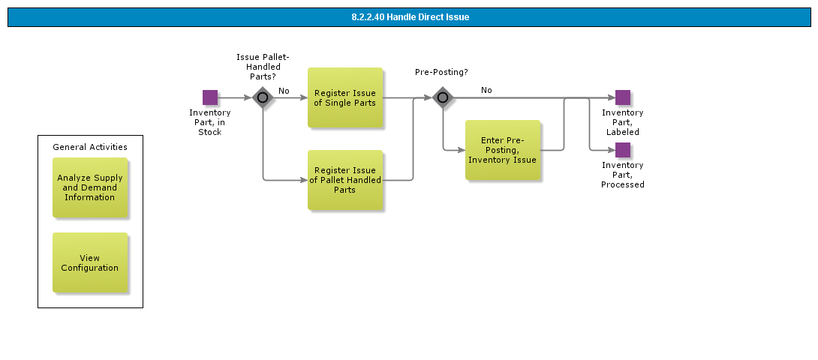

Objective
Write the objective here.

Background information
Write the background here.

Steps

Handle Barcodes

Introduction
Write introduction here.
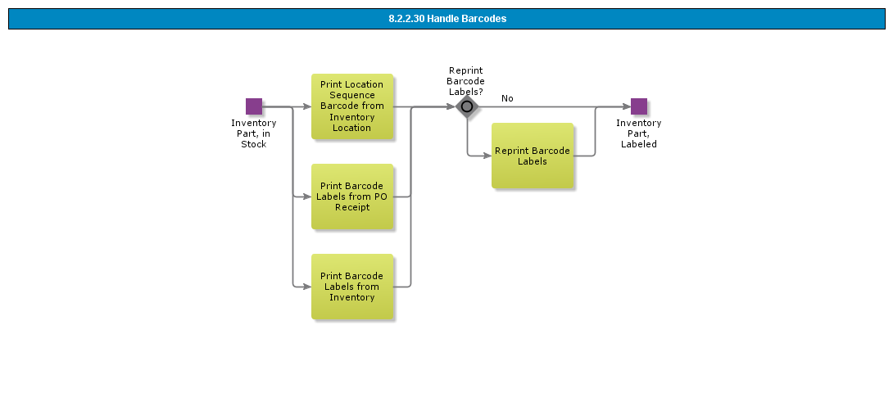

Objective
Write the objective here.

Background information
Write the background here.

Steps

Change Inventory Location, Transport Tasks

Introduction
Write introduction here.
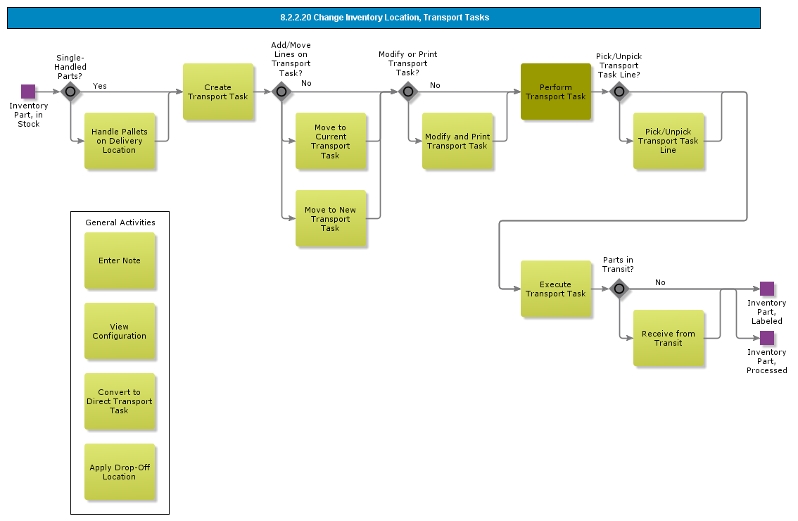

Objective
Write the objective here.

Background information
Write the background here.

Steps

Change Inventory Location

Introduction
Write introduction here.
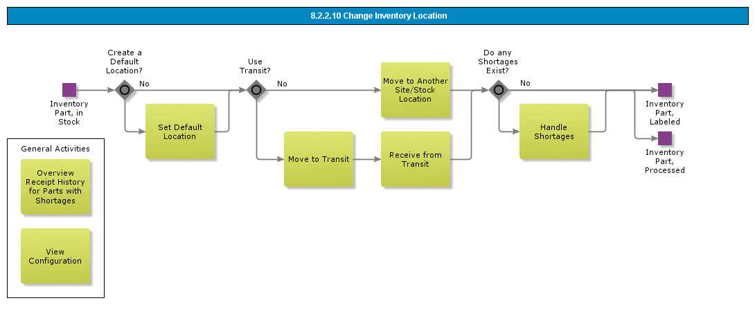

Objective
Write the objective here.

Background information
Write the background here.

Steps

Issue Material

Introduction
Write introduction here.
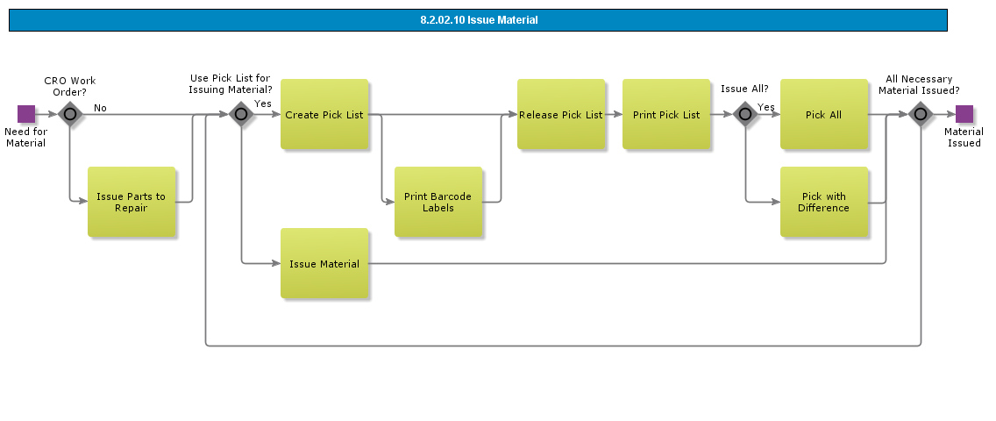

Objective
Write the objective here.

Background information
Write the background here.

Steps

Handle Material Requisition (std)

Introduction
Write introduction here.
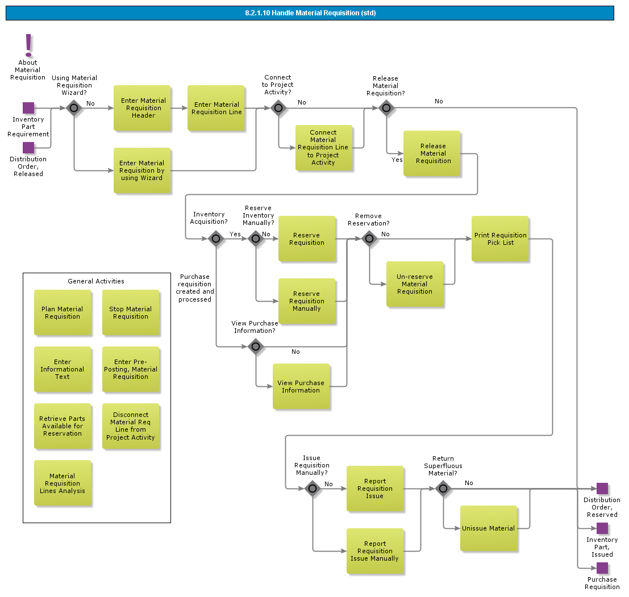

Objective
Write the objective here.

Background information
Write the background here.

Steps

BDR for Substance

Introduction
Write introduction here.
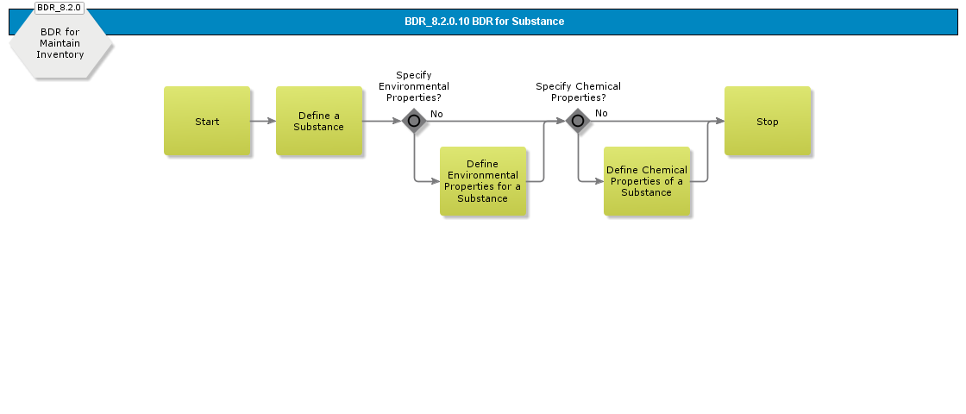

Objective
Write the objective here.

Background information
Write the background here.

Steps

BDR for Periodic Weighted Average

Introduction
Write introduction here.
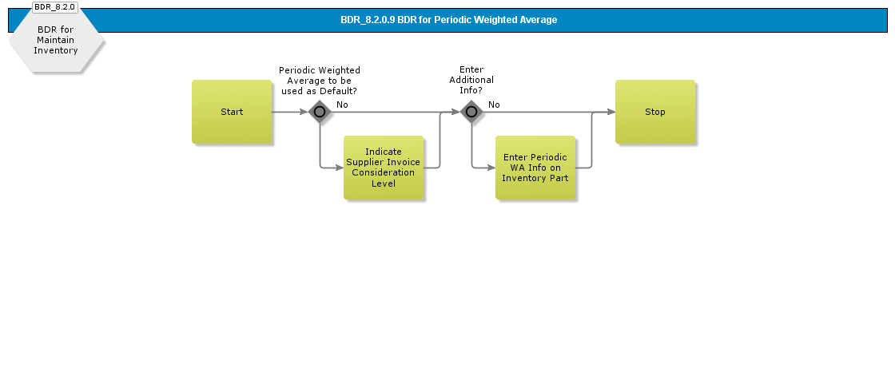

Objective
Write the objective here.

Background information
Write the background here.

Steps

BDR for Multiple UoM

Introduction
Write introduction here.
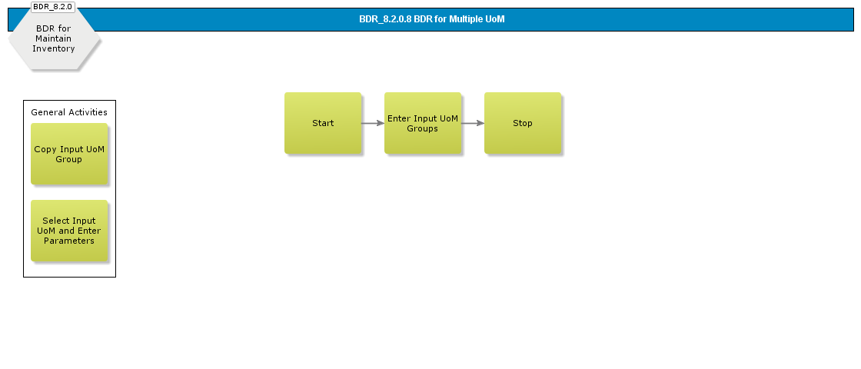

Objective
Write the objective here.

Background information
Write the background here.

Steps

BDR for Planning Hierarchy

Introduction
Write introduction here.
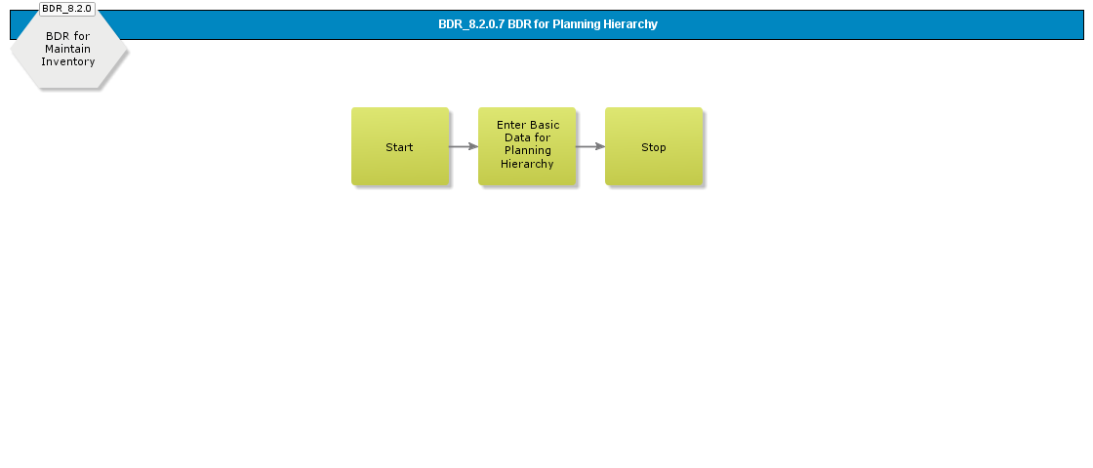

Objective
Write the objective here.

Background information
Write the background here.

Steps

BDR for Inventory Locations

Introduction
Write introduction here.
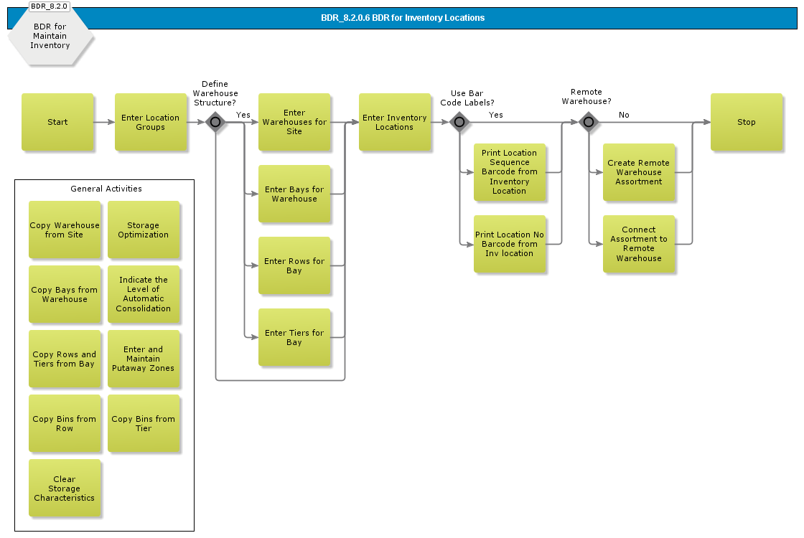

Objective
Write the objective here.

Background information
Write the background here.

Steps

BDR for Inventory

Introduction
Write introduction here.
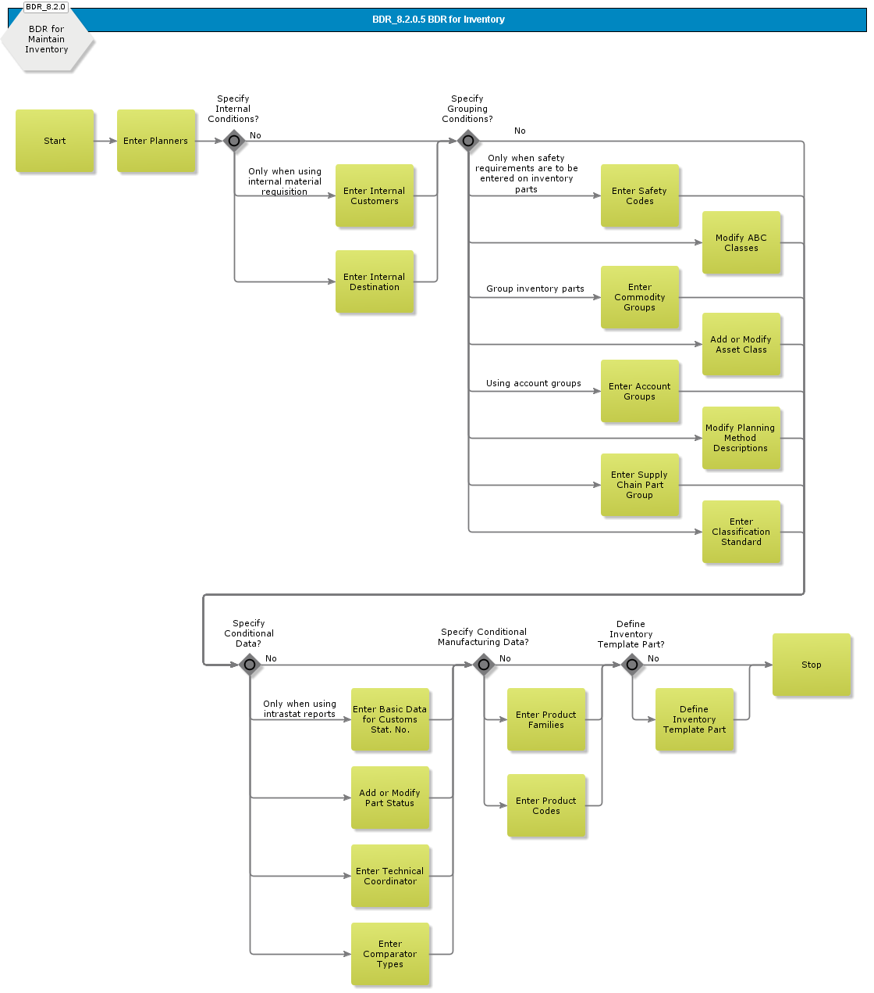

Objective
Write the objective here.

Background information
Write the background here.

Steps

BDR for Handling Units

Introduction
Write introduction here.
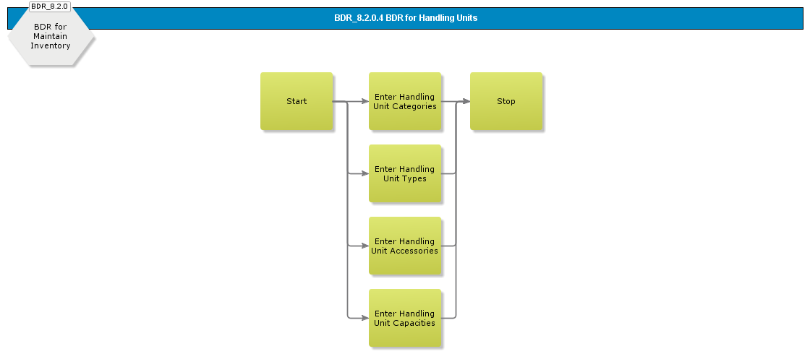

Objective
Write the objective here.

Background information
Write the background here.

Steps

BDR for Externally Owned Stock

Introduction
Write introduction here.
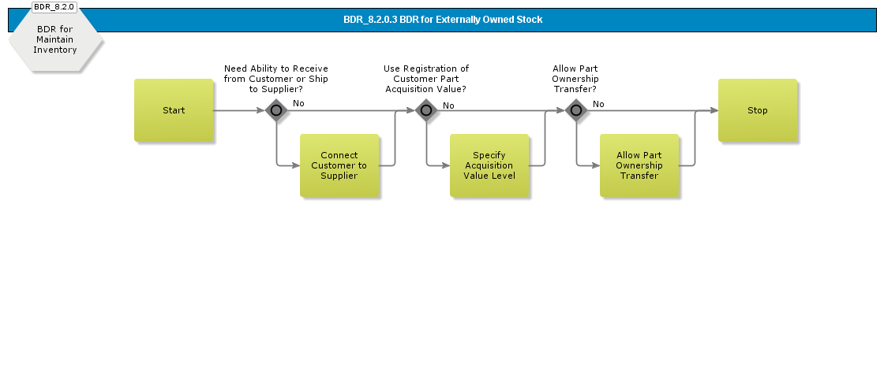

Objective
Write the objective here.

Background information
Write the background here.

Steps

BDR for Availability Control

Introduction
Write introduction here.
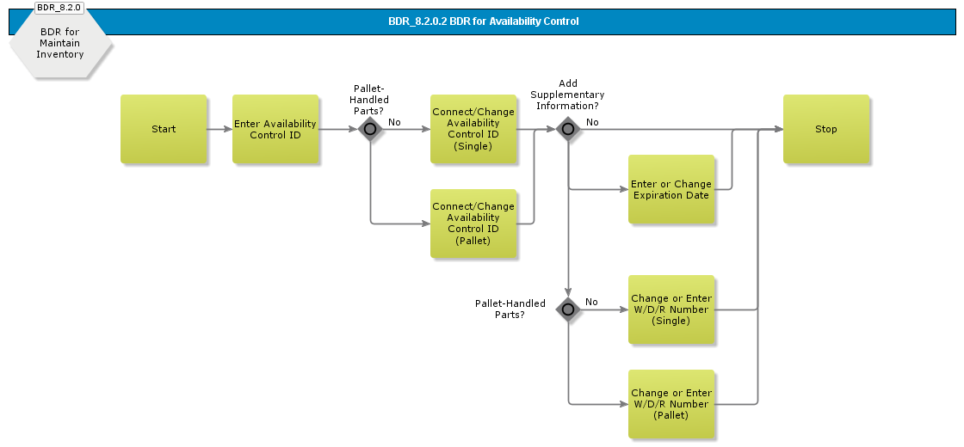

Objective
Write the objective here.

Background information
Write the background here.

Steps

BDR for Automatic Interchange of Planning Method

Introduction
Write introduction here.
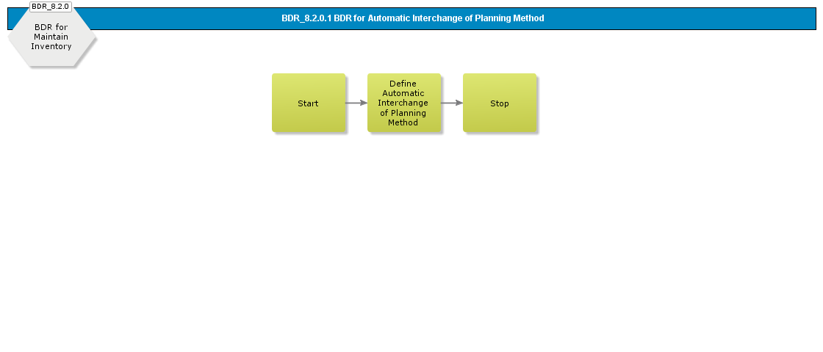

Objective
Write the objective here.

Background information
Write the background here.

Steps

Handle Receipt for Direct Delivery

Introduction
Write introduction here.
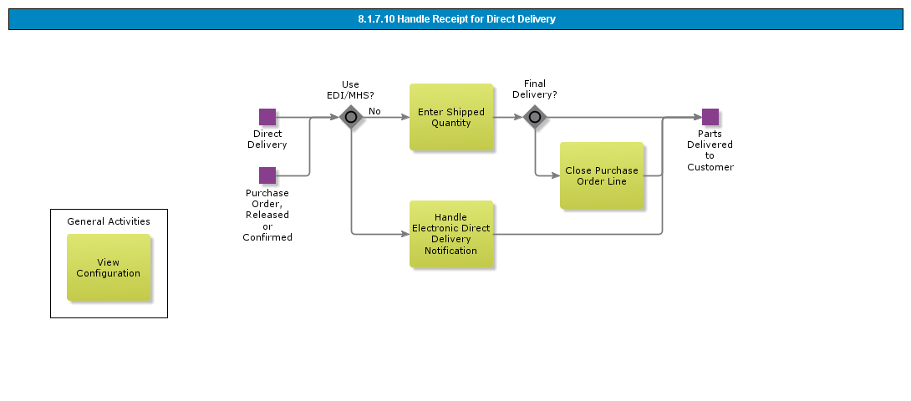

Objective
Write the objective here.

Background information
Write the background here.

Steps

Move into Stock with Pallet Handled Parts

Introduction
Write introduction here.

Objective
Write the objective here.

Background information
Write the background here.

Steps

Move into Stock with No Pallet Handled Parts

Introduction
Write introduction here.
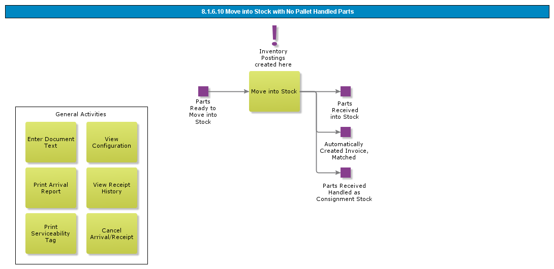

Objective
Write the objective here.

Background information
Write the background here.

Steps

Handle Arrival

Introduction
Write introduction here.
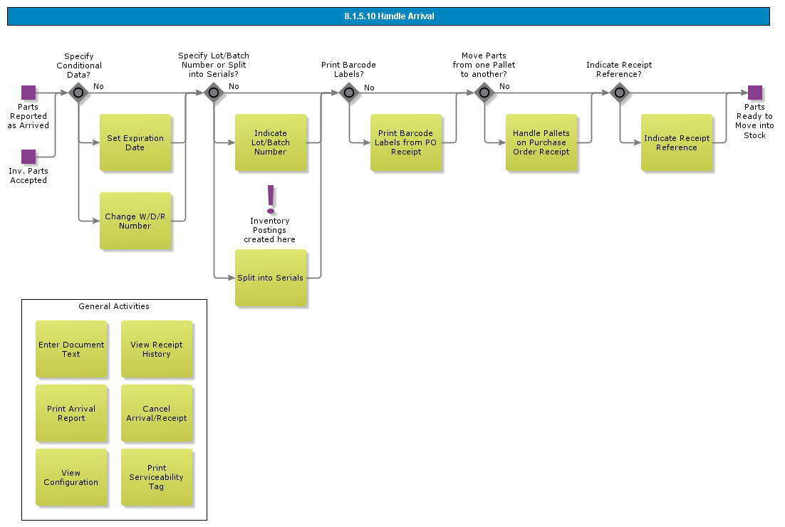

Objective
Write the objective here.

Background information
Write the background here.

Steps

Perform Quality Inspection & Handle Discrepancies

Introduction
Write introduction here.
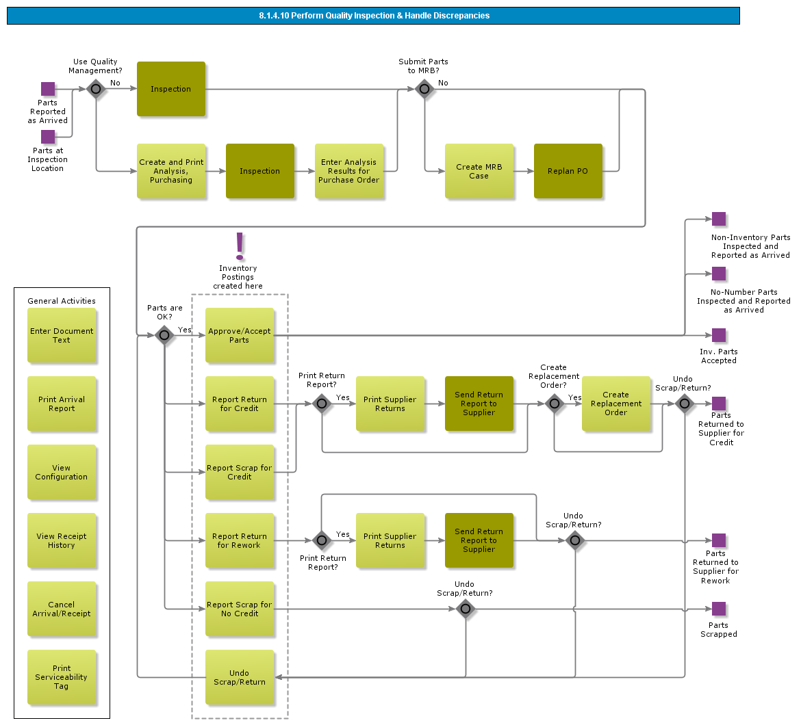

Objective
Write the objective here.

Background information
Write the background here.

Steps

Move Into Inspection Location with Pallet Handled Parts

Introduction
Write introduction here.

Objective
Write the objective here.

Background information
Write the background here.

Steps

Move Into Inspection Location with No Pallet Handled Parts

Introduction
Write introduction here.
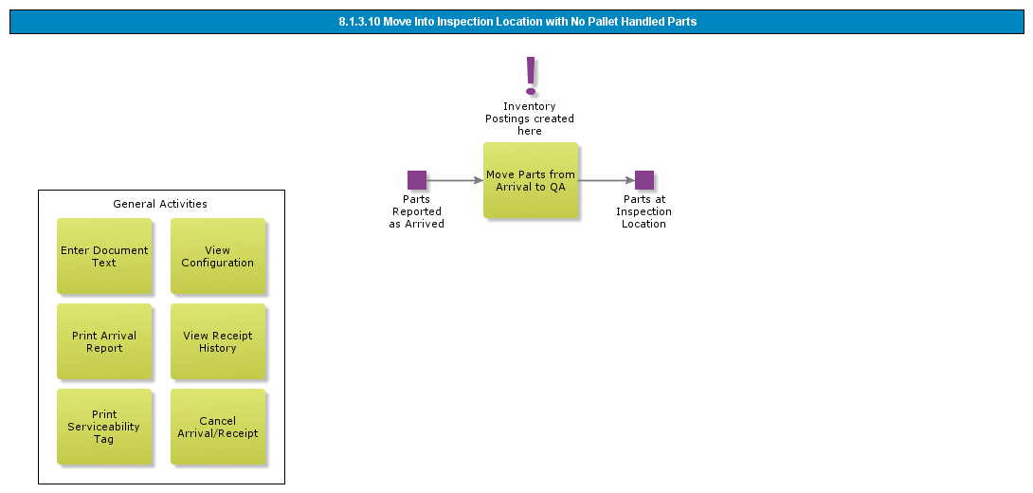

Objective
Write the objective here.

Background information
Write the background here.

Steps

Report Arrival, Component MRO

Introduction
Write introduction here.
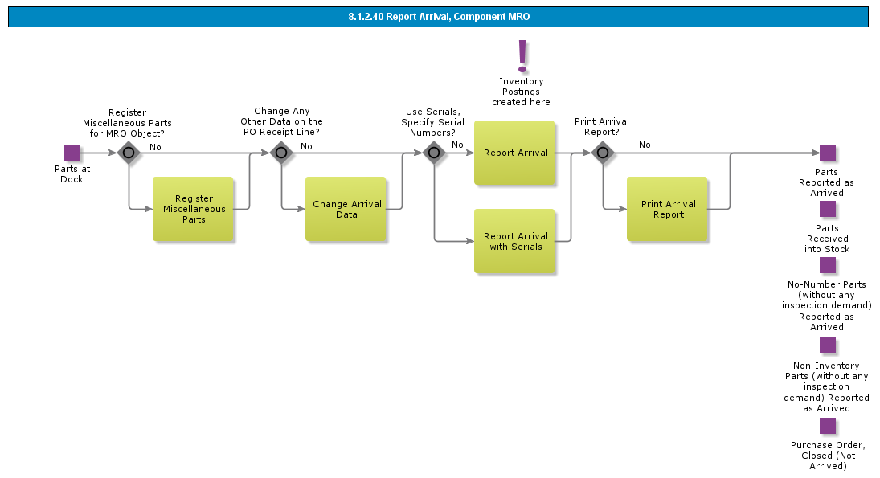

Objective
Write the objective here.

Background information
Write the background here.

Steps

Report Direct Receipt of No-Number Parts

Introduction
Write introduction here.
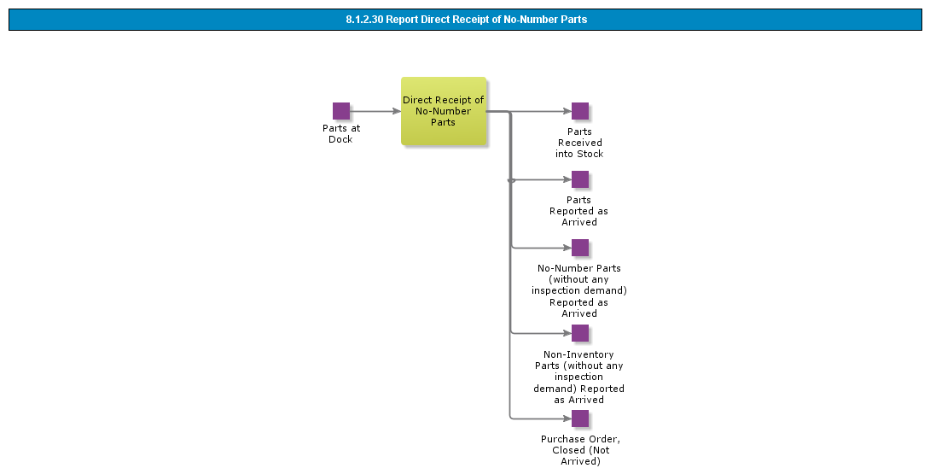

Objective
Write the objective here.

Background information
Write the background here.

Steps

Report Arrival Using Dispatch Advice

Introduction
Write introduction here.
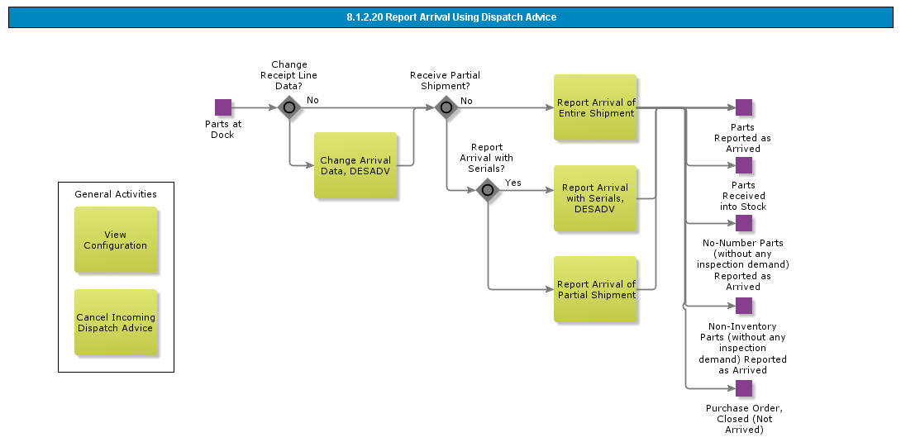

Objective
Write the objective here.

Background information
Write the background here.

Steps

Report Arrival

Introduction
Write introduction here.
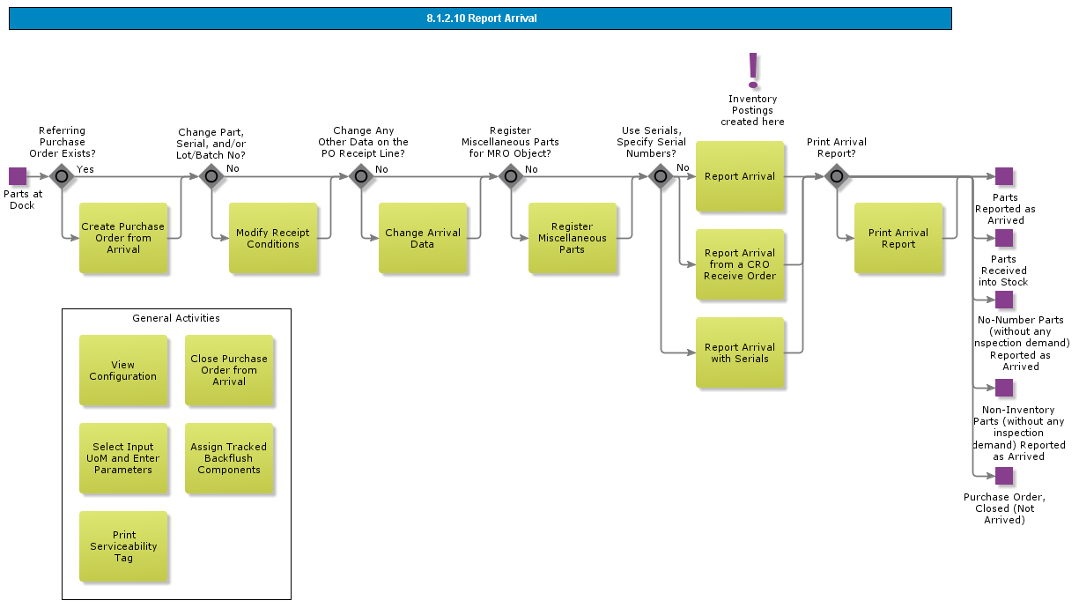

Objective
Write the objective here.

Background information
Write the background here.

Steps

BDR for Warehousing

Introduction
Write introduction here.
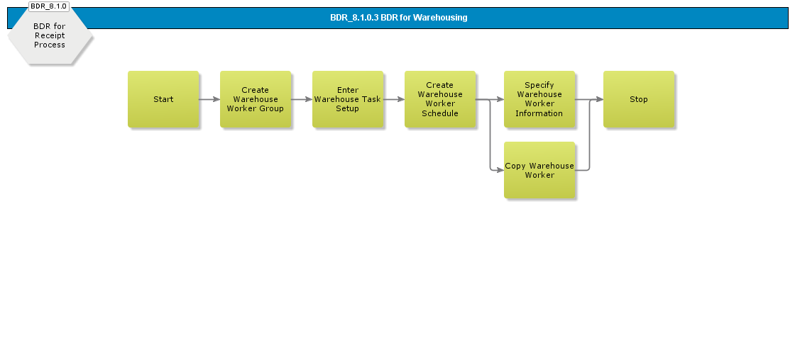

Objective
Write the objective here.

Background information
Write the background here.

Steps

BDR for Receipt, Pallets

Introduction
Write introduction here.
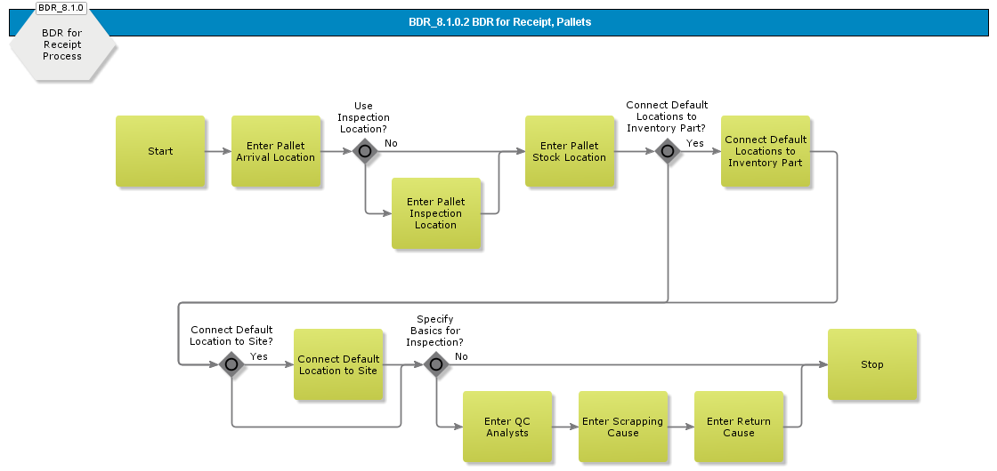

Objective
Write the objective here.

Background information
Write the background here.

Steps

BDR for Receipt

Introduction
Write introduction here.
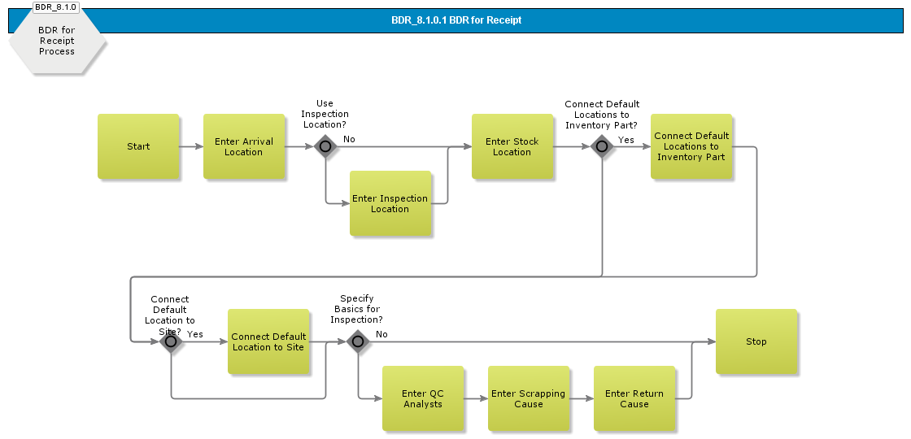

Objective
Write the objective here.

Background information
Write the background here.

Steps

Acme Financial Management

Acme Process AR - Customer Invoicing
The Purpose of this process is handling relevant Customer Invoicing capabilities.

Customer Order Invoicing
Invoicing customer orders normally takes place towards the end of the customer order flow. The goods ordered have to be fully or partially delivered before invoicing is carried out. The order can be invoiced either manually or automatically.

Normal invoice - generated for every order.

- Collective invoice- generated for a group of customer orders.
- Credit Invoice

The Customer Order Invoicing Process can be supported in multiple ways, for example,

- Advance Invoicing - Customer order invoices can be prepared even before the goods are delivered.
- Prepayment Based Invoicing - Prepayment-based invoices are created before the goods are delivered, but unlike advance invoices, prepayment-based invoices are created only after a prepayment for a customer order has been received
- Shipment Invoicing - Shipments can be invoiced as one entity. We create an invoice on the complete shipment, instead of one for each delivered order
- Self Billing - occurs when a customer creates an invoice for himself and thereby eliminates the need for the supplier to create and send him an invoice in order to receive payment for deliveries.
- Stage Billing - can be used whenever an order is to be paid in multiple stages. This functionality enables you to invoice an order at any stage in the order flow, not just after delivery.
- Correction Invoice - When a correction invoice is created, the system automatically creates two lines for each debit line of the reference invoice.

Manage Customer Invoice Output

Queries Invoicing
The Follow-up and Analysis process contains the following queries:

- The Customers window is used to obtain a general idea of the company's customers. You can quickly obtain information on each customer's balances, due amounts, open pre-payments, etc.
- The Customer Analysis window is used to view detailed information about a certain customer or party ID. The window contains detailed information about all invoices and due amounts, as well as invoice/pre-payment dates, etc.
- The Customer Invoices Analysis window is used to obtain information about customer invoices, both unpaid and paid.
- The Customer Invoice Analysis window states detailed information about customer, invoice details, payments and discount, voucher, etc. The window is divided into six different tabs.
- The Customer Invoices Analysis window is used to view all entered customer invoices, e.g., instant invoices and customer invoices. This includes invoices created by other parts of IFS Applications, e.g., IFS Distribution. Both paid and unpaid. Preliminary posted and finally posted are displayed.
- The Customer Invoices Due for Payment Analysis window is used to view or query for all customer invoices due for payment. You can view instant invoices, customer invoices, and invoices loaded through external files.
- The Customer Analysis window is used to view detailed information about a specific customer invoice. You can enter customer credit management header and line notes to exclude a whole invoice or specific lines from being included in customer credit management calculations.
- The Customer Invoice Postings Analysis window is used for obtaining a general idea of customer invoice postings and for viewing invoices that are printed via the printout function. If an error arose in connection with printing so that no voucher was created, the lines are error marked.

Reports Invoicing
The Follow-up and Analysis process contains the following reports:

- The Customer Invoice Journal shows customer invoices per invoice series and invoice date. The customer invoices created since the last printout are shown in the report.
- The Tax report - Sales is used as a basis for filling in quarterly reports for Tax. The report shows invoicing per customer in another EU country.
- The Customer Statement of Account states all transactions per selected customer and period.

Acme Process AR - Customer Payment
The Purpose of this process is to handle customer payments. The customer payment process includes functionality for manual payment, payment on File, Check payment and Bill of Exchange payments. For the business manual payment and payment on file might be relevant. When a payment is saved a voucher is automatically generated based on the set up of accounting rules. The voucher contains postings for customer claims, cash transactions, bank fees and currency differences.

- The system allows the entry of multi company customer payments and to use deduction. This is a function that covers payments where customer invoices are produced and stored in several individual companies, but customer payments are received and entered in only one company.

BDR for Customer Payments

Customer Payment, Manually matched Payment Specification
The Customer Payment process is used for entering customer payments through the various payment institutes.

Offsets can be entered at the same time as payments.

These can be offsets between debit and credit invoices, between invoices and payments on account or between invoices and payments in advance.

When you save a payment, a voucher is generated automatically to the hold table in IFS/Accounting Rules.

The voucher belongs to voucher group B and contains postings for customer claims, cash transactions, bank fees and currency differences..

- The system allows the entry of multi company customer payments and to use deduction. This is a function that covers payments where customer invoices are produced and stored in several individual companies, but customer payments are received and entered in only one company. A benefit of this is that a group of companies can use centralized cash application.

Customer Payment on File
The Customer Payments on File process is used to create customer payments out of electronic files received from various payment institutes. An agreement exists between the company and the payment institute regarding the electronic payment files service. Each electronic file contains payment information and matching information for a specific account and currency on existing invoices in Accounts Receivable.
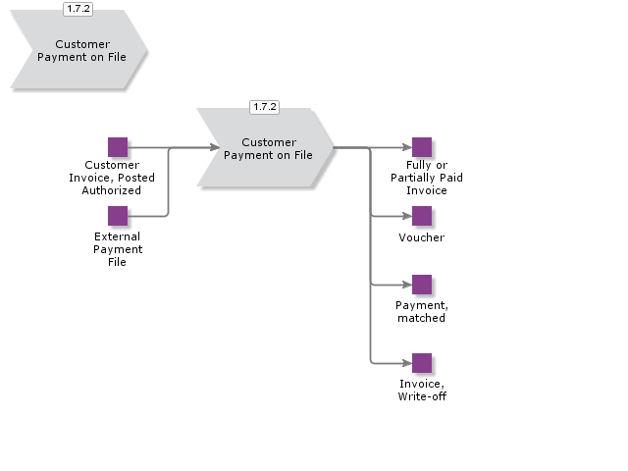

Customer Direct Debiting, Create Payment Order
The Customer Direct Debiting process is used for carrying out automatic customer payments to the customer's account. The process starts with generating a customer payment proposal i.e. a direct debiting proposal based on, for example payment date interval, currency, customers to be covered and payment method.
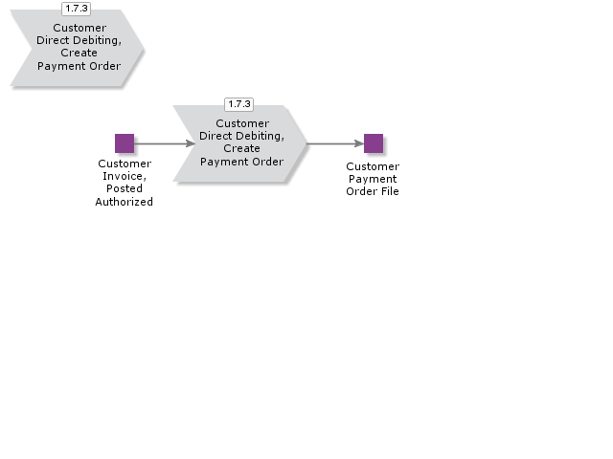

Customer Repayment Process, Create Repayment Order
The Customer Repayment process is used for carrying out automatic customer payments to the customer's account. The process starts with generating a customer payment proposal i.e. a repayment proposal based on, for example payment date interval, currency, customers to be covered and payment method.
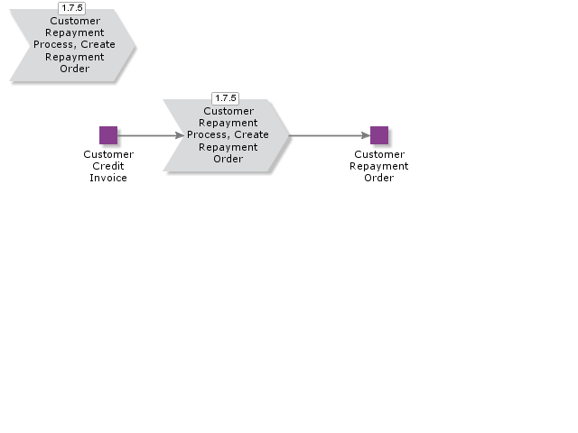

Acknowledge and Create Customer Payments
Payments are created within the system when acknowledging a customer payment, i.e. when the payments have been implemented adhering to documentation received from the payment institutes.
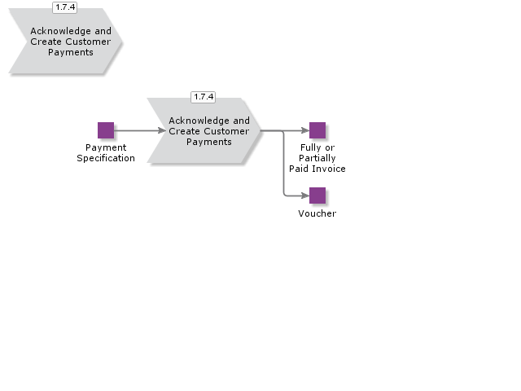

Acme Process AP - Supplier Invoice Management
The Supplier Invoicing process is used to enter and post supplier invoices, update the supplier ledger with supplier invoices created in an external (non-IFS) system, and view information on suppliers and supplier invoices.

The Supplier Invoicing process is divided into three processes:

- Enter and Post Supplier Invoice
- External Supplier Invoices on File
- Follow-up and Analysis, Supplier Invoice

BDR for Supplier Invoice, Enter and Post

Receive or Enter Supplier Invoice

Purchase Order Receipt Matching

Post Supplier Invoice

Authorize Supplier Invoice for Payment

Cancel Supplier Invoices

Acme Process AP - Supplier Payment
Use this process to manage transactions in connection with supplier payments.

The process contain functions for handling Automatic Supplier Payments via file, manual supplier payments, check payments, supplier bill of exchange payments, supplier payments loaded via file.

Netting between customer and supplier is possible, but only if netting has been agreed upon.

The process also contain functions for supplier offsets, for example offset between debit and credit invoices.

If for some reason cancellation of payment is needed it can be handled.

There is sub process where you find information on follow -up and Analysis such as queries and reports..

The Supplier Payments process is divided into following sub processes.

- Automatic Supplier Payment on File
- Manual Supplier Payment
- Automatic Supplier Check Payment
- Manual Supplier Check Payment
- Automatic Supplier Bill of Exchange Payment
- Manual Supplier Bill of Exchange Payment
- External Supplier Payment on File
- AP/AR Nettings
- Follow-up and Analysis, Supplier Payment

BDR for Supplier Payments

Manual Supplier Payment
The Manual Supplier Payment process is used to enter details of your company’s manual payments and manual check payments to the suppliers through the various payment institutes.

Offsets can be entered at the same time as the payments.

These can be offsets between debit and credit invoices or between invoices, payments on account and payments in advance.

You can also process invoices that have been placed as parked payments and enter these as paid.

When you enter a manual payment, a voucher is generated automatically to the hold table in IFS/Accounting Rules.

This is updated to the general ledger in connection with the next update.

If payment cancellation is needed there are functions for undoing a whole payment or part of a payment.

Undoing means that you post invoices and prepayments as unpaid..
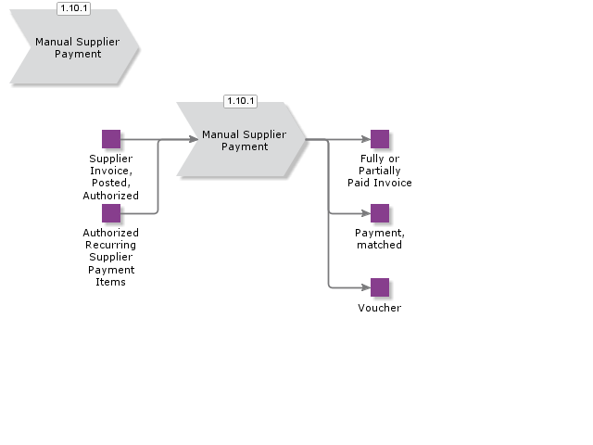

Supplier Interest Payment

Cancel Supplier Payment

Cancel Supplier Bill of Exchange Payment

Introduction
Write introduction here.

Objective
Write the objective here.

Background information
Write the background here.

Steps

Reverse Cashed Supplier Check

Introduction
Write introduction here.

Objective
Write the objective here.

Background information
Write the background here.

Steps

Cancel Supplier Payment

Introduction
Write introduction here.
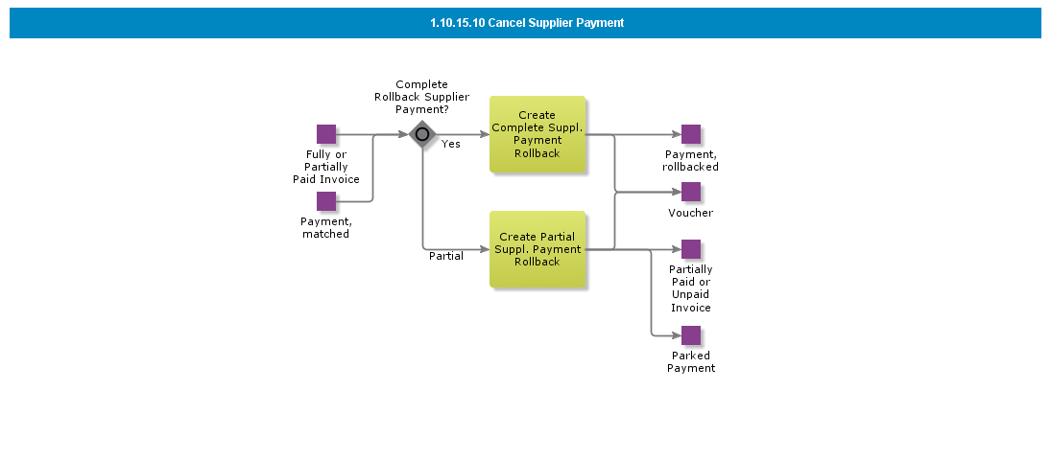

Objective
Write the objective here.

Background information
Write the background here.

Steps

Calculate Supplier Interest Provision

Introduction
Write introduction here.
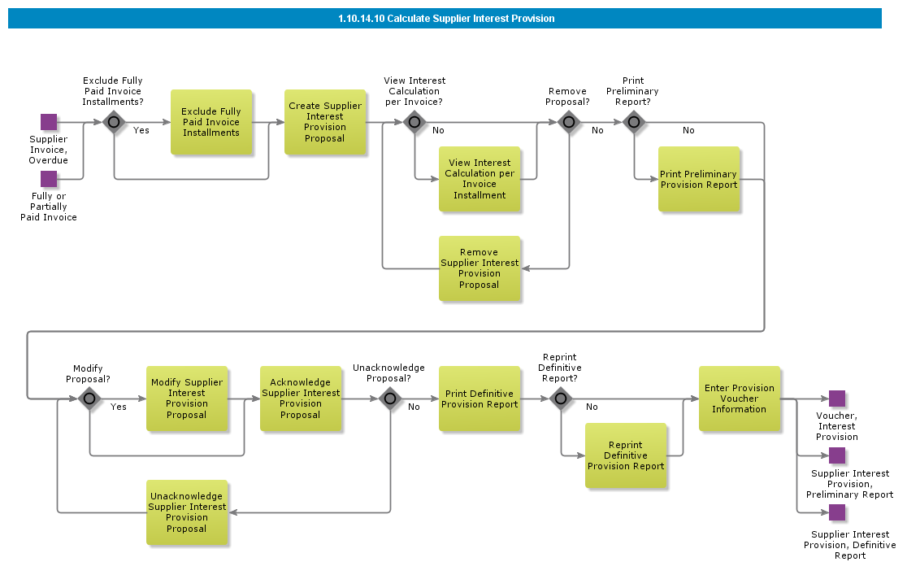

Objective
Write the objective here.

Background information
Write the background here.

Steps

Enter and Match Supplier Payment

Introduction
Write introduction here.
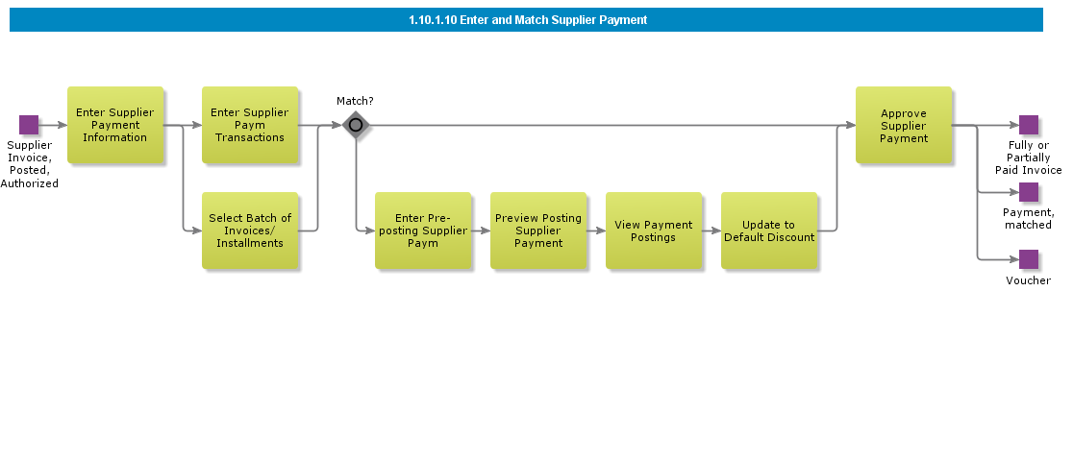

Objective
Write the objective here.

Background information
Write the background here.

Steps

BDR for External Payment Recipient

Introduction
Write introduction here.
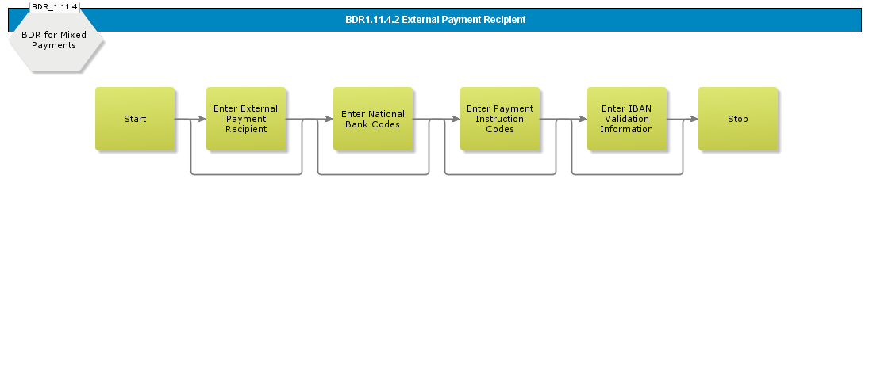

Objective
Write the objective here.

Background information
Write the background here.

Steps

Specify Stamp Duty Info for Supplier Bills of Exchange

Introduction
Write introduction here.
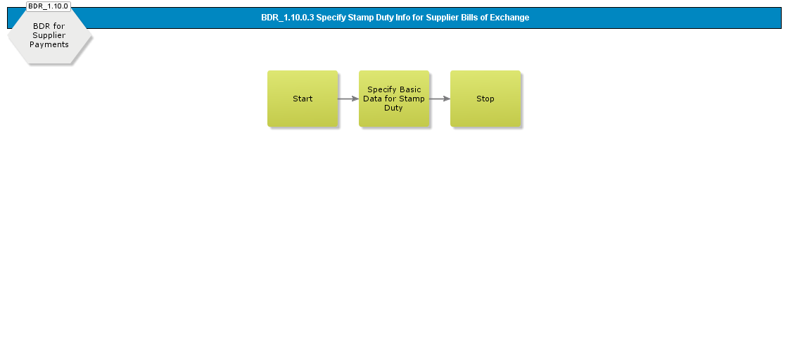

Objective
Write the objective here.

Background information
Write the background here.

Steps

Enter Basic Data and Set Up Reports for Central Bank Reporting

Introduction
Write introduction here.
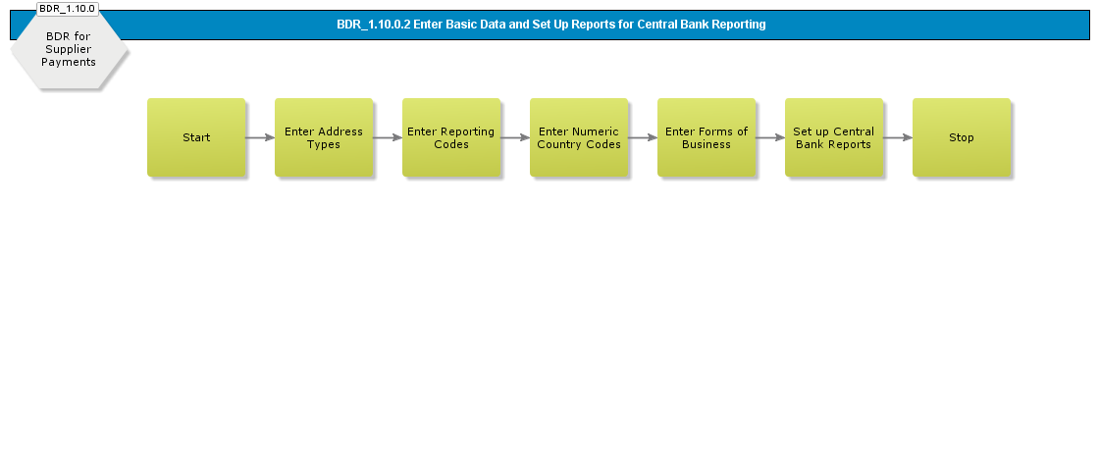

Objective
Write the objective here.

Background information
Write the background here.

Steps

Define External Clearing System Identification Codes

Introduction
Write introduction here.
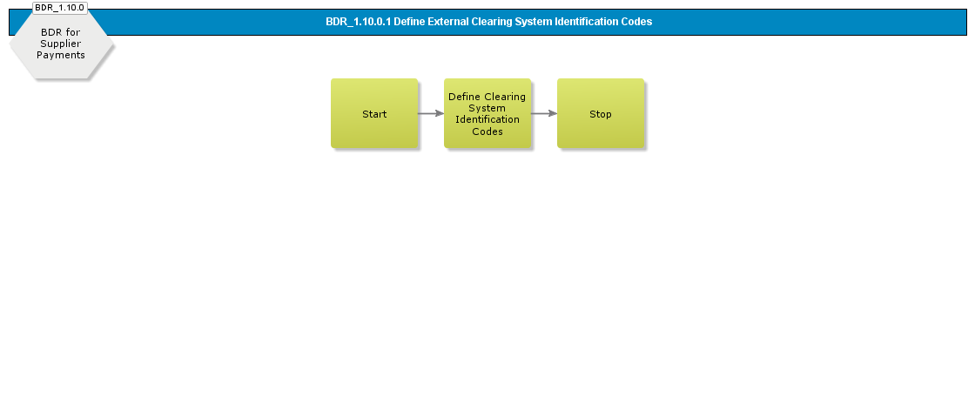

Objective
Write the objective here.

Background information
Write the background here.

Steps

Cancel Supplier Invoices

Introduction
Write introduction here.
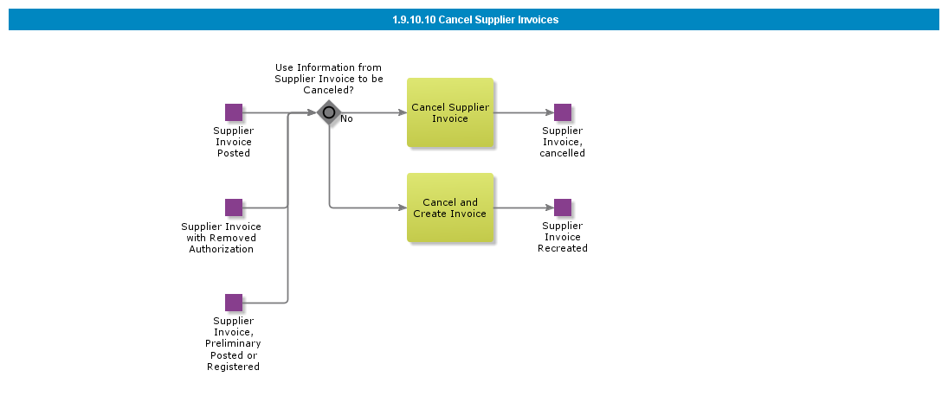

Objective
Write the objective here.

Background information
Write the background here.

Steps

Authorize Supplier Invoice for Payment

Introduction
Write introduction here.
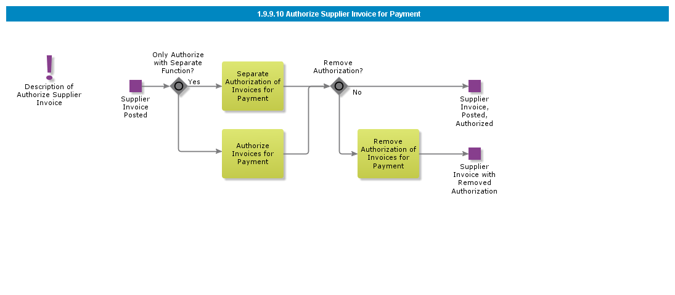

Objective
Write the objective here.

Background information
Write the background here.

Steps

BDR for Supplier Invoice, Enter and Post

Introduction
Write introduction here.
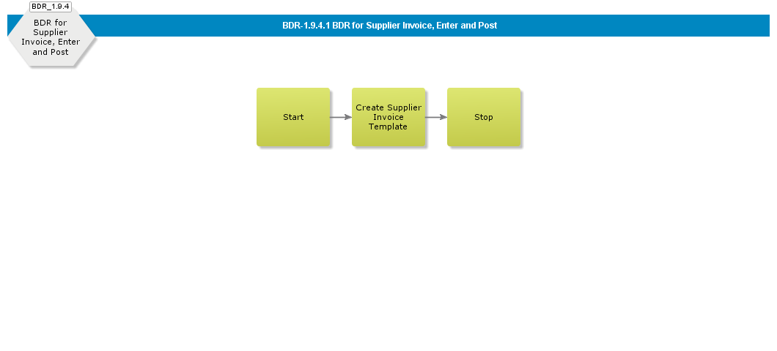

Objective
Write the objective here.

Background information
Write the background here.

Steps

Post Supplier Invoice

Introduction
Write introduction here.
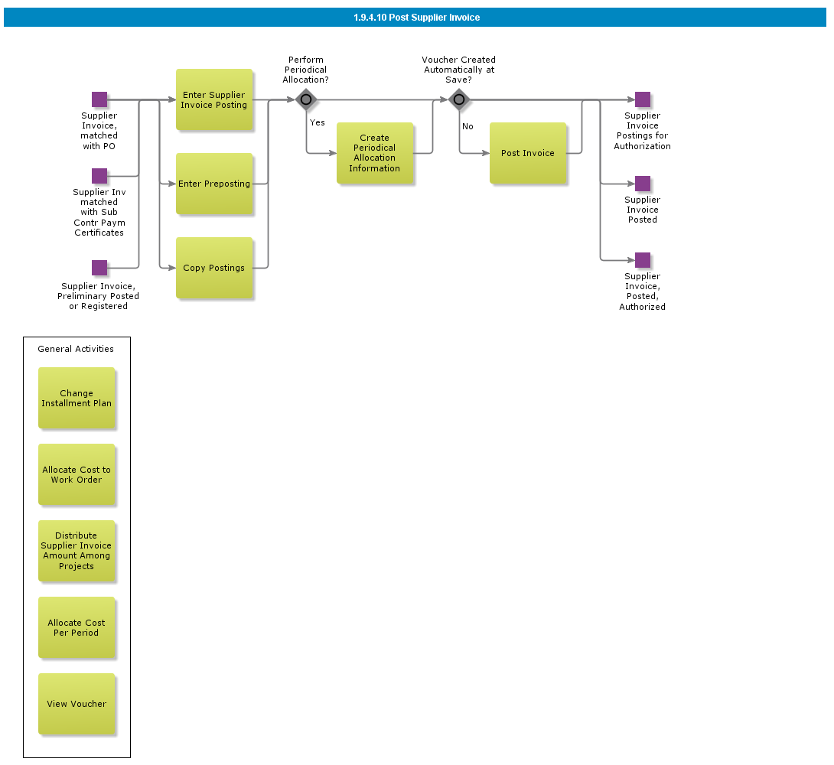

Objective
Write the objective here.

Background information
Write the background here.

Steps

Manually Balance Supplier Invoice

Introduction
Write introduction here.
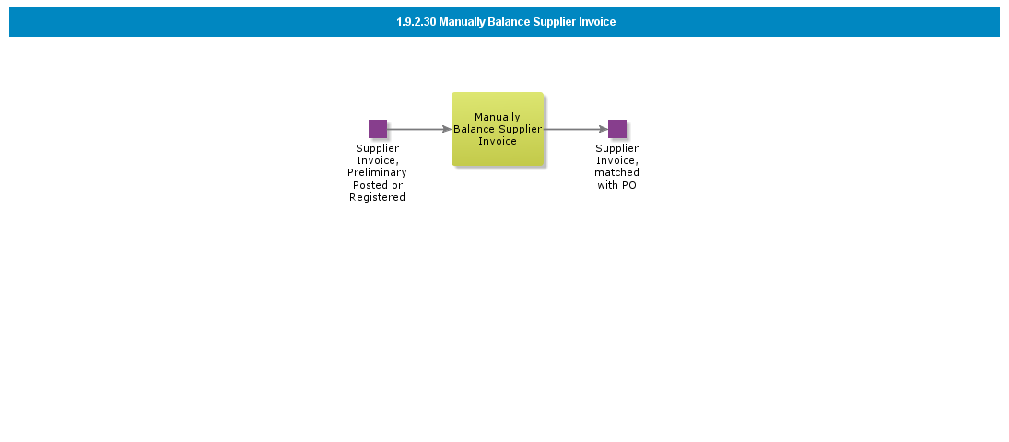

Objective
Write the objective here.

Background information
Write the background here.

Steps

Match and Adjust Purchase Order Receipt

Introduction
Write introduction here.
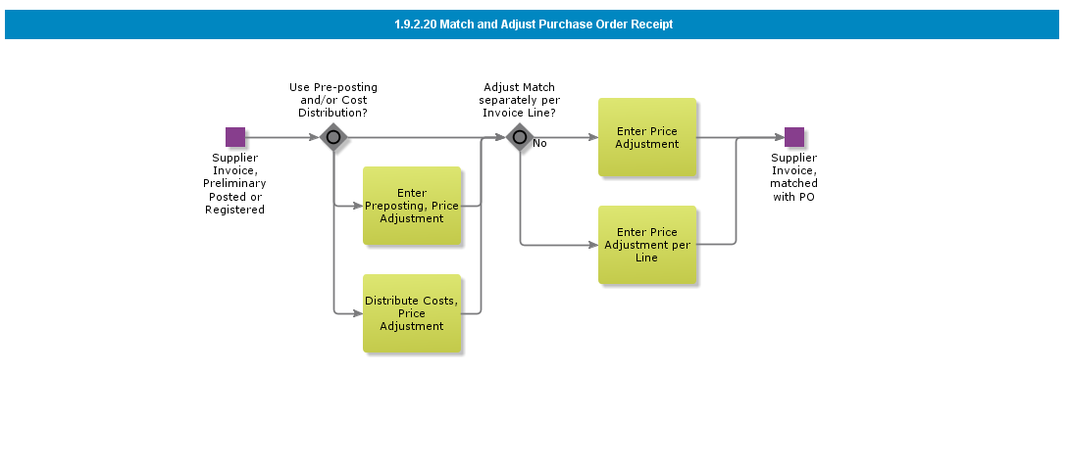

Objective
Write the objective here.

Background information
Write the background here.

Steps

Match Purchase Order Receipt

Introduction
Write introduction here.
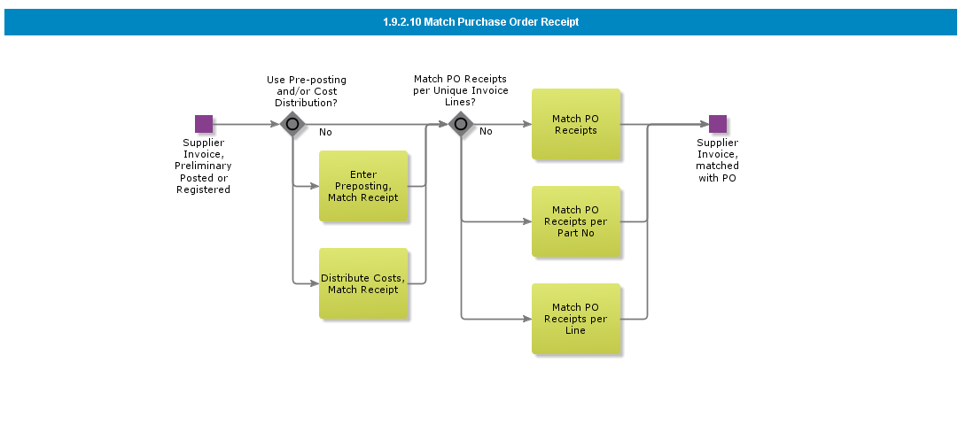

Objective
Write the objective here.

Background information
Write the background here.

Steps

BDR for External Supplier Invoices

Introduction
Write introduction here.
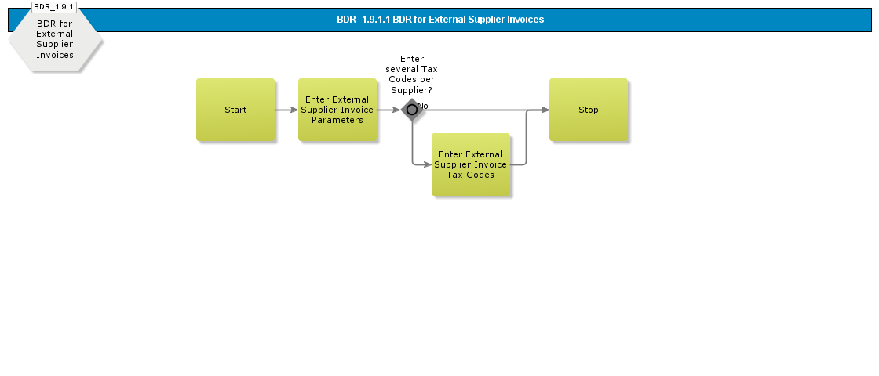

Objective
Write the objective here.

Background information
Write the background here.

Steps

Receive Supplier Invoice on File

Introduction
Write introduction here.
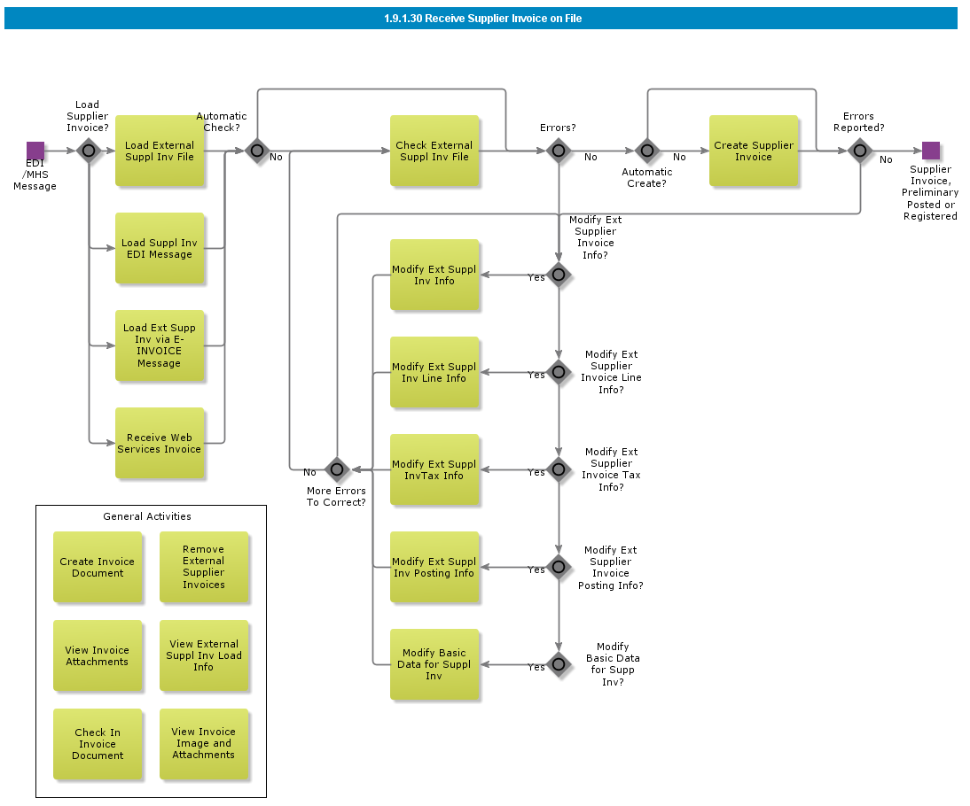

Objective
Write the objective here.

Background information
Write the background here.

Steps

Enter Manual Supplier Invoice

Introduction
Write introduction here.
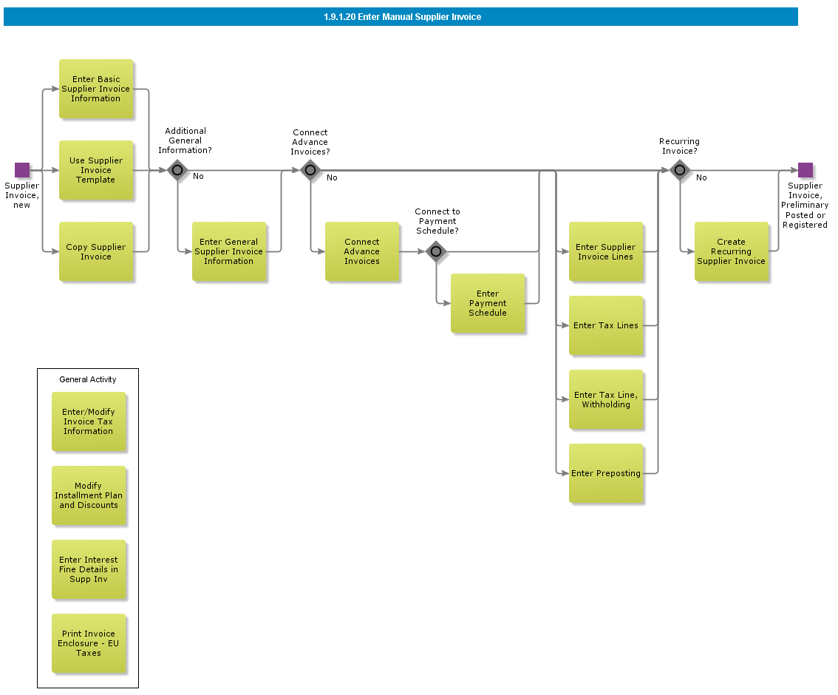

Objective
Write the objective here.

Background information
Write the background here.

Steps

Enter Preliminary Supplier Invoice

Introduction
Write introduction here.
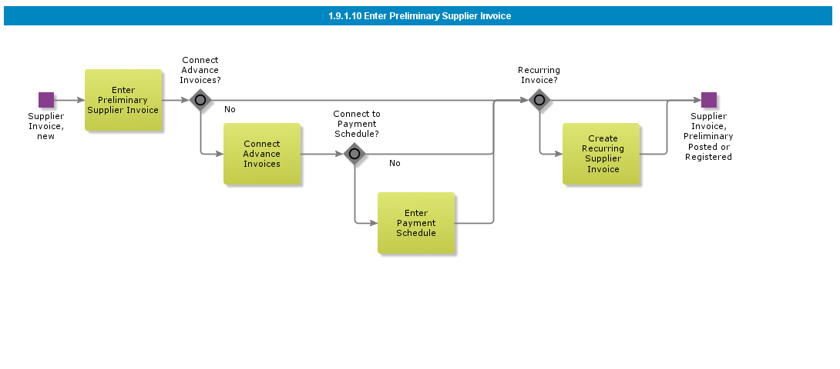

Objective
Write the objective here.

Background information
Write the background here.

Steps

BDR for Posting Template

Introduction
Write introduction here.
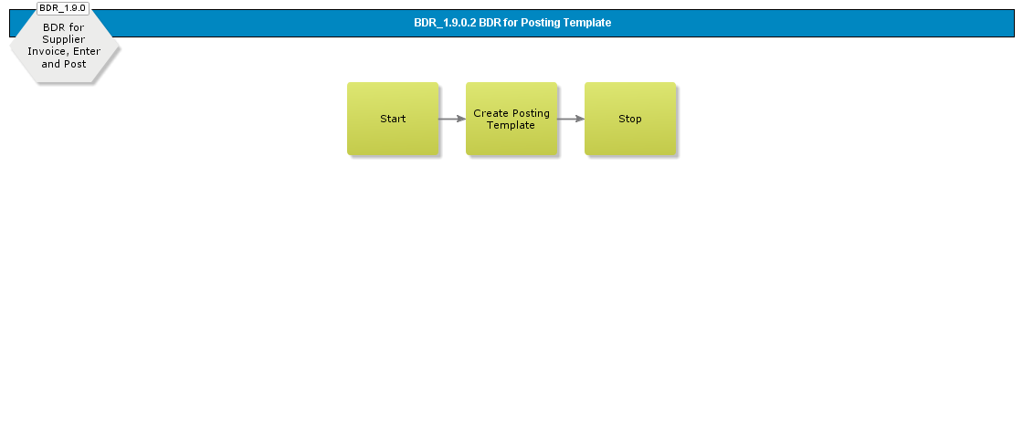

Objective
Write the objective here.

Background information
Write the background here.

Steps

BDR Create Supplier Invoice Template

Introduction
Write introduction here.
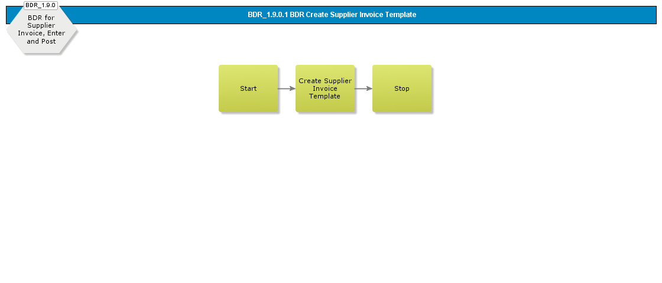

Objective
Write the objective here.

Background information
Write the background here.

Steps

Acknowledge Payment Order and Create Customer Payments

Introduction
Write introduction here.
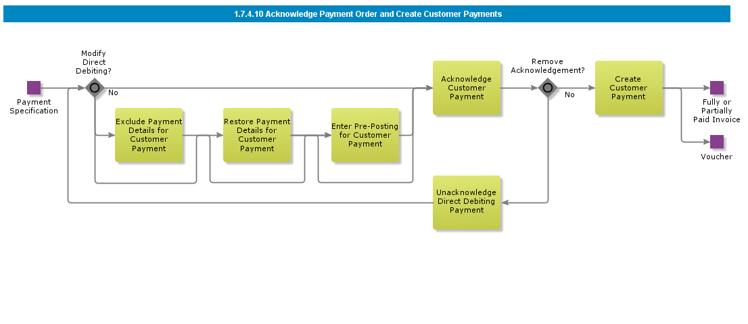

Objective
Write the objective here.

Background information
Write the background here.

Steps

Create Repayment Order for Customer Repayment, Check

Introduction
Write introduction here.
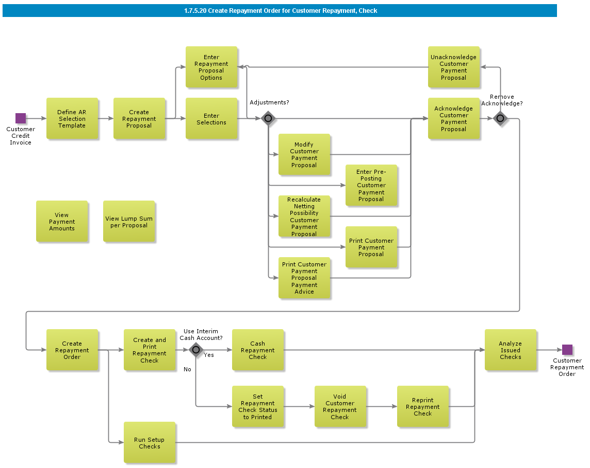

Objective
Write the objective here.

Background information
Write the background here.

Steps

Create Repayment Order for Customer Repayment, File

Introduction
Write introduction here.
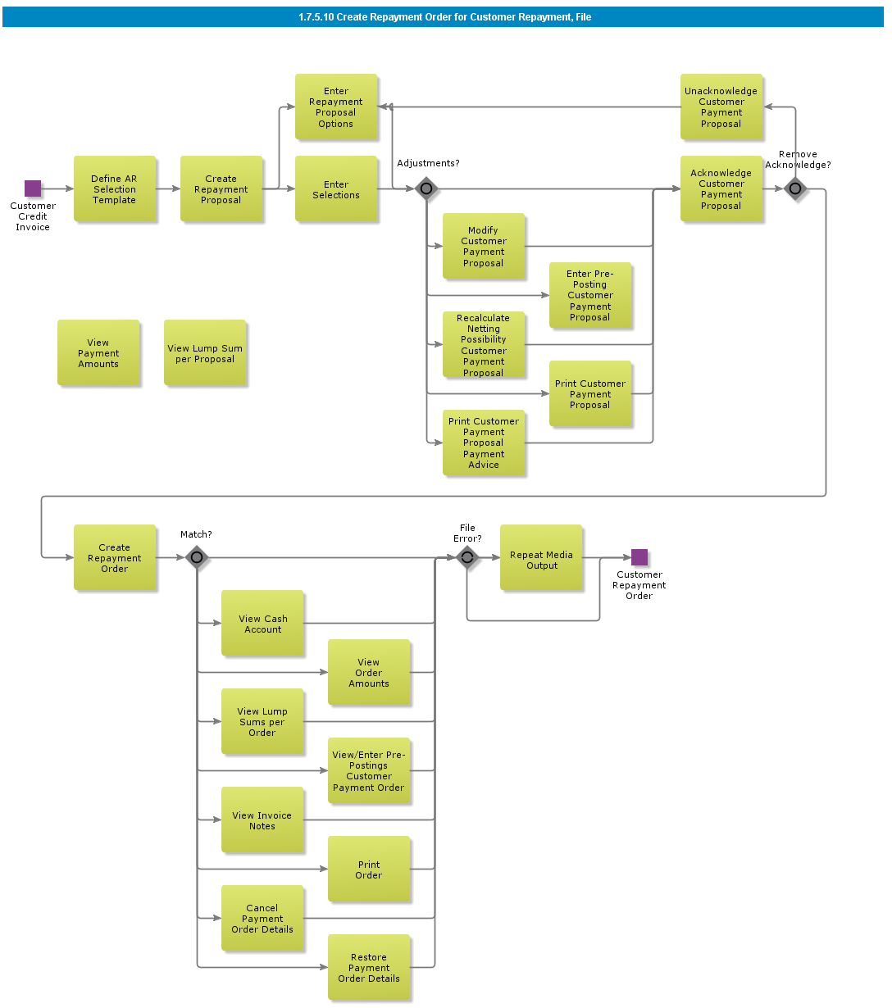

Objective
Write the objective here.

Background information
Write the background here.

Steps

Create Payment Order for Customer Direct Debiting

Introduction
Write introduction here.
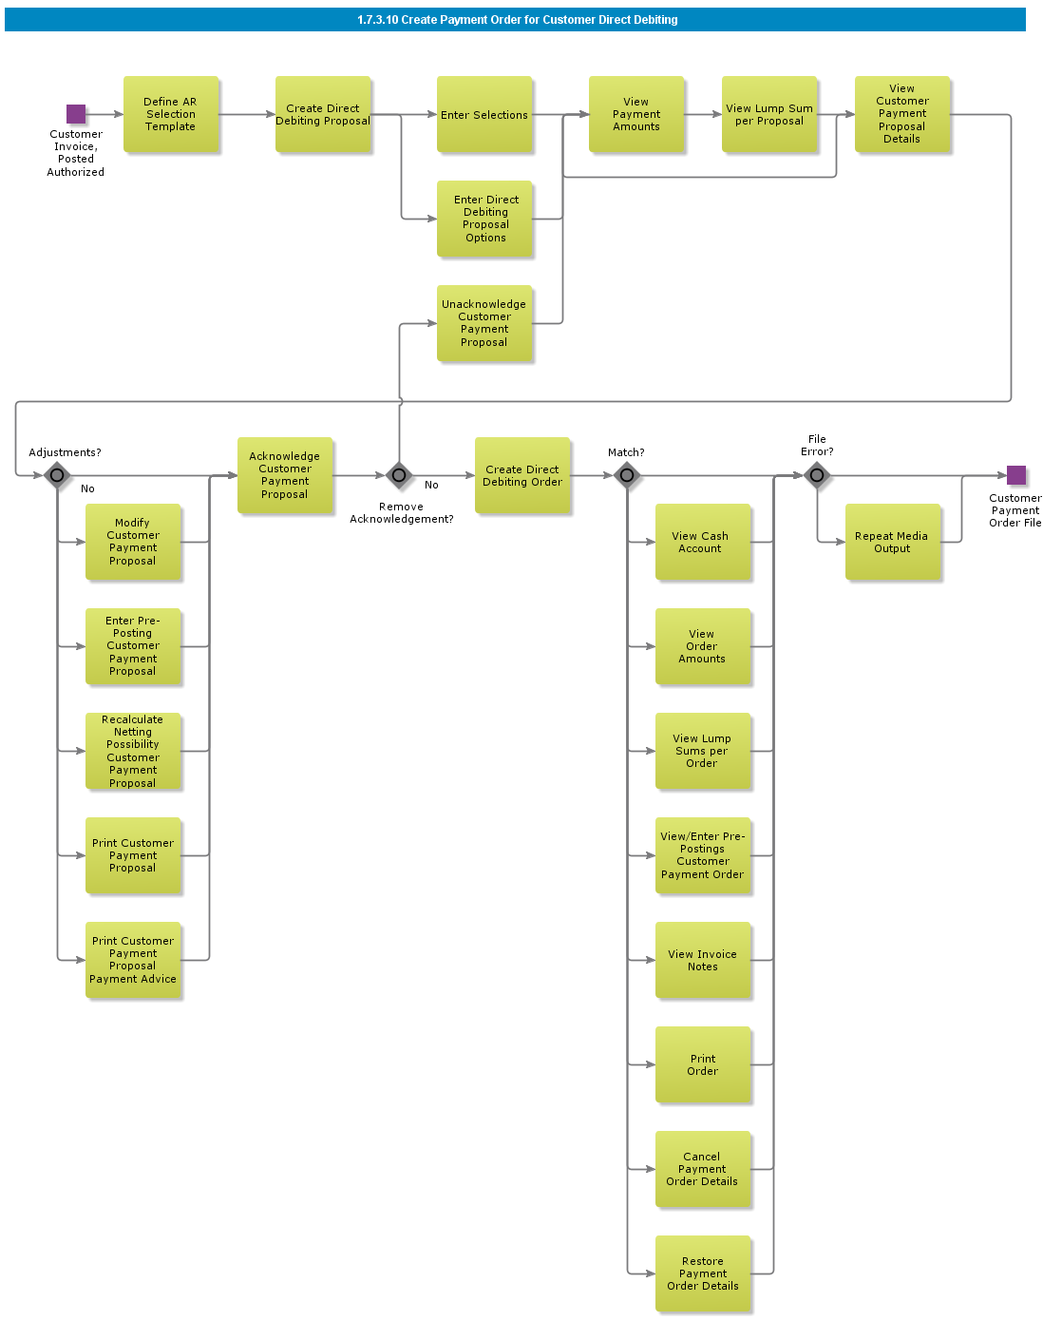

Objective
Write the objective here.

Background information
Write the background here.

Steps

Customer Payment on File

Introduction
Write introduction here.
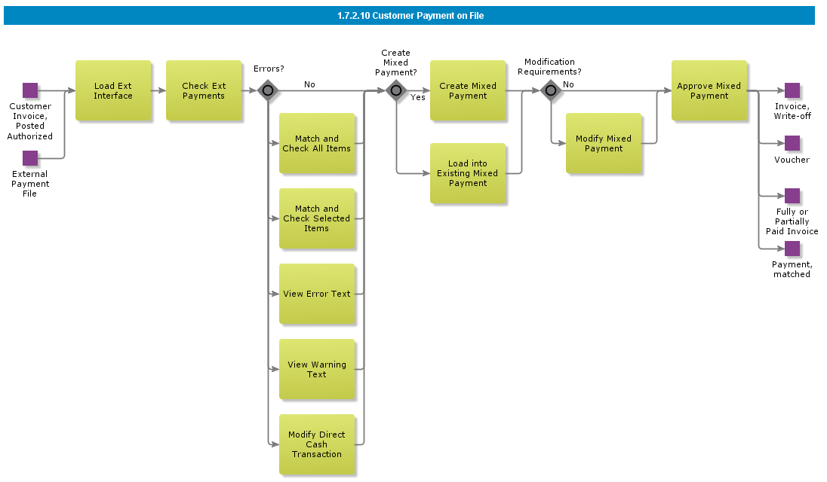

Objective
Write the objective here.

Background information
Write the background here.

Steps

Manual Customer Payment

Introduction
Write introduction here.
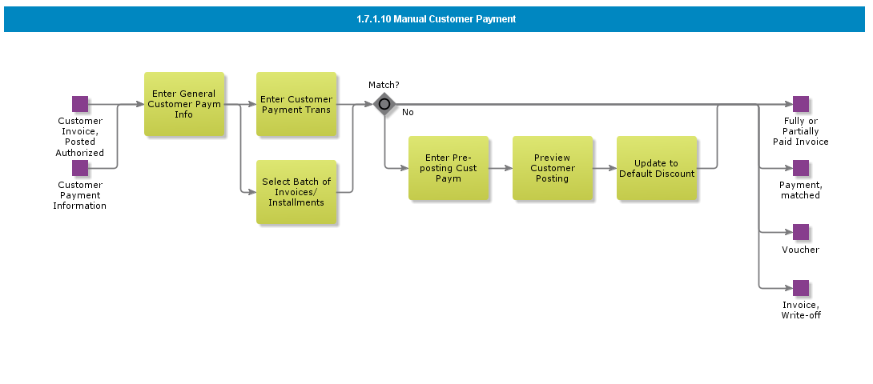

Objective
Write the objective here.

Background information
Write the background here.

Steps

BDR for Payment Documents

Introduction
Write introduction here.
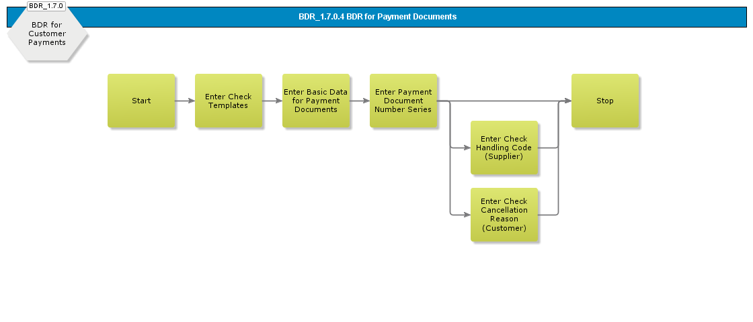

Objective
Write the objective here.

Background information
Write the background here.

Steps

BDR for External Payments

Introduction
Write introduction here.
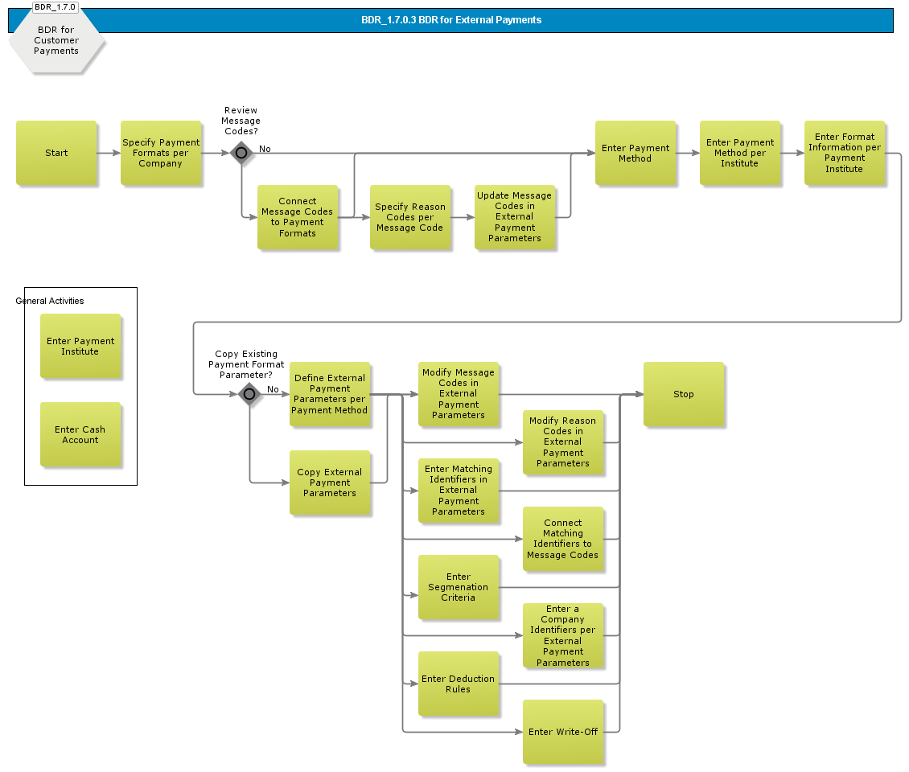

Objective
Write the objective here.

Background information
Write the background here.

Steps

BDR for Define Selection Template

Introduction
Write introduction here.
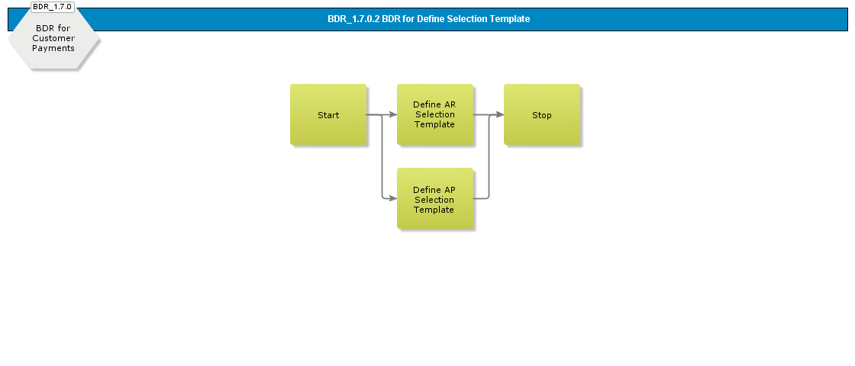

Objective
Write the objective here.

Background information
Write the background here.

Steps

BDR for Bill of Exchange

Introduction
Write introduction here.
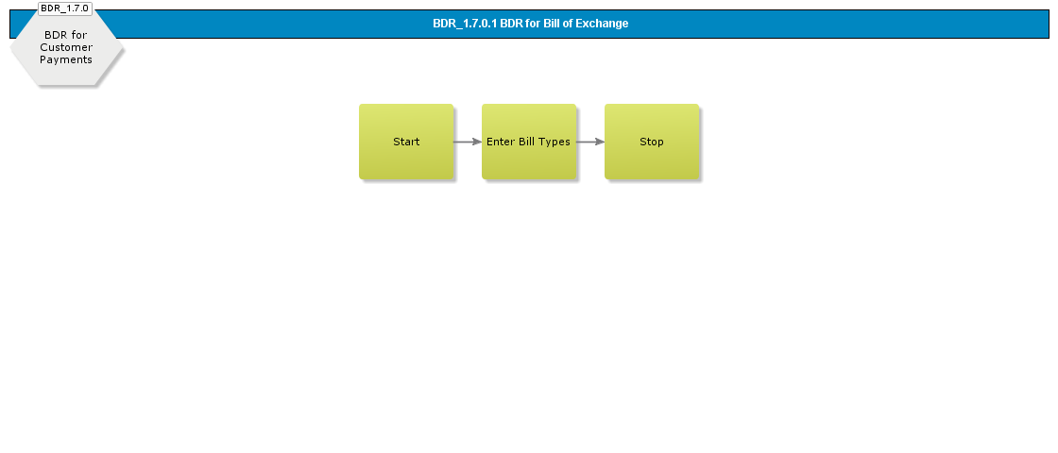

Objective
Write the objective here.

Background information
Write the background here.

Steps

Reports Invoicing

Introduction
Write introduction here.
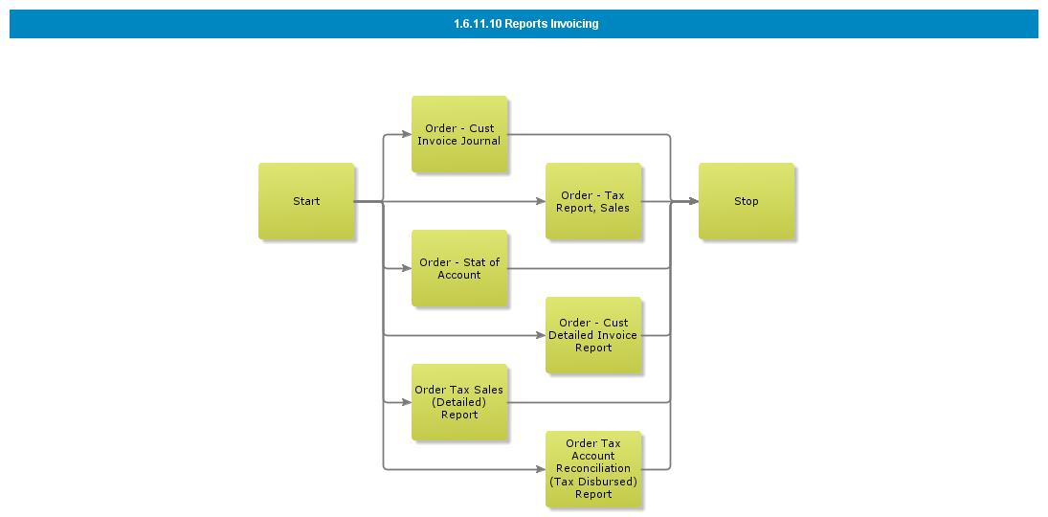

Objective
Write the objective here.

Background information
Write the background here.

Steps

Queries Invoicing

Introduction
Write introduction here.
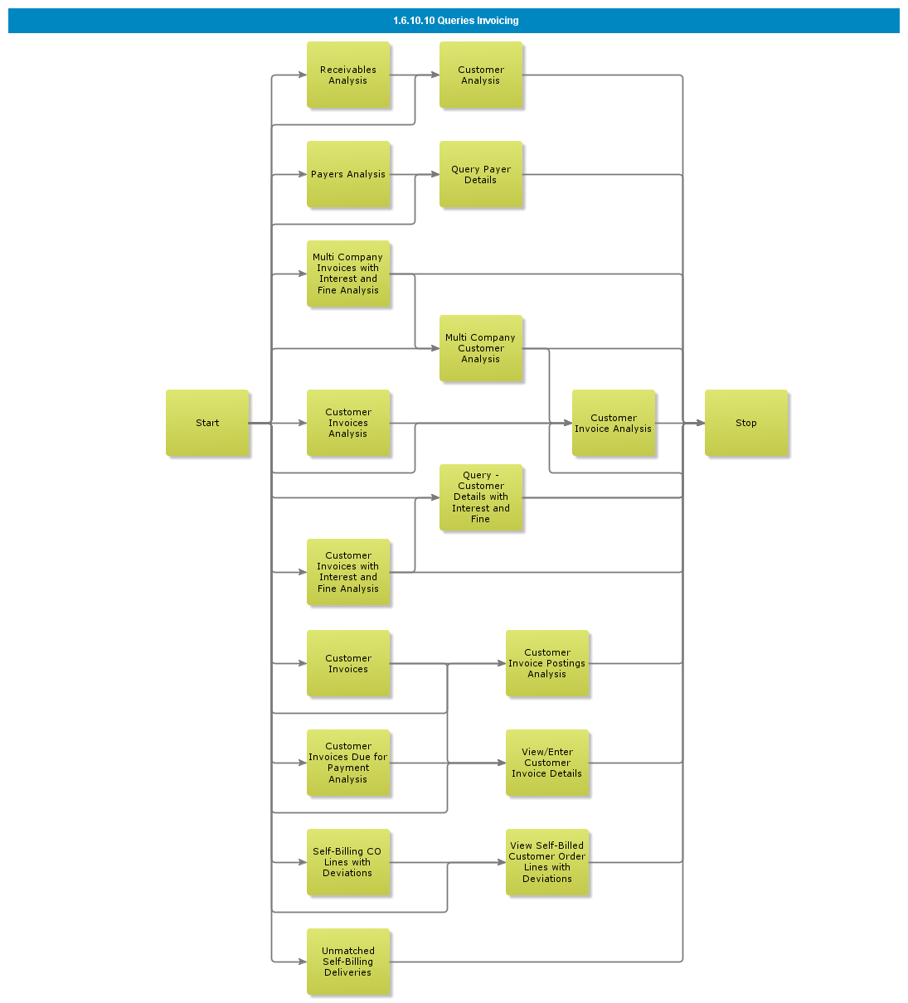

Objective
Write the objective here.

Background information
Write the background here.

Steps

Send Invoice via file (XML/EDI)

Introduction
Write introduction here.
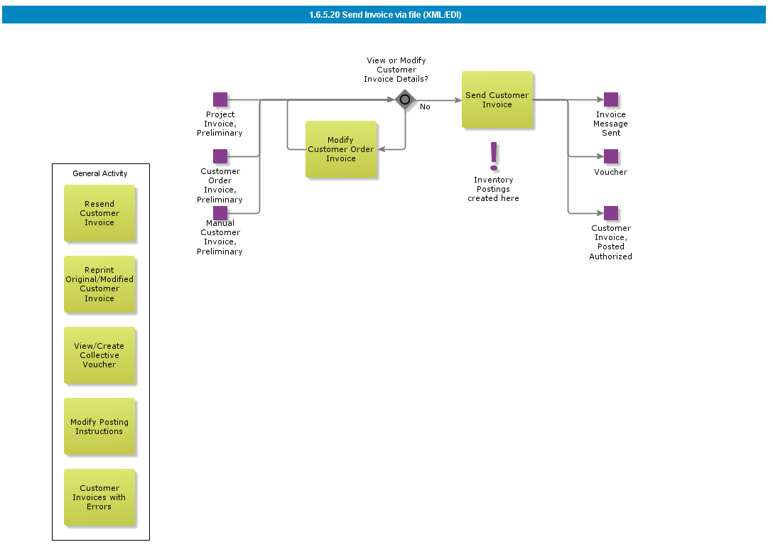

Objective
Write the objective here.

Background information
Write the background here.

Steps

Handle, Print and Post Customer Invoice

Introduction
Write introduction here.
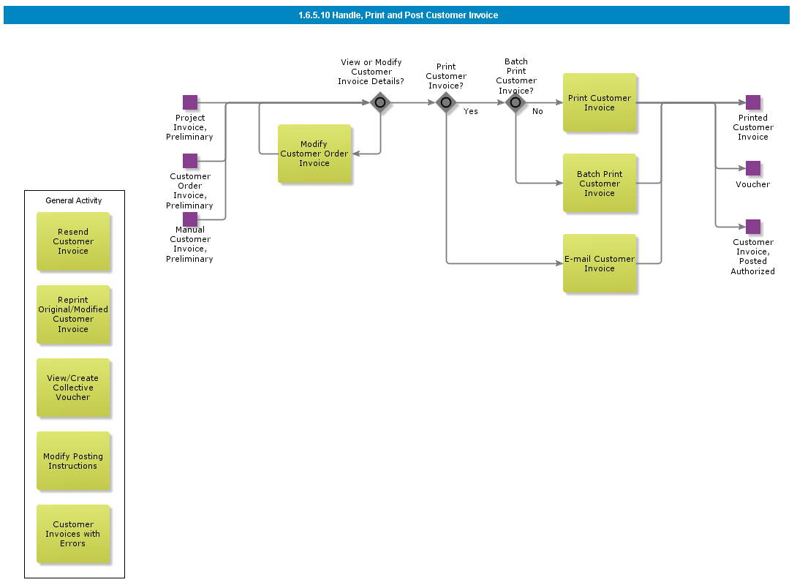

Objective
Write the objective here.

Background information
Write the background here.

Steps

BDR for Self-Billing

Introduction
Write introduction here.
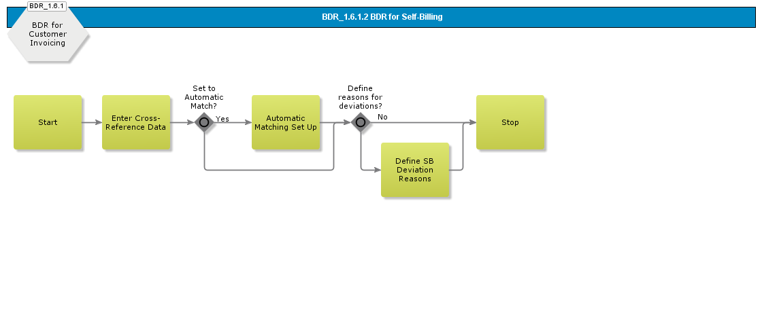

Objective
Write the objective here.

Background information
Write the background here.

Steps

BDR for External Customer Invoices

Introduction
Write introduction here.
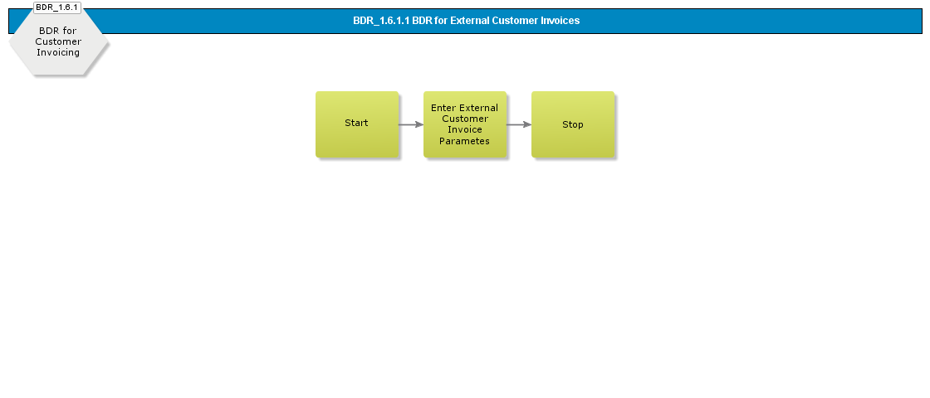

Objective
Write the objective here.

Background information
Write the background here.

Steps

Customer Order Invoicing for consignment

Introduction
Write introduction here.

Objective
Write the objective here.

Background information
Write the background here.

Steps

Create Customer Order Correction Invoice

Introduction
Write introduction here.
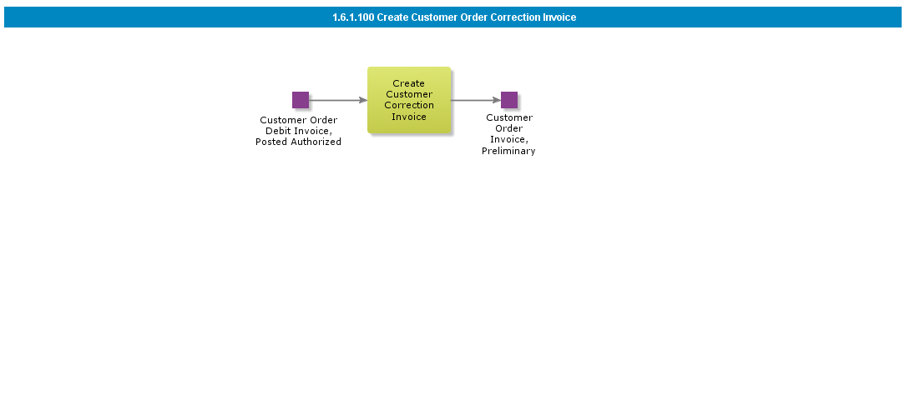

Objective
Write the objective here.

Background information
Write the background here.

Steps

Create Customer Order Credit Invoice

Introduction
Write introduction here.
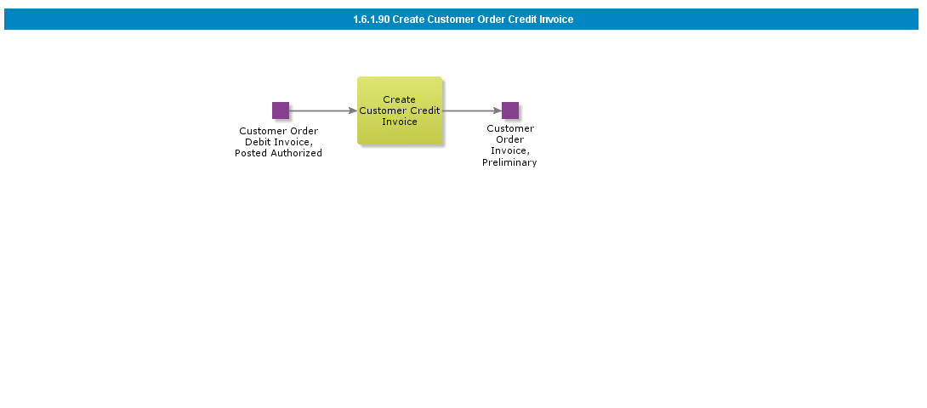

Objective
Write the objective here.

Background information
Write the background here.

Steps

Create Rebate Credit Invoice

Introduction
Write introduction here.

Objective
Write the objective here.

Background information
Write the background here.

Steps

Create Shipment Invoice

Introduction
Write introduction here.

Objective
Write the objective here.

Background information
Write the background here.

Steps

Create Stage Billing Invoice

Introduction
Write introduction here.

Objective
Write the objective here.

Background information
Write the background here.

Steps

Create Prepayment Based Invoice

Introduction
Write introduction here.

Objective
Write the objective here.

Background information
Write the background here.

Steps

Create Advance Invoice

Introduction
Write introduction here.

Objective
Write the objective here.

Background information
Write the background here.

Steps

Self Billing Invoice

Introduction
Write introduction here.

Objective
Write the objective here.

Background information
Write the background here.

Steps

Create Customer Order Collective Invoice with Rental Transactions

Introduction
Write introduction here.

Objective
Write the objective here.

Background information
Write the background here.

Steps

Create Customer Order Collective Invoicing

Introduction
Write introduction here.
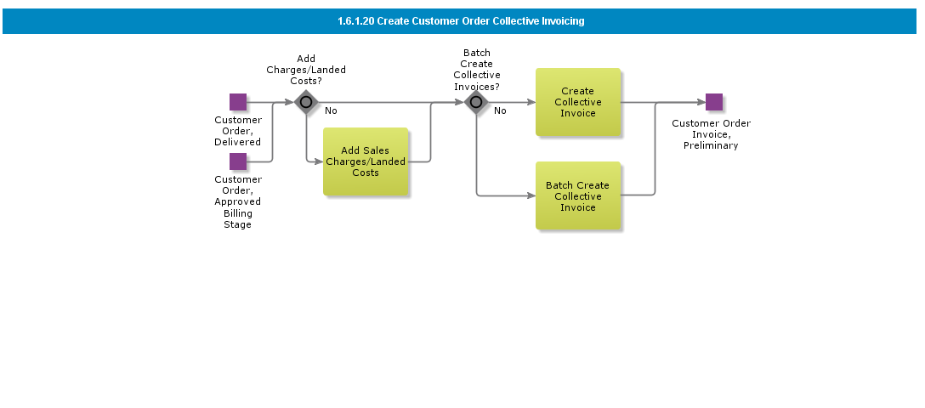

Objective
Write the objective here.

Background information
Write the background here.

Steps

Create Customer Order Invoice with Rental Transactions

Introduction
Write introduction here.

Objective
Write the objective here.

Background information
Write the background here.

Steps

Create Customer Order Invoice

Introduction
Write introduction here.
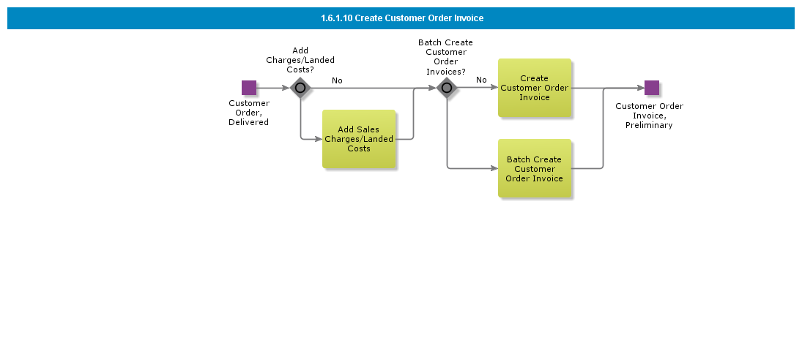

Objective
Write the objective here.

Background information
Write the background here.

Steps

Acme End 2 End Processes

Acme E2E Process Order to Cash

Enter Customer Order
This sub process creates the customer order.

- During the process of creating a customer order you enter the customer order, specify any detailed information about pre-posting, complementary parts, charges, taxes, milestones, or staged billing. Also enter any notes and document text.
- When you are working in a CTO environment, entering a customer order works much in the same way as described above, but in this process you can also create and handle configurations and interim orders.
- This sub process can also handle the creation of a customer order in a preliminary or planned state when the order has been received as an EDI/MHS/XML order message or updates a customer order if a message to change an existing order is received.

Release Customer Order

Confirm Customer Order
This sub process handles the notification to the customer that the customer order is confirmed once the fulfillment of the customer order has been verified. Depending on the customer the method of notification can be a printed notification, and email or and EDI message.

Reserve Customer Order
This sub process reserves the items on the customer order

- If the order is prioritized, you do not need to prioritize the parts. They were already reserved when the customer order was released.
- If the order is not prioritized, the ordered parts must be reserved. You can do this either manually or in batch. If there are not enough parts and you use the batch method, not all order lines will be reserved. Instead, they will appear in the shortage window. In the same window you can also calculate the optimal time of delivery, simulate what will happen if the delivery date is prolonged or partial deliveries take place,
- Finally, you can issue a booking proposal to a forwarding agent.

Handle Picking
This Sub process creates Pick List and the reported picked goods. You can choose wether you want to use Transport Task or not for the picking.

Deliver Customer Order

Customer Order Invoicing
Invoicing customer orders normally takes place towards the end of the customer order flow. The goods ordered have to be fully or partially delivered before invoicing is carried out. The order can be invoiced either manually or automatically.

Normal invoice - generated for every order.

- Collective invoice- generated for a group of customer orders.
- Credit Invoice

The Customer Order Invoicing Process can be supported in multiple ways, for example,

- Advance Invoicing - Customer order invoices can be prepared even before the goods are delivered.
- Prepayment Based Invoicing - Prepayment-based invoices are created before the goods are delivered, but unlike advance invoices, prepayment-based invoices are created only after a prepayment for a customer order has been received
- Shipment Invoicing - Shipments can be invoiced as one entity. We create an invoice on the complete shipment, instead of one for each delivered order
- Self Billing - occurs when a customer creates an invoice for himself and thereby eliminates the need for the supplier to create and send him an invoice in order to receive payment for deliveries.
- Stage Billing - can be used whenever an order is to be paid in multiple stages. This functionality enables you to invoice an order at any stage in the order flow, not just after delivery.
- Correction Invoice - When a correction invoice is created, the system automatically creates two lines for each debit line of the reference invoice.

Manage Customer Invoice Output

Acme E2E Process Purchase to Pay

Handle Purchase Requisition
The purpose of this sub-process is to transfer an requisition to purchase order. The input are manually or system generated purchase order requisitions and out-put are a planned purchase order.

- Once you have entered the purchase requisition entry, you must release the requisition before it can be further processed. If using the authorization routine, a specified user must authorize the requisition before it can be converted into a purchase order. A supplier must have been specified on the requisition line before you can convert the requisition into a purchase order.

If required, you can convert lines on the purchase requisition into a request for order quotation. Using this option, no suppliers need to be specified on the requisition lines and no authorization is required.

Handle Purchase Order
The purpose of this sub process is to process the purchase order.

- The input are a purchase order created manually or from purchase order requisition and output are to finalized purchase order released and/or send to supplier.

Print and/or Send Purchase Order

Report Arrival
This process object is divided into three scenarios:

- Report arrival - this scenario is normally used, except when handling dispatch advice and direct receipt of no-number parts.
- Report direct receipt of no-number parts - this is used when no-number parts should be entered as arriving directly from the purchase order. The no-part order line is entered as arrived, and the order line status is changed to Closed. You can view and cancel the receipt lines in the receipt function. Receipt history is logged for each line entered. When an inspection is required, you must continue to the Purchase Order Receipt window. The status on the receipt line is then set to To be Inspected. When you enter the inspection results, the status on the receipt line changes to Received.
- Report arrival using dispatch advice - this is used when arrivals should be done by using a dispatch advice. When reporting an arrival from a dispatch advice, you can choose between reporting an entire shipment as arrived or reporting a partial arrival of single lines.

The following receive cases use this process object:

- Receive into arrival
- Receive into inventory
- Receive into arrival, perform putaway
- Receive into arrival, inspect at arrival
- Receive into arrival, inspect at QA
- Receive into QA, inspect at QA

Serial-handling: The arrival registration is performed in different dialog boxes depending on whether the parts are serial-handled, or if serial numbers will be defined at the arrival registration or afterwards. If you are dealing with serial-handled parts and have decided to postpone the serial number assignment, enter the arrival by using the dialog box for parts without serial numbers.

Pallet-handling: Pallets are created for pallet-handled parts that are placed in a pallet arrival location. However, you can handle pallet-handled parts in the same manner as single-handled parts and then create pallets in IFS/Inventory. If the parts are divided among pallets, the quantity of parts per pallet can be modified.

Arrival Report: A printout of the arrival report in connection to the arrival registration can be produced. However, you have the option to print this later on.

Create Purchase Order from Arrival: You have the option to create a new purchase order from the arrival registration window.

This can be useful when goods arrive without an order from your company.

This occurs, for example, when a supplier refills a consignment stock located in your warehouse.

When the goods arrive, you then do not have a corresponding purchase order line on which to enter the arrival, thus a purchase order line has to be created afterwards.

Once a purchase order line is created, enter the arrival in the usual manner..

Perform Quality Inspection & Handle Discrepancies
This Sub process is used for following receive cases:

- Receive into arrival, inspect at arrival
- Receive into arrival, inspect at QA
- Receive into QA, inspect at QA

If necessary information is entered in IFS/Quality Management, you can create an analysis in the receipt function and then enter test results in the aforementioned component. Notice that these control operations are not connected to inspection codes or to the entry of inspection results in IFS/Purchasing. The testing results can be used as guidelines when entering the inspection results in IFS/Purchasing.

The inspection should then be performed and the inspection results entered.

The quantity to inspect is calculated by the inspection code.

In connection with reporting, the inspection results' faulty parts can be scrapped, returned for rework, or returned for credit.

A replacement order can be created for parts that are returned for credit.

If for some reason you have entered a scrap or return by mistake, you can undo this action.

To do so, enter an inspection approval for parts where the scrap or return is undone..

Once the quality inspection is completed, the receipt is also completed and the receipt line acquires the Received status with regards to lines with non-inventory registered purchase parts and no-number parts. Also, the receipt line with inventory registered purchase parts acquires the To be Received status.

Receive or Enter Supplier Invoice

Purchase Order Receipt Matching

Post Supplier Invoice

Authorize Supplier Invoice for Payment

Manual Supplier Payment
The Manual Supplier Payment process is used to enter details of your company’s manual payments and manual check payments to the suppliers through the various payment institutes.

Offsets can be entered at the same time as the payments.

These can be offsets between debit and credit invoices or between invoices, payments on account and payments in advance.

You can also process invoices that have been placed as parked payments and enter these as paid.

When you enter a manual payment, a voucher is generated automatically to the hold table in IFS/Accounting Rules.

This is updated to the general ledger in connection with the next update.

If payment cancellation is needed there are functions for undoing a whole payment or part of a payment.

Undoing means that you post invoices and prepayments as unpaid..

Handle Arrival
The following receive cases use this Sub process. (This Sub process can be regarded as optional since no activity is crucial for the working process.):

- Receive into arrival
- Receive into arrival, inspect at arrival
- Receive into arrival, inspect at QA
- Receive into QA, inspect at QA

Before the inventory registered purchase parts are received into a stock location, you can add or update information such as the expiration date, W/D/R number, lot/batch number, split into serials, and printing of barcode labels, depending on the settings for the part.

Move into Stock
The following receive cases use this Sub process:

- Receive into arrival
- Receive into arrival, perform putaway
- Receive into arrival, inspect at arrival
- Receive into arrival, inspect at QA
- Receive into QA, inspect at QA

When the arrival registration and any required inspection is performed (with or without an inspection location), the inventory registered purchase parts should be moved into one or more stock locations, e.g., a picking location. Pallet-handled parts are moved by using pallet transport tasks. The stock location type for pallet-handled parts can be pallet, pallet deep, or pallet buffer.

Once moving into a stock location, the receipt line with inventory registered purchase parts acquires the Received status and the receipt-handling is completed.

For parts with perform putaway enabled, the best possible location is found and the parts are moved to that location. Transport tasks are created.

Purchase Order Confirmation

Enter and Match Supplier Payment

Introduction
Write introduction here.

Objective
Write the objective here.

Background information
Write the background here.

Steps

Authorize Supplier Invoice for Payment

Introduction
Write introduction here.

Objective
Write the objective here.

Background information
Write the background here.

Steps

BDR for Supplier Invoice, Enter and Post

Introduction
Write introduction here.

Objective
Write the objective here.

Background information
Write the background here.

Steps

Post Supplier Invoice

Introduction
Write introduction here.

Objective
Write the objective here.

Background information
Write the background here.

Steps

Manually Balance Supplier Invoice

Introduction
Write introduction here.

Objective
Write the objective here.

Background information
Write the background here.

Steps

Match and Adjust Purchase Order Receipt

Introduction
Write introduction here.

Objective
Write the objective here.

Background information
Write the background here.

Steps

Match Purchase Order Receipt

Introduction
Write introduction here.

Objective
Write the objective here.

Background information
Write the background here.

Steps

BDR for External Supplier Invoices

Introduction
Write introduction here.

Objective
Write the objective here.

Background information
Write the background here.

Steps

Receive Supplier Invoice on File

Introduction
Write introduction here.

Objective
Write the objective here.

Background information
Write the background here.

Steps

Enter Manual Supplier Invoice

Introduction
Write introduction here.

Objective
Write the objective here.

Background information
Write the background here.

Steps

Enter Preliminary Supplier Invoice

Introduction
Write introduction here.

Objective
Write the objective here.

Background information
Write the background here.

Steps

Send Invoice via file (XML/EDI)

Introduction
Write introduction here.

Objective
Write the objective here.

Background information
Write the background here.

Steps

Handle, Print and Post Customer Invoice

Introduction
Write introduction here.

Objective
Write the objective here.

Background information
Write the background here.

Steps

BDR for Self-Billing

Introduction
Write introduction here.

Objective
Write the objective here.

Background information
Write the background here.

Steps

BDR for External Customer Invoices

Introduction
Write introduction here.

Objective
Write the objective here.

Background information
Write the background here.

Steps

Customer Order Invoicing for consignment

Introduction
Write introduction here.

Objective
Write the objective here.

Background information
Write the background here.

Steps

Create Customer Order Correction Invoice

Introduction
Write introduction here.

Objective
Write the objective here.

Background information
Write the background here.

Steps

Create Customer Order Credit Invoice

Introduction
Write introduction here.

Objective
Write the objective here.

Background information
Write the background here.

Steps

Create Rebate Credit Invoice

Introduction
Write introduction here.

Objective
Write the objective here.

Background information
Write the background here.

Steps

Create Shipment Invoice

Introduction
Write introduction here.

Objective
Write the objective here.

Background information
Write the background here.

Steps

Create Stage Billing Invoice

Introduction
Write introduction here.

Objective
Write the objective here.

Background information
Write the background here.

Steps

Create Prepayment Based Invoice

Introduction
Write introduction here.

Objective
Write the objective here.

Background information
Write the background here.

Steps

Create Advance Invoice

Introduction
Write introduction here.

Objective
Write the objective here.

Background information
Write the background here.

Steps

Self Billing Invoice

Introduction
Write introduction here.

Objective
Write the objective here.

Background information
Write the background here.

Steps

Create Customer Order Collective Invoice with Rental Transactions

Introduction
Write introduction here.

Objective
Write the objective here.

Background information
Write the background here.

Steps

Create Customer Order Collective Invoicing

Introduction
Write introduction here.

Objective
Write the objective here.

Background information
Write the background here.

Steps

Create Customer Order Invoice with Rental Transactions

Introduction
Write introduction here.

Objective
Write the objective here.

Background information
Write the background here.

Steps

Create Customer Order Invoice

Introduction
Write introduction here.

Objective
Write the objective here.

Background information
Write the background here.

Steps

Deliver Customer Order Box Line (Retail ext)

Introduction
Write introduction here.

Objective
Write the objective here.

Background information
Write the background here.

Steps

Deliver Customer Order, Single Order Delivery, Pre-shipment Delivery Note

Introduction
Write introduction here.

Objective
Write the objective here.

Background information
Write the background here.

Steps

Deliver Customer Order, Load List

Introduction
Write introduction here.

Objective
Write the objective here.

Background information
Write the background here.

Steps

Finalize Shipment

Introduction
Write introduction here.

Objective
Write the objective here.

Background information
Write the background here.

Steps

Deliver Customer Order, Shipment

Introduction
Write introduction here.

Objective
Write the objective here.

Background information
Write the background here.

Steps

Deliver Customer Order, Single Order Delivery

Introduction
Write introduction here.

Objective
Write the objective here.

Background information
Write the background here.

Steps

Handle Picking of Boxes without Shipment (Retail ext)

Introduction
Write introduction here.

Objective
Write the objective here.

Background information
Write the background here.

Steps

Handle Picking with Shipment

Introduction
Write introduction here.

Objective
Write the objective here.

Background information
Write the background here.

Steps

Handle Picking without Shipment

Introduction
Write introduction here.

Objective
Write the objective here.

Background information
Write the background here.

Steps

Move into Stock with Pallet Handled Parts

Introduction
Write introduction here.

Objective
Write the objective here.

Background information
Write the background here.

Steps

Move into Stock with No Pallet Handled Parts

Introduction
Write introduction here.

Objective
Write the objective here.

Background information
Write the background here.

Steps

Handle Arrival

Introduction
Write introduction here.

Objective
Write the objective here.

Background information
Write the background here.

Steps

Perform Quality Inspection & Handle Discrepancies

Introduction
Write introduction here.

Objective
Write the objective here.

Background information
Write the background here.

Steps

Report Arrival, Component MRO

Introduction
Write introduction here.

Objective
Write the objective here.

Background information
Write the background here.

Steps

Report Direct Receipt of No-Number Parts

Introduction
Write introduction here.

Objective
Write the objective here.

Background information
Write the background here.

Steps

Report Arrival Using Dispatch Advice

Introduction
Write introduction here.

Objective
Write the objective here.

Background information
Write the background here.

Steps

Report Arrival

Introduction
Write introduction here.

Objective
Write the objective here.

Background information
Write the background here.

Steps

Confirm Purchase Order

Introduction
Write introduction here.

Objective
Write the objective here.

Background information
Write the background here.

Steps

Send Purchase Order to B2B Portal

Introduction
Write introduction here.

Objective
Write the objective here.

Background information
Write the background here.

Steps

Print/Send/E-mail Purchase Order

Introduction
Write introduction here.

Objective
Write the objective here.

Background information
Write the background here.

Steps

Print / Send Purchase Order

Introduction
Write introduction here.

Objective
Write the objective here.

Background information
Write the background here.

Steps

Process Purchase Order for External Service Order

Introduction
Write introduction here.

Objective
Write the objective here.

Background information
Write the background here.

Steps

Process Subcontracting Purchase Order

Introduction
Write introduction here.

Objective
Write the objective here.

Background information
Write the background here.

Steps

Process Purchase Order from Quotation

Introduction
Write introduction here.

Objective
Write the objective here.

Background information
Write the background here.

Steps

Modify Purchase Order Terms or Alternate Delivery Address

Introduction
Write introduction here.

Objective
Write the objective here.

Background information
Write the background here.

Steps

Handle Purchase Order (Basic)

Introduction
Write introduction here.

Objective
Write the objective here.

Background information
Write the background here.

Steps

Handle Purchase Order

Introduction
Write introduction here.

Objective
Write the objective here.

Background information
Write the background here.

Steps

Process Centralized Purchase Requisitions into one Purchase Order

Introduction
Write introduction here.

Objective
Write the objective here.

Background information
Write the background here.

Steps

Handle Purchase Requisition, Automatic Order Processing

Introduction
Write introduction here.

Objective
Write the objective here.

Background information
Write the background here.

Steps

Handle Express Purchase Order Requisition

Introduction
Write introduction here.

Objective
Write the objective here.

Background information
Write the background here.

Steps

Process PO Requisition to Quotation

Introduction
Write introduction here.

Objective
Write the objective here.

Background information
Write the background here.

Steps

Process Purchase Order Requisition

Introduction
Write introduction here.

Objective
Write the objective here.

Background information
Write the background here.

Steps

Handle Purchase Requisition

Introduction
Write introduction here.

Objective
Write the objective here.

Background information
Write the background here.

Steps

Run Automatic Reservation of Box Order Line, Started Manually (Retail ext)

Introduction
Write introduction here.

Objective
Write the objective here.

Background information
Write the background here.

Steps

Run Automatic Reservation of Customer Order Line, Started Manually

Introduction
Write introduction here.

Objective
Write the objective here.

Background information
Write the background here.

Steps

Run Automatic Reservation of Customer Order, Started by Order Type

Introduction
Write introduction here.

Objective
Write the objective here.

Background information
Write the background here.

Steps

Run Automatic Reservation of Customer Order, Started Manually

Introduction
Write introduction here.

Objective
Write the objective here.

Background information
Write the background here.

Steps

Run Automatic Reservation of a Batch of Customer Orders per Site, Started by Scheduled Task

Introduction
Write introduction here.

Objective
Write the objective here.

Background information
Write the background here.

Steps

Run Automatic Reservation of a Batch of Customer Orders per Site, Started Manually

Introduction
Write introduction here.

Objective
Write the objective here.

Background information
Write the background here.

Steps

Manually Reserve Customer Order Line

Introduction
Write introduction here.

Objective
Write the objective here.

Background information
Write the background here.

Steps

Reserve Customer Order (Std)

Introduction
Write introduction here.

Objective
Write the objective here.

Background information
Write the background here.

Steps

Release Customer Order

Introduction
Write introduction here.

Objective
Write the objective here.

Background information
Write the background here.

Steps

Send Customer Order Confirmation via EDI

Introduction
Write introduction here.

Objective
Write the objective here.

Background information
Write the background here.

Steps

Email Customer Order Confirmation

Introduction
Write introduction here.

Objective
Write the objective here.

Background information
Write the background here.

Steps

Print Customer Order Confirmation

Introduction
Write introduction here.

Objective
Write the objective here.

Background information
Write the background here.

Steps

Confirm Customer Order

Introduction
Write introduction here.

Objective
Write the objective here.

Background information
Write the background here.

Steps

Manually Create Customer Order, CTO

Introduction
Write introduction here.

Objective
Write the objective here.

Background information
Write the background here.

Steps

Manually Create Customer Order, Basic

Introduction
Write introduction here.

Objective
Write the objective here.

Background information
Write the background here.

Steps

Enter Customer Order

Introduction
Write introduction here.

Objective
Write the objective here.

Background information
Write the background here.

Steps

Error! No table of figures entries found.

